Prevent Harassment or Discrimination (PHD)
Setup in Infinite Campus
*Confirm your IC instance is at least updated to Campus.2503.6
- Create a New Behavior Event Category Named Investigation
  - In the Menu, expand System Settings
  - Click on Core Attribute/Dictionary 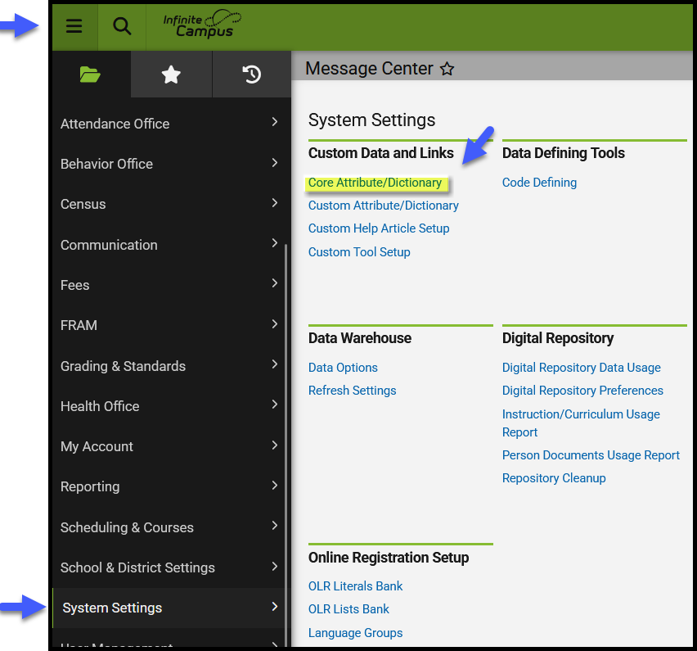
  - Scroll down to Behavior and expand
  - Expand Behavior Event Category
  - Click to open Dictionary 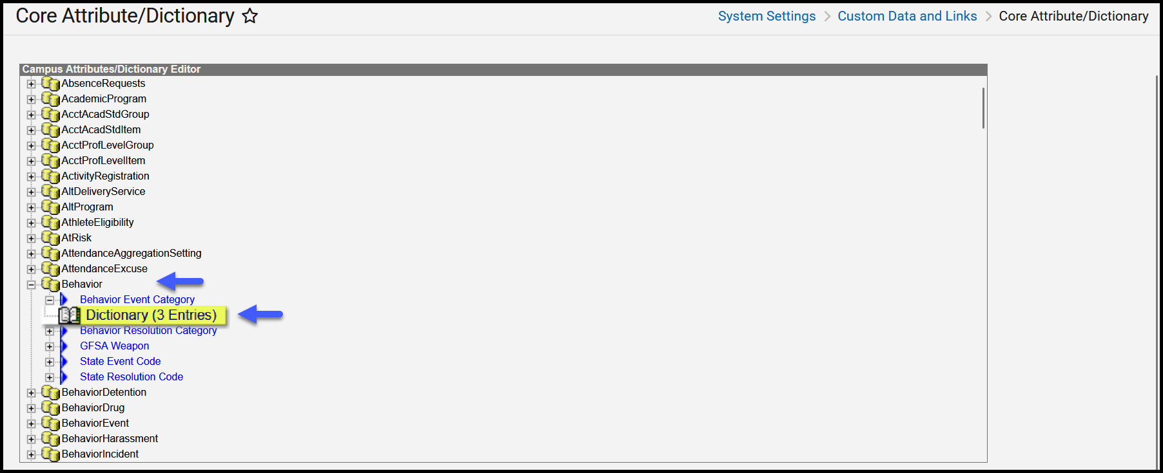
  - Click ‘Add Row’ to add a new Behavior Event Category. 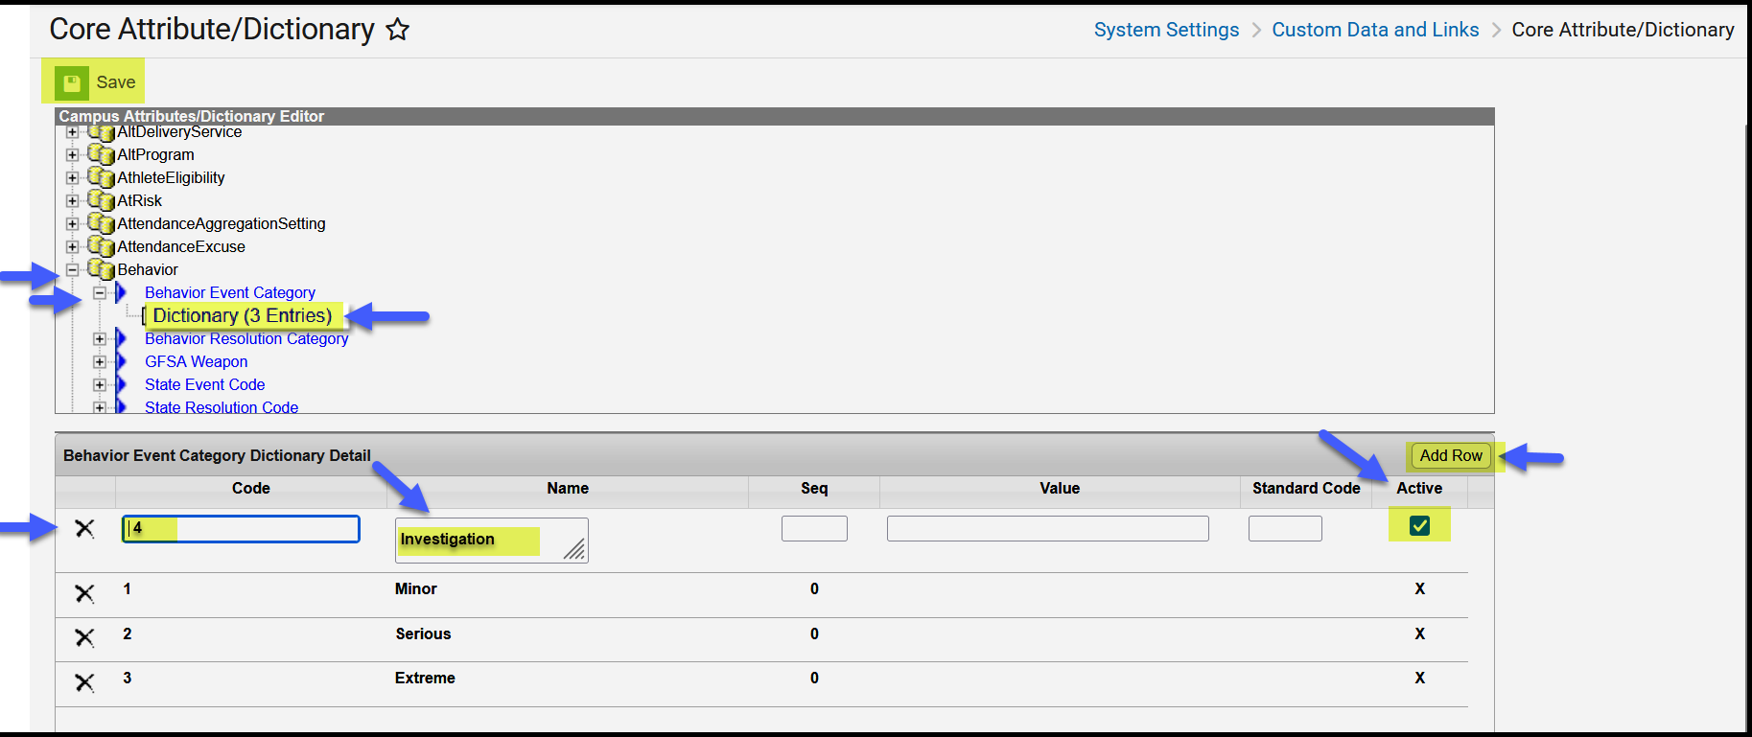
  - Fill in Code, using the next number in sequence. For most schools this will be number 4.
  - Enter Name ‘Investigation’
  - Sequence, Value and Standard Code are not needed and can be left blank
  - Save your changes and you will now have a Behavior Event Category labeled ‘Investigation’.
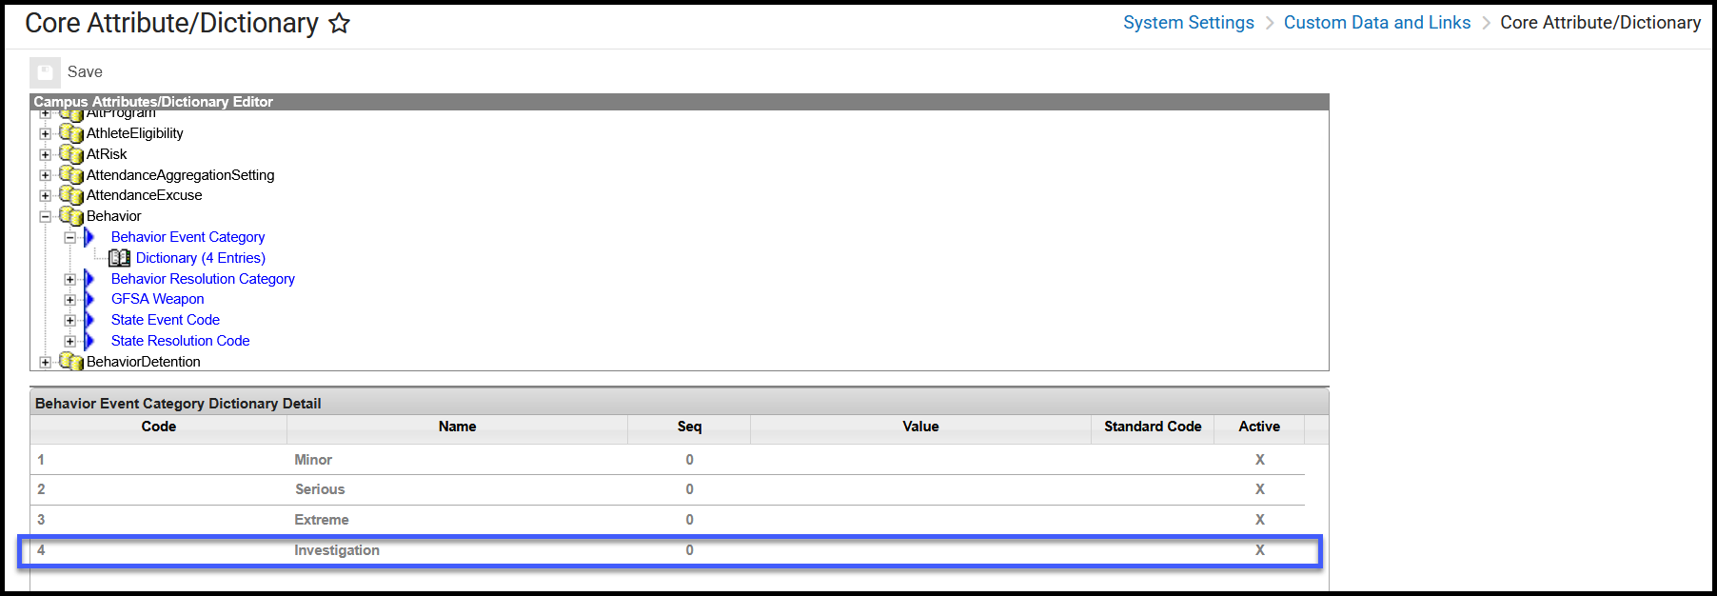

- Create a New Behavior Resolution Category Named Investigation
  - Still in the Core Attribute/Dictionary, now click to expand the Behavior Resolution Category.
  - Click to open Dictionary
  - Click ‘Add Row’ to add a new Behavior Resolution Category 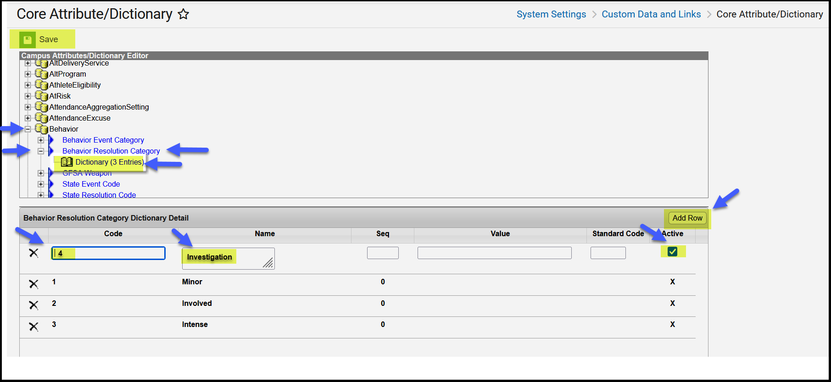
  - Fill in Code, using the next number in sequence. For most schools this will be number 4.
  - Enter Name ‘Investigation’
  - Sequence, Value and Standard Code are not needed and can be left blank
  - Save your changes and you will now have a Behavior Resolution Category labeled ‘Investigation’. 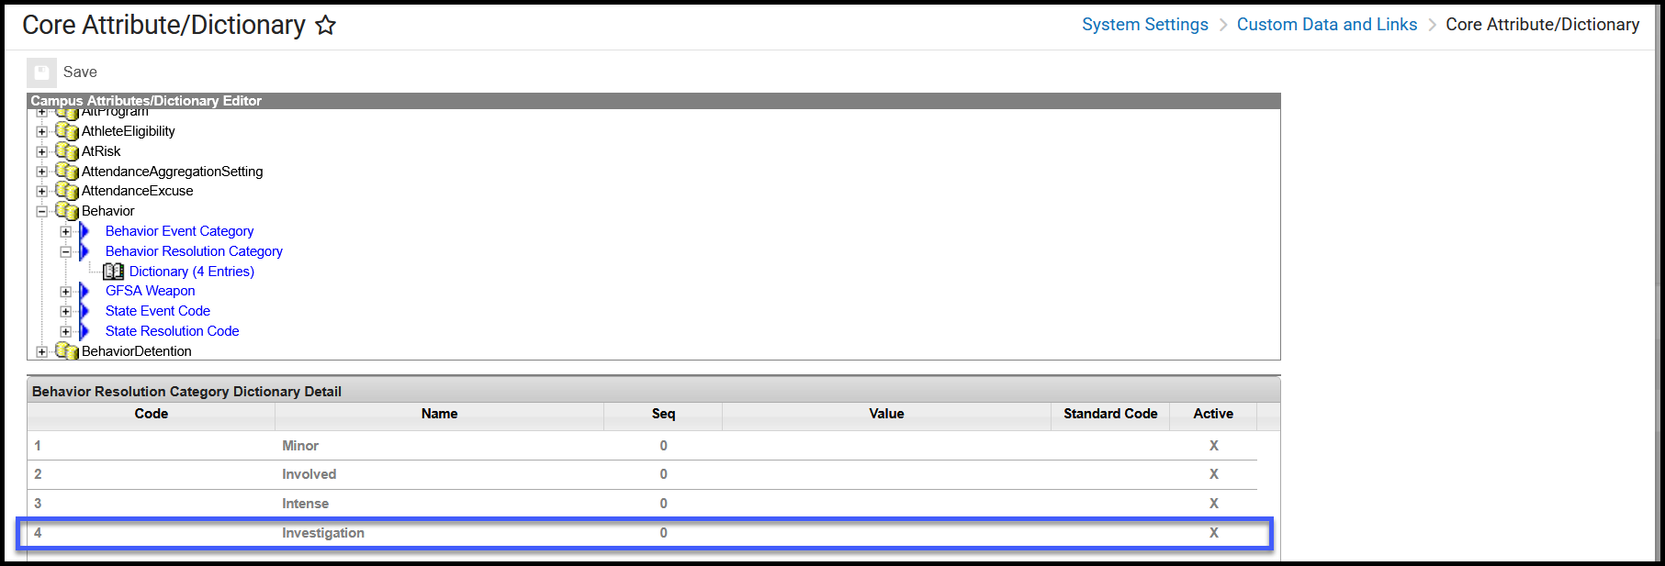
- Create a New Behavior Type for Investigation
  - In the Menu, expand Behavior Office
  - Under Settings, click on ‘Event Type Setup’
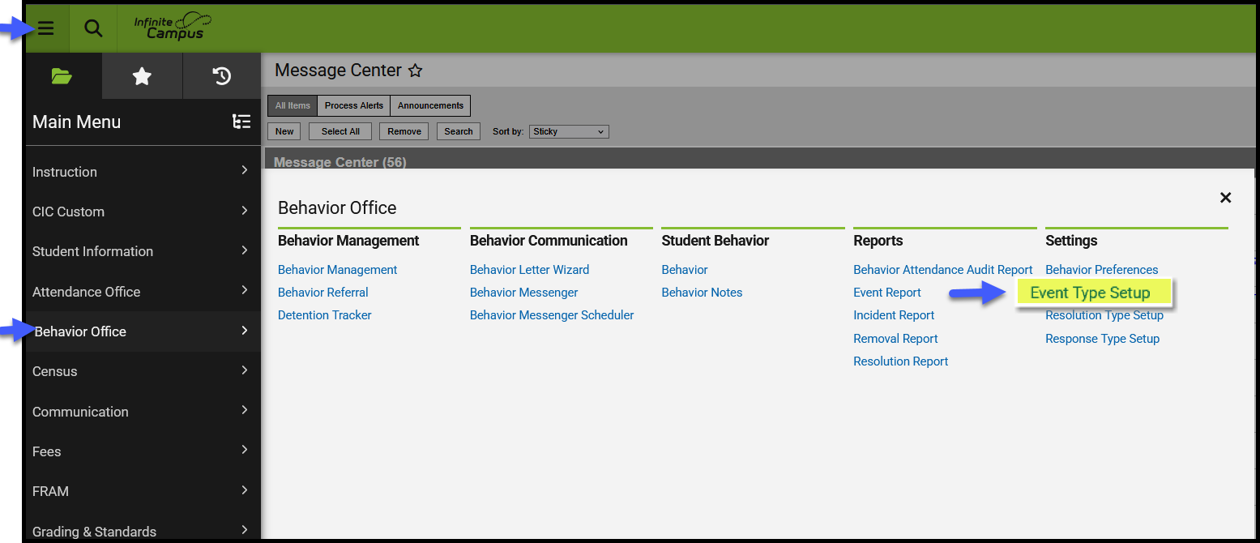
  - Click on New
  - Fill out all required fields using the example below 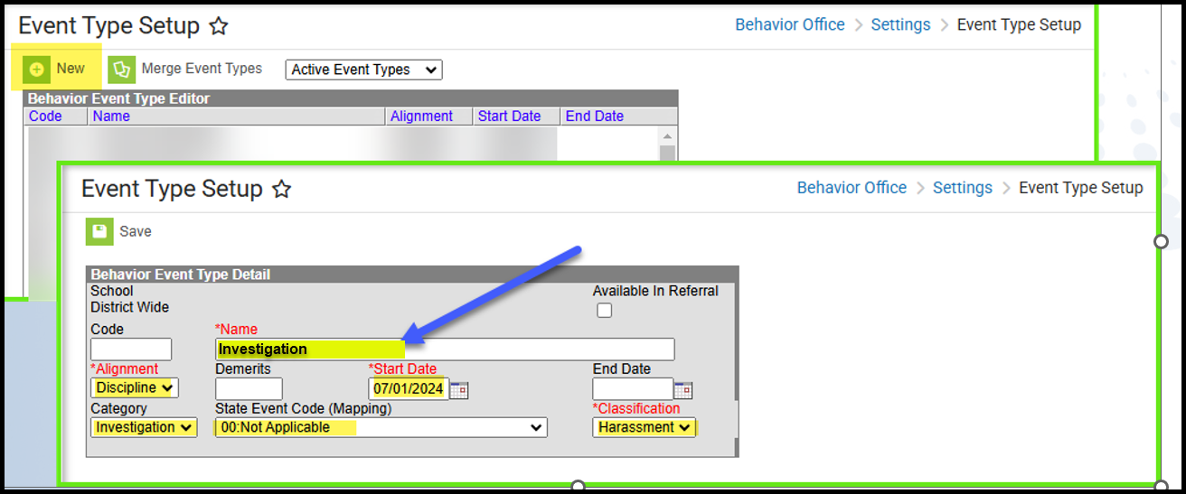
**PHD Colorado report logic says: pull this event IF the state event code mapping is 00 and the event classification is Harassment. You can name the event and resolution anything you want - it will be district defined. The only requirement is DO NOT map to a state code.

- Create a New Resolution Event Type for Investigation Incidents
  - In the Menu, expand Behavior Office
  - Under Settings, click on ‘Resolution Type Setup’
  - Click on New
  - Fill out all required fields using the example below 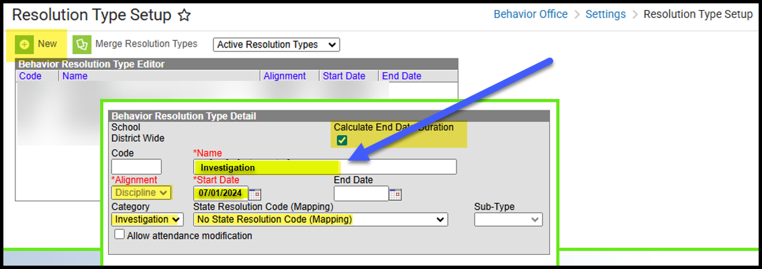

Entering PHD Data in Infinite Campus for an Investigation
- Creating a new Investigation Event
  - In the Menu, expand Behavior Office
  - Under Behavior Management, click on Behavior Management 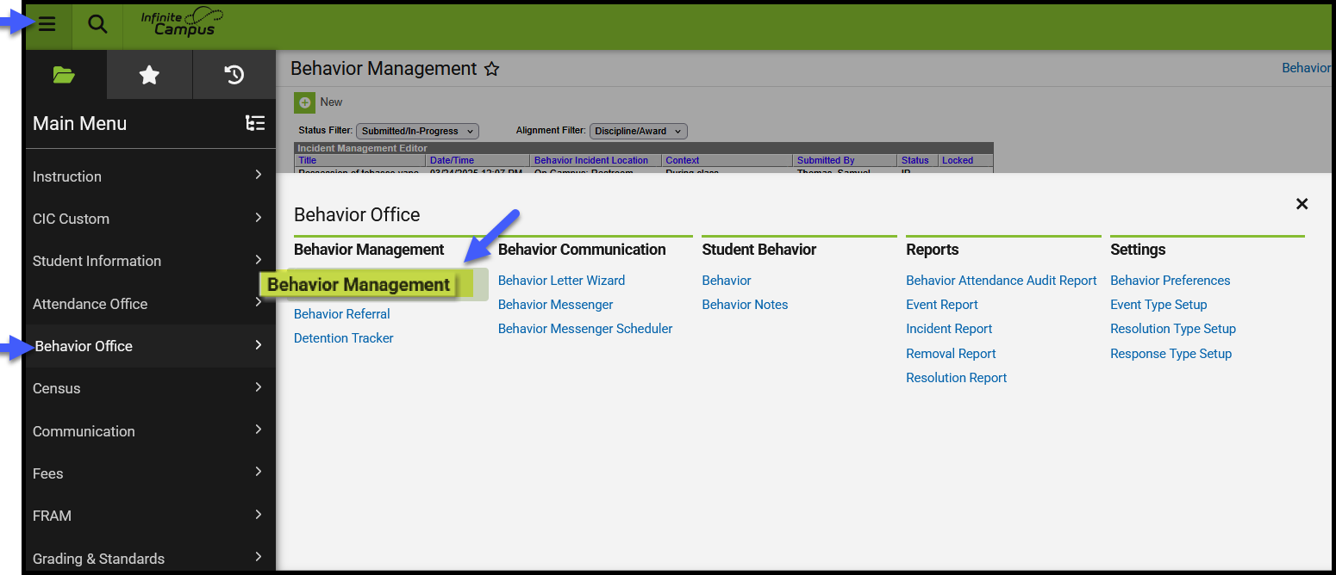
  - Click New
  - Fill in the highlighted fields
  - Click Add Event/Participant 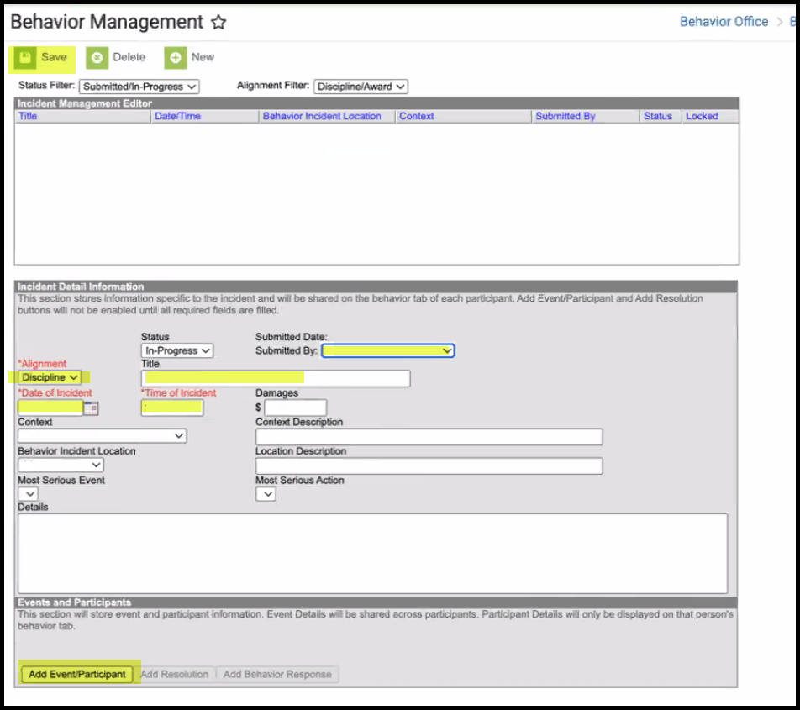
  - Select Event Type ‘Investigation’
  - Add Participant 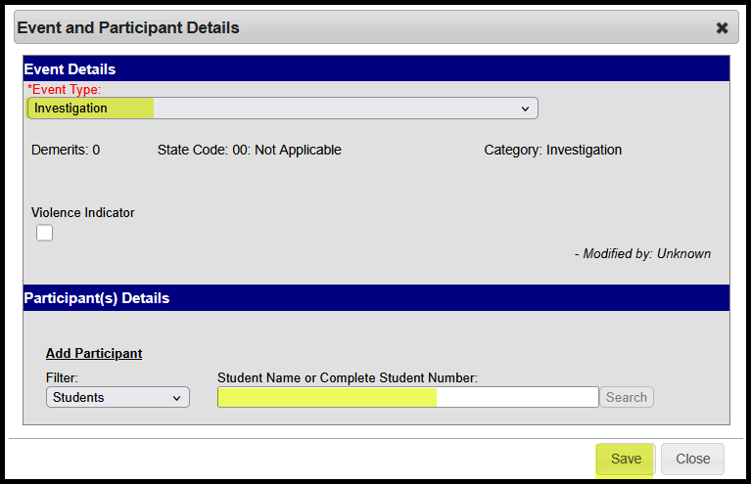
  - Once you hit save, it will open another screen for you to enter additional information about the participant and type of harassment. 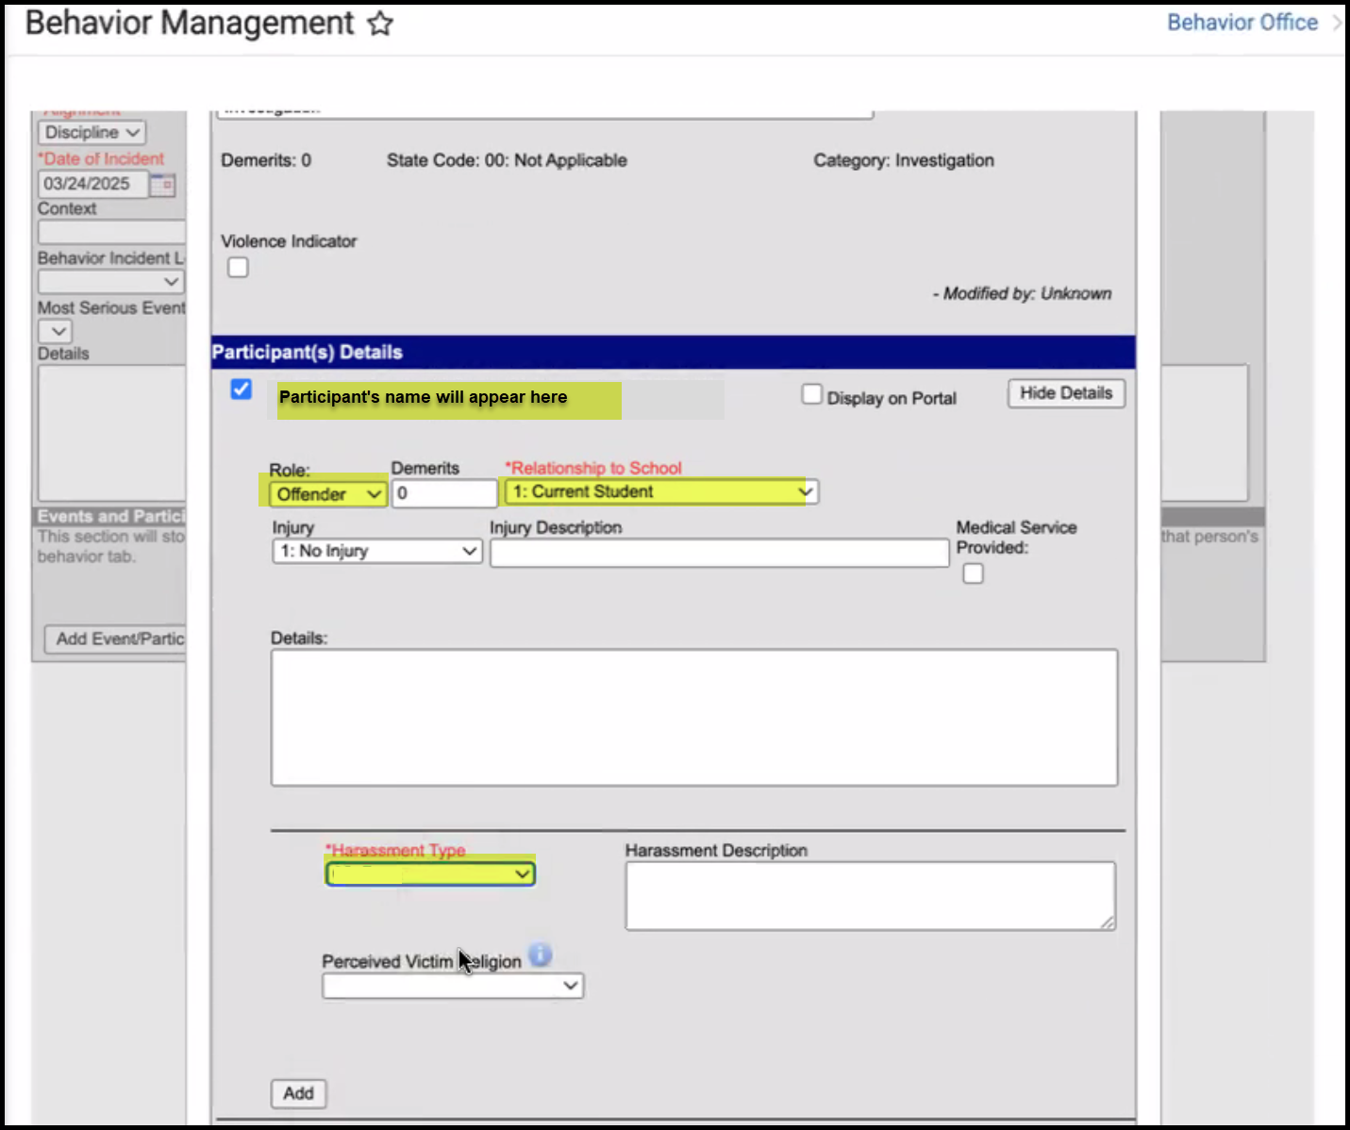
  - If there is no Harassment type, then select 99: No Bias.
  - If there is more than one Harassment type, click the ‘Add’ at the bottom of the Participant(s) Details section. This will expand into another selection where a second Harassment Type dropdown can be filled in. Repeat for as many applicable Harassment Types for the Investigation Event.
  - Save Event

- Adding a Resolution
  - Click on Add Resolution 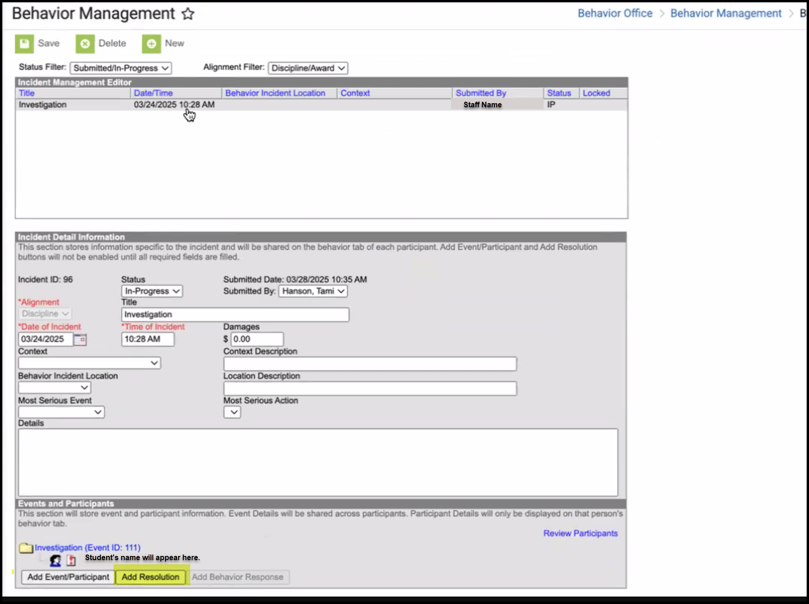
  - Select Resolution Type “Investigation”
  - Fill in start and end dates to calculate investigation duration
  - Attach Resolution to the student
  - Save 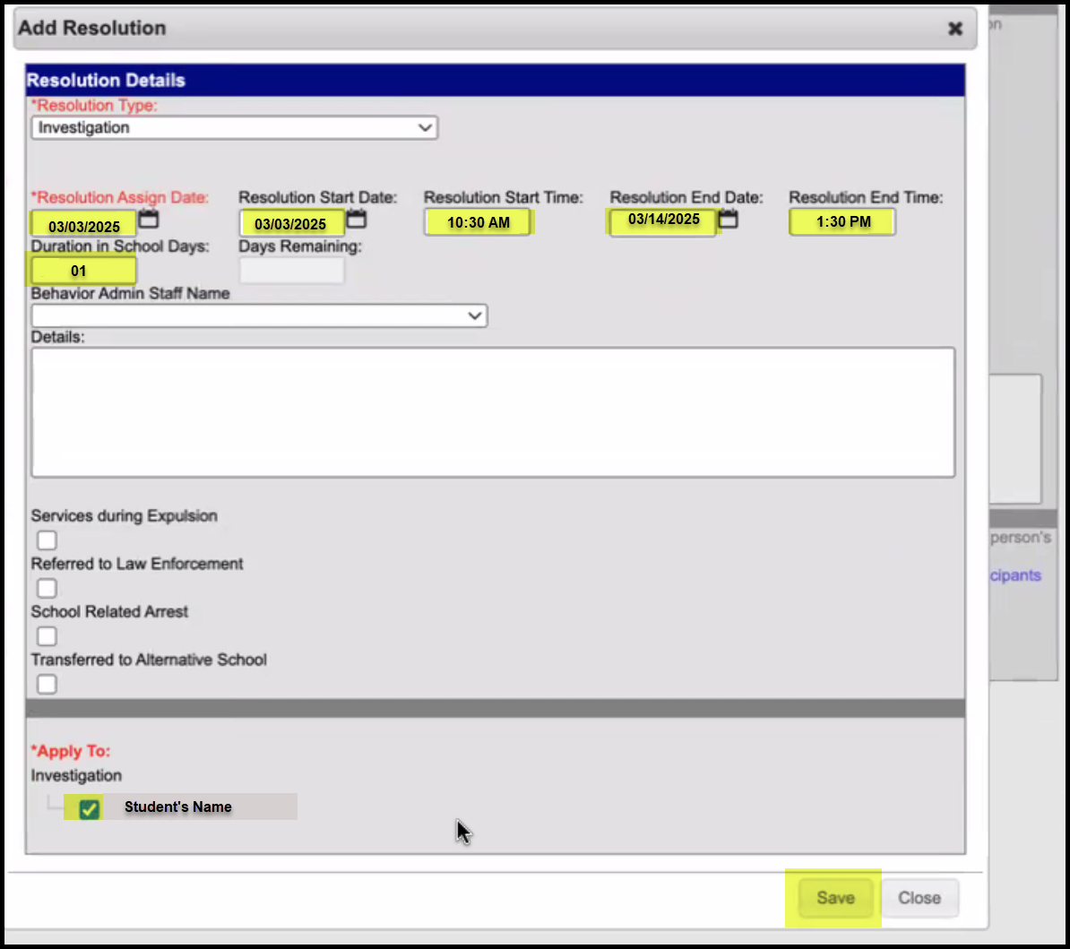

**Note the example below for coding the duration of the investigation. **
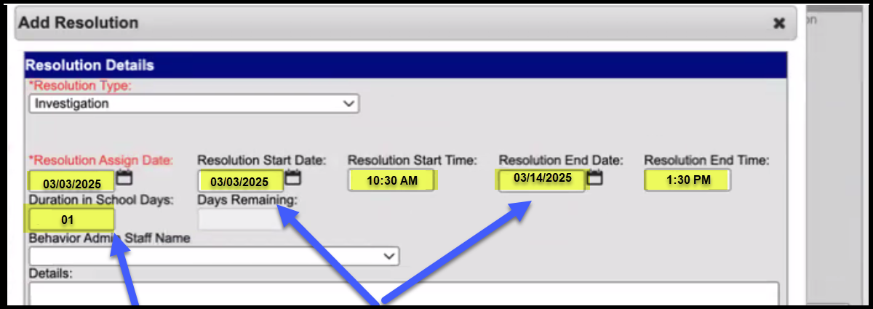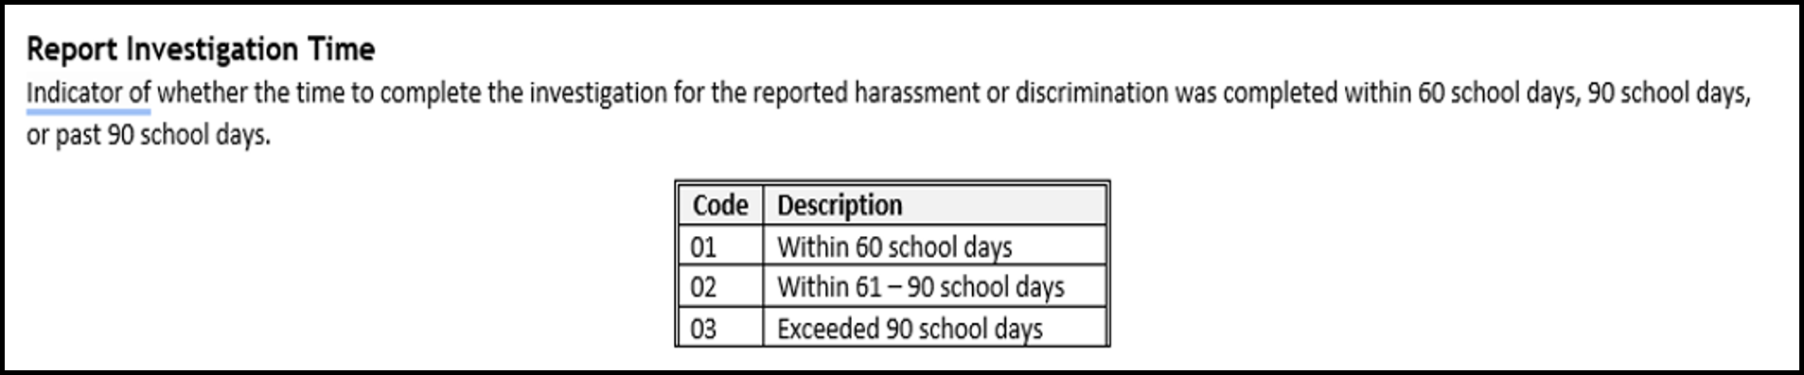

How to Run a PHD Report
- To run a PHD report
  - In the Menu, expand Reporting
  - Under CO Data Pipeline, Click on Prevent Harassment and Discrimination 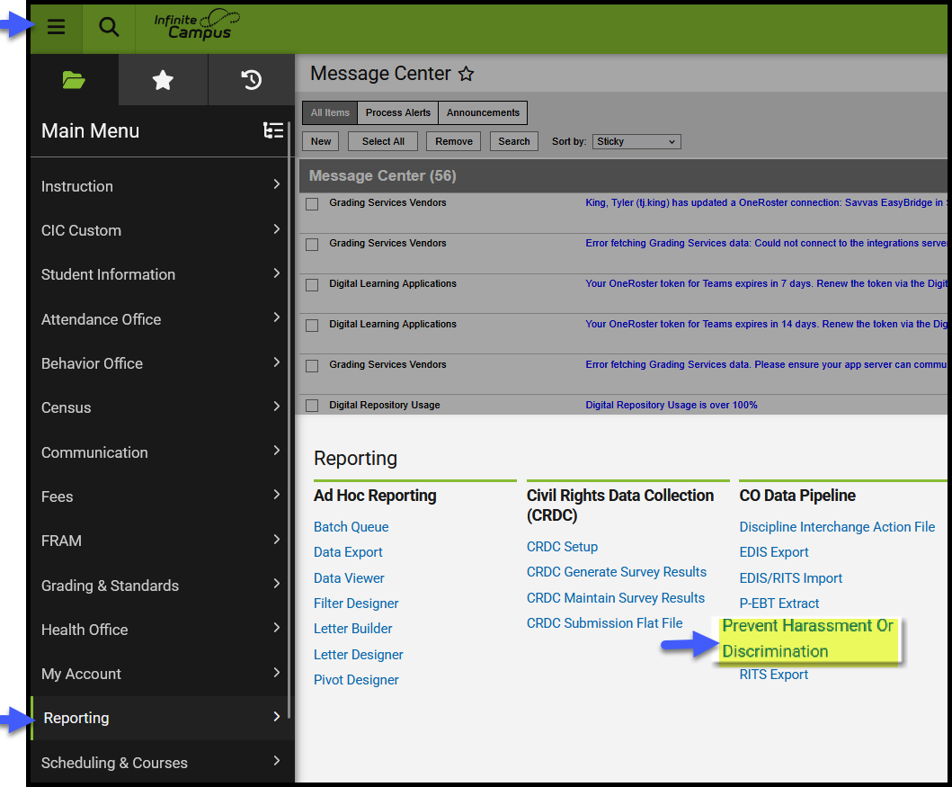

  - Fill in the required fields
