Colorado SKIES Academy Transfer Application

Table of Contents
Page numbers within the Table of Contents will not automatically update. Therefore, please use this Table of Contents as a guide for understanding how this document is organized. You can click on any item below (ex: Applicant Eligibility, Application Components, etc.) to be taken to that section of the document.
Page numbers at the bottom of each page will automatically update. Therefore, once you have responded to all applicable items within this document, please identify below the page number that each section of the application begins on. You do not need to provide page numbers for the introductory, instructional pages (Applicant Eligibility through Application Instructions). Once you’ve added page numbers, please print this document to be included in the printed version of your application materials.

Contents | Page #
Applicant Eligibility
The CSI Transfer Application Process
Application Components
Application Instructions
Transfer Evaluation | 6
Application Checklist | 7
Executive Summary | 9
A. Academic Program | 13
B. Student Services | 25
C. Finance | 35
D. Governance | 38
E. Operations | 43
F. Evidence of Need | 46

Introduction
The Colorado Charter School Institute (CSI) is committed to fostering high-quality charter schools. We understand charter schools and advocate for their success. We offer support, flexibility, and transparent accountability to ensure our schools are in the best position possible to serve their students. This vision is reflected in our approach to requests for charter school expansions.

Transfer Evaluation
The primary method for evaluation of a school wishing to transfer authorization to CSI is through the CSI Annual Review of Schools (CARS) system. This system was developed in order to build upon the evaluation lens utilized by the State and to provide a more comprehensive and robust evaluation that includes strong indicators of charter viability and sustainability. At the foundation of this evaluation are the CSI Performance Frameworks (available at www.csi.state.co.us/accountability). These documents were developed in conjunction with the National Association of Charter School Authorizers (NACSA) to evaluate school performance in the areas of academics, finance, and organization.

At the foundation of this evaluation are the CSI Performance Frameworks (available at www.csi.state.co.us/accountability). These documents were developed in conjunction with The National Association of Charter School Authorizers (NACSA) to evaluate school performance in the areas of Academics, Finance, and Organization.

Transfer Application Process
Transfer applications should focus on providing evidence of the performance of the existing school. The application should be as concise as possible. All requested documentation should be provided as attachments to the narrative. This includes any specific, documented evidence, tables, statistics, and other information which may require elaboration beyond the scope of the narrative. CSI may request additional information during the review period. CSI may, but is not required to, accept any additional information the applicant provides that is not specifically requested.

Transfer Application Timeline
Schools should submit transfer application materials in accordance with the timelines established annually by the CSI Board and Staff, unless waived. The standard transfer application timeline includes application submission in January and CSI board action on the transfer application in March.

Applicant Eligibility
An application may only be submitted by an existing charter school. Private schools and current non-charter public schools may not apply to CSI through this process.

CSI can authorize charter schools in:
- districts that do not retain exclusive chartering authority (ECA), and
- districts that retain ECA but have or are willing to release an Applicant to CSI or waive ECA through a board resolution.

A list of districts with their chartering authority status can be found on the CDE website: www.cde.state.co.us/cdechart/distauthinfo. For applicants planning to locate in a district with exclusive chartering authority, please be sure you have already communicated with the geographic district about the potential to seek authorization with CSI. Please note, the CSI Board will be unable to act on an application unless the Board of Education of the geographic district releases the applicant.

Submission of Application Materials
All application materials—application, required attachments, applicable addenda, geographic district notification, etc.—must be submitted to CSI electronically. The Applicant must address all items within this Transfer Application. Please limit your responses so that the completed version of this Transfer Application document does not exceed 75 pages.

To confirm that you have reviewed your application for completeness before submitting to CSI, the Application Checklist contained within this document should be submitted along with the application.

If the Applicant would like to provide additional attachments to supplement information provided in the application narrative or to provide additional information that is not required as part of the Transfer application, the additional attachments should be clearly referenced within the Transfer Application Narrative by filename and/or document title/page number. The CSI Review Team is not required to review information that is not requested as part of the Transfer application process.

Completeness Check
An application is considered filed when the Institute receives the application. Within 15 days of receiving an application, CSI shall determine whether the application satisfies the requirements listed in the Application Checklist and is therefore complete. If the application is not complete, CSI shall notify the applicant within the 15-day period and provide a list of the information required to complete the application.

The applicant has 15 days after the date it receives the notice to provide the required information to CSI for review. Upon submission of a complete application, the 90-day clock between application receipt and Board vote begins. The Institute is not required to take action on the application if the applicant does not provide the required information within the 15-day period. CSI may request additional information during the review period and provide reasonable time for the applicant to respond.

Applicant Geographic Meeting
Applicants will host a geographic meeting in the community of the proposed transfer school in January or February, to be determined by the Applicant, once the application has been deemed complete. A CSI representative will be in attendance. Applicants will be asked to share information about the proposed transfer and change in authorizer and address questions and concerns from the community.

Applicant Interview
Applicants will have an interview with members of the CSI Review Team in early February. The date and time will be finalized once the application has been deemed complete. The Applicant should bring as many members of the school leadership team, governing board etc. to ensure the team can respond to questions across all sections of the application.

Applicant Presentation to CSI Board
Applicants will present a 15-minute summary of the proposed transfer school to the CSI Board’s Performance Management Committee during a public hearing in February. Following the presentation, there will be an opportunity for members of the Board to ask questions directly of the Applicant.

CSI Board Discussion
CSI staff will publicly share the staff recommendation report with members of the CSI Board at the Performance Management Committee meeting in March. Applicants are invited to attend and will receive a copy of the CSI staff recommendation report in advance of the meeting.

CSI Board Action
The CSI Board, in a public hearing, will rule on the application in March. The CSI Board can vote to approve, conditionally approve, or deny the application.
Summary of the Transfer Application Process Components | Date/Deadline
Letter of Intent Due | November
Application Due | December
Applicant Geographic Meeting | January or February, Date TBD by Applicant
Applicant Interview | Early February, Date TBD by Applicant and CSI
Applicant Presentation to CSI Board Performance Management Committee | February
Applicant Presentation to CSI Board | February
CSI Board Discussion of Recommendation | March
CSI Board Action | March

Please note that the CSI Executive Director may grant or deny a timeline waiver request for transfer applications provided the request is reasonable, that such timeline waiver does not interfere with CSI’s ability to execute its application processes in line with statutory requirements and best practice, and that the applicant demonstrates a legitimate need for the timeline waiver.

Application Components
The following components are required in order for an application to be deemed complete. A more detailed listing of application components can be found in the Application Checklist.

- Transfer Application Narrative
Unless otherwise noted, Applicants must complete all items in this Transfer Application Narrative. Please respond directly below each application question. Do not delete any questions or instructions from this document.

- Required Attachments
As detailed in the Transfer Application Narrative, some sections of the application require the Applicant to submit additional, supporting documentation (ex: the Governance & Operations and Evidence of Need, Support sections). Additionally, an Applicant may be required to submit one or more Addenda based on the proposed school’s model and as determined by responses in the Letter of Intent. A description of two of the required attachments are included below. Please see the Application Checklist or Transfer Application Narrative for a comprehensive list of required attachments.

- Notice to Geographic District
On or before submitting the application to CSI, the Applicant shall provide notice that it is submitting a Transfer application to CSI to the Board of Education and District Accountability Committee (DAC) of the geographic district in which it is proposing to locate. The Applicant shall provide the Institute proof that it has given such notice as part of its application submission. Such proof may consist of a certified mail receipt, a hand written receipt or other written acknowledgement from the recipient that written notification was provided. Failure to provide the district with notice of the application will result in denial of the application by CSI.

Upon determining it has received a complete application, CSI will make the complete application available on the CSI website. CSI will also post on its website the schedule by which the application will be evaluated and voted on, the details of the geographic meeting, instructions regarding how the school may request additional information, and an invitation of the local board to send any concerns regarding any portion of the application. The Board of Education and District Accountability Committee may each comment on the application, amendment or supplement to the Institute, in writing, within 30 days of receiving notice from CSI of the submission.

- Board Resolution from Districts Retaining Exclusive Chartering Authority
For charter schools proposing to locate in districts that have retained exclusive chartering authority (ECA), a resolution from that district’s Board of Education releasing the school to apply to CSI will be required before the CSI Board can formally consider (i.e. vote on) the application. A list of districts with their chartering authority status can be accessed from the Colorado Department of Education’s website: www.cde.state.co.us/cdechart/distauthinfo. Applicants proposing to locate in districts that do not have exclusive chartering authority may submit a proposal directly to CSI without seeking the consent of the geographic district. However, all Applicants should still provide the geographic district notice of its application to CSI. If the Applicant is in the process of attaining the required resolution from the geographic district’s Board of Education, documentation detailing where the Applicant is in the process and the anticipated date of receiving the geographic district’s board resolution should be included.

- Signed School Board Resolution Expressing Intent to Apply to CSI
Applicants must provide a signed local school board resolution expressing intent to apply to transfer authorization to CSI.

Application Checklist
The Application Checklist should be used by the applicant to ensure all sections of the Transfer Application as well as any required supporting documentation have been completed. The CSI Review Team will also use this checklist during the Completeness Check process. Note - Please click on each application component to be taken to the corresponding section/requirement of the Transfer proposal.
Application Components |  | Applicant Check | Reviewer Check
Letter of Intent |  | ☐ | ☐
Transfer Application Narrative  Items to be completed that are found within the Transfer Application Narrative. | Executive Summary | ☐ | ☐
 | - Academic Program | ☐ | ☐
 | - Student Services | ☐ | ☐
 | - Finance | ☐ | ☐
 | - Governance & Operations | ☐ | ☐
 | - Evidence of Need, Support | ☐ | ☐
Required Attachments  Items to be completed that require the applicant to create separate attachments | Notice to Geographic District | ☐ | ☐
 | Geographic District Board Resolution if applicable | ☐ ☐N/A | ☐ ☐N/A
 | Signed School Board Resolution | ☐ | ☐
 | A10(a) All Academic Performance Reports/Dashboards | ☐ | ☐
 | C2(a) Independent Financial Audit | ☐ | ☐
 | C2(b) Quarterly Financial Statements | ☐ | ☐
 | C2(c) Quarterly Balance Sheet | ☐ | ☐
 | C2(d) 5-Year Projected Budget | ☐ | ☐
 | C2(e) Financial Policies and Procedures | ☐ | ☐
 | C2(f) All Financial Performance Reports/Dashboards | ☐ | ☐
 | D7(a) Current Charter Contract | ☐ | ☐
 | D7(b) Any Contracts that Describe Preexisting Conditions | ☐ | ☐
 | D7(c) Annual Performance Reports from Current Authorizer | ☐ | ☐
 | D7(d) External Evaluations | ☐ | ☐
 | D7(e) Board Bylaws | ☐ | ☐
 | D7(f) Employee Handbook | ☐ ☐N/A | ☐ ☐N/A
 | D7(g) Student Handbook | ☐ ☐N/A | ☐ ☐N/A
 | D7(h) Student Discipline Policy | ☐ | ☐
 | D7(i) School Enrollment Policy | ☐ | ☐
 | D7(j) Strategic Plan | ☐ ☐N/A | ☐
 | D7(k) School Leader Evaluation and Succession Plan | ☐ | ☐
 | D7(l) Board Self-evaluation | ☐ | ☐
 | D7(m) All Organizational Performance Reports/Dashboards | ☐ ☐N/A | ☐
 | D7(n) Lease Agreement | ☐ ☐N/A | ☐ ☐N/A
 | D7(o) Original Charter Application | ☐ | ☐
 | D7(p) Notices of noncompliance | ☐ ☐N/A | ☐
 | D7(q) Board Meeting Minutes | ☐ | ☐
 | D7(r) School Accountability Committee Minutes | ☐ | ☐
 | F9 Evidence of Support | ☐ | ☐
 | Addendum I: Online School if applicable | ☐ ☐N/A | ☐ ☐N/A
 | Addendum II: Innovation School if applicable | ☐ ☐N/A | ☐ ☐N/A
 | Addendum III: Education Management Provider if applicable | ☐ ☐N/A | ☐ ☐N/A
 | Addendum IV: Alternative Education Campus if applicable | ☐ ☐N/A | ☐ ☐N/A
Added page numbers to the Table of Contents |  | ☐ | ☐
Electronic copy of entire application |  | ☐ | ☐

Executive Summary

Please provide narrative that summarizes the elements of the application and provides an overview of the school. The Executive Summary should be three to five pages long and include the following:
- Overview and rationale for the proposed transfer
- The school’s name, grade levels served, proposed transfer date (month and year), and growth plan (if the school plans to grow enrollment or add additional grade levels)
- Student body to be served, such as key demographic data, targeted geographical area, etc.
- Evidence that an adequate number of stakeholders support the transfer to CSI.
- A brief description of how the school will adjust its organizational capacity to accommodate the transfer.
- A brief description of key financial implications for the organization as a result of the transfer.
- A brief description of the educational program and the school’s past track record of academic performance.

The Board of Colorado SKIES Academy (CSA) proposes the transfer of our middle grades charter school with an educational focus on aviation and aerospace from the Cherry Creek School District (CCSD) to Colorado Charter School Institute (CSI). CCSD denied CSA’s charter extension application on February 12, 2024, citing financial concerns as the primary reason for denial. CCSD voted to release CSA on March 11, 2024, and CSA’s Board of Directors approved the application submission on March 13, 2024. CSA recognizes the concerns from CCSD and has a comprehensive plan to address them including a detailed recruiting plan with defined and measurable metrics that will allow the school to meet enrollment projections and maintain necessary funding levels for long term viability. In addition, the school’s ability to successfully secure a long-term charter authorization will assist CSA in securing multi-year funding commitments from aerospace industry partners to support unique programs and for CSA’s state-of-the-art building.

CSA leadership recognizes the recruiting process consists of multiple steps that require dedicated focus at each stage. We have added dedicated resources whose sole mission is to develop and execute recruiting events and practices using a measurable process to evaluate the results from these drives and activities. This includes generating awareness and interest in our school, educating families on what makes our school unique, staying in touch with candidate families until the enrollment process is complete, and continuing to engage with them after enrollment to ensure that they feel welcomed and valued and are fully informed on what is to follow.

Colorado Skies Academy, using historical enrollment trends, understands that we need to generate roughly three times as much interest in our program to achieve the targeted enrollment. We have also determined that our Intent to Enroll target needs to be at least 1.5 times the budgeted enrollment to be successful.

Identified recruiting activities include paid advertising and paid search, and more importantly, participating at numerous in-person events such as Girls in Aviation, community farmers markets and neighborhood events, Wings Over the Rockies showcases, and STEM themed activities. In addition, the school recognizes the importance of retaining learners by keeping families connected once enrolled with activities such as Astronomy Nights, Movies in the Hangar, CSA Summer Family Nights, and more.

Colorado Skies Academy will continue to serve grades 6-8 with a proposed transfer date at the end of the 2023-2024 school year (May 2024) with 100% demonstrated support by our parents, staff, learners, and other stakeholders. CSA is the first public charter school dedicated to aerospace career introduction in the Rocky Mountain region and guides students to a path towards achieving their dreams in aviation and space science. Currently, there are no other local public schools that focus directly on aerospace interests and passions of learners in grades 6 through 8. We are located on the grounds of Centennial Airport, the nation’s busiest general aviation airport, on the Wings Over the Rockies Exploration of Flight campus.

CSA serves an ethnically and economically diverse group of young people, primarily within the CCSD and DCSD school districts, who are united by a desire to explore and pursue careers in aerospace, and related industries. Our hands-on project-based learning curriculum allows us to successfully support learners of all abilities. CSA has historically served a greater population of learners with IEPs, ALPs, and 504s and is currently double the CCSD district average in this area as a percentage of our student body.

Colorado Skies Academy uses project-based learning (PBL) with a strong emphasis on social emotional learning (SEL) and treats each learner as a “whole-child” that “not only fosters all areas of children’s development and learning but also lays the foundation for lifelong learning, ensuring that children are excited and engaged learners with positive approaches to learning”. A whole-child approach lends itself to using the vocabulary of “learner” in place of student. Similarly, the role of the teacher, in this setting, better lends itself to the word “facilitator,” reflecting the vision that learners are responsible for their own learning, supported by competent and caring adults in the form of facilitators.

High-quality STEAM (Science, Technology, Engineering, Art, and Mathematics) education, using a rigorous PBL approach, prepares Colorado Skies Academy learners for careers in the aviation and aerospace industries. Facilitators use backwards design techniques to create projects that incorporate culturally responsive strategies for all learners, including support for English Language Learners (ELL) and students with learning differences. Instructional technology, Common Core Standards, and 21st Century skills are integrated through lesson planning and instructional practice. The rigorous pedagogy includes:

- Data-driven course design incorporating real-world applications and relevance
- Research-based learning theories and design models
- Rigorous course content using multiple learning modalities and learner-centric, problem-based projects
- Critical thinking, creativity, collaboration, and communication skills development
- Multi-disciplinary curriculum, standards-based content, and personalized learning options
- Differentiated instruction
- Meaningful learner and facilitator interaction
- Formative and summative assessments and discussion-based assessments
- Demonstration of mastery through competency portfolio projects

While the school’s vision is to provide an educational program that develops critical thinking, academic rigor, and post-secondary and workforce readiness, we also believe in developing social-emotional strengths, skills and mindsets like grit, growth mindset, curiosity, self-control, passion, optimism, gratitude, social intelligence, and zest. With a focus on academic and social-emotional growth, our learners develop into creative, innovative, reflective individuals who are leaders at home, at school and in their community.

Projects include the following key elements:

- Authentic, challenging, real-world driving questions that learners need to answer, embedding appropriate and applicable cross curricular, grade level standards
- Formative and summative assessments to track and support learner progress
- Opportunities for personalized learning and entry points including extensions and modifications, as needed
- Connections to aerospace and aviation experts for exposure to career, skill, and content development
- Social Emotional Learning targets mindfully applied throughout the project
- Metacognitive practices to increase learner agency and life-long learning strategies
- High engagement, high rigor
- Presentation of Learning, where learners present the valid, relevant and challenging project process and/or product(s) for an authentic audience

CSA project-based learning equips learners to solve complex problems using both fundamental skills (reading, writing, math, and science) and workplace skills (teamwork, problem solving, research gathering, time management, information synthesizing, utilization of high-tech tools). Colorado Skies Academy uses personalized instruction to meet individual learner needs. A culture of excellence and achievement is nurtured by calibrating proficiency, developing learner agency, and designing responsive systems of support for all learners. Learners are supported and challenged to become strong thinkers and problem-solvers through rigorous STEAM expeditionary learning in aerospace and aviation education.

Our educational model is resonating with learners and driving positive results as evidenced by CSA’s Performance achievement in the Performance Framework Rating for both achievement and growth.

While Colorado Skies Academy is designed to serve learners first and foremost, the school is also addressing an important need of Colorado employers and the aerospace industry. Colorado ranks second in the nation for aerospace industry employment yet imports more than 50% of this labor force from outside the state. Many of Colorado’s high-paying aerospace jobs are being filled by workers from other states and countries. Colorado jobs being filled by Colorado graduates will fuel economic growth and stability throughout the state. Local employers want to fill Colorado jobs with Colorado graduates to reduce employee turnover and generate greater economic growth and stability but have been unable to find local talent emerging from high schools. Colorado Skies Academy helps fill this gap by offering aerospace and aviation education opportunities that put learners on the path to pursuing college degrees and industry-recognized certifications.

There are two primary organizational capacity changes that will be required after the change in authorizer. The delivery of Special Education services is currently contracted through, and provided by, Cherry Creek School District. The school will be directly responsible for employing or contracting these roles and will use CSI’s Administrative Unit for oversight. These roles include SPED case managers, mental health providers, speech language pathology, occupational therapist, and school nurse.

The School Food Authority for CSA will also change from CCSD to CSI. We will contract with a food service vendor, either a school district or independent vendor, and employ the food service staff directly through CSA.

Transitioning to CSI oversight will result in a slight increase in funding because all Title funds will be available, and there will be less funding held back for administrative costs. The other revenue components in the budget are similar to the funding assumptions with Cherry Creek School District.

While the exact categorical impacts aren’t definitive currently, CSA believes that there is opportunity in many areas due to increased visibility. With CSI oversight, the school may gain access to additional categorical funding or resources targeted to specific student populations, such as special education, English Language Learners, or low-income students. This can provide valuable support for meeting the diverse needs of learners and enhancing educational outcomes.

In addition, the school district does not pass all Federal funding to the Charter School. In this case, all Title 1 funds are withheld and used at the district level. With CSI, all federal funds are passed to the school which will increase the available funding for the school.

CSA plans to allocate any increased funding in alignment with the school’s goals and prioritizing investments in areas such as academic programs, student support services, professional development, and leadership density to maximize the impact on learner achievement and school success.

Colorado Skies Academy has developed a long-term financial sustainability plan that considers potential fluctuations in funding levels and future growth opportunities. Establishing reserves, leveraging grants, and implementing several cost-saving measures mitigate financial risks and ensure the school’s continued success over time. By leveraging the increased funding available under CSI oversight, engaging with industry partners, and implementing a strategic contingency plan, the school can enhance its educational programs, support services, and overall effectiveness in serving learners and the community.

A. Academic Program

- Please provide usernames and passwords to the following:

Data System | Username | Password
Interim Assessment Vendor  MAP | meredith.motley@coloradoskiesacademy.org | meredith1
PowerSchool | mmotley | Mered!th2
Schoology | mmotley | Mered!th2

- Complete the Assessment Matrix below, documenting all school-selected and state-required diagnostic, formative, and summative assessments that will be administered at the school.

Assessment Name | Content Areas (ex: Math, Early Literacy) | Purpose (Provide a rationale for the selection of this assessment, including alignment with curriculum and instruction.) | Type (Diagnostic, Interim, Summative) | Frequency (ex: Annual, 2/year) | Administration Calendar (ex: Jan-Feb)
W-APT | English | Identify language proficiency of students with a home language other than English | Diagnostic | Upon enrollment / | Within 30 days of enrollment /
WJ-IV | English, Math | Identify academic level for students in initial SPED process, or re-evaluation | Diagnostic | SPED - every 3 years or during initial eval | as needed
NWEA | Reading (6+), Math (6+), Language Usage (2-12), Science (6-8) | NWEA assessments are used to measure a student’s growth across a school year. The assessment is aligned to state academic standards for mathematics, reading and science. This assessment is used for class placement, and as a universal screener for MTSS | Interim | Beginning of Year (BOY), Middle of Year (MOY), End of 3rd Qtr | August, November, March
CMAS | Reading, Math, Science | The assessment measures the academic growth and achievement of students. This assessment is required by the state. | Summative | Annual | April

- Please use the CSI Baseline Targets Template below to set annual targets on the various state-required assessments and performance measures.
For accountability purposes, schools are expected to set their own annual targets for academic achievement, academic growth, academic growth gaps and postsecondary and workforce readiness. Targets for all state-required assessments are required to be included in this form. If you have mission-specific measures that you wish to incorporate within these standard indicators (such as measures of postsecondary readiness above and beyond those evaluated by the State). Be sure to include or attach a definition of each additional measure, as well as the methodology used to evaluate, document and determine metrics for each measure.

- For each assessment identified in Assessment Template Matrix above, please include a target in this form.
- Under the Measure column, please identify the measure or interim assessment(s) that is being proposed.
- Under the Metric column, please identify what you will be measuring (% at/above benchmark, scale score, etc.)
- Under the Annual Performance Targets columns, please set a 1-year and 2-year target for each measure. Because the measure and metric have already been defined in other columns, these columns may just have a numeric value (ex: for the Grad Rate target, a 90 in the Year 1 and 95 in the Year 2 targets would mean that the school is targeting 90% and 95% graduation rates in Years 1 and 2, respectively.
- In the Interim Measures during Year 1 column, identify what interim assessment(s) will be used at least quarterly to monitor progress towards reaching the Year 1 target.
- In the Progress Monitoring Strategies column, identify any strategies that will be used to help the school meet the target.

Indicators | Measure | Metric | Student Group | Annual Performance Targets |  | Interim Measures during Year 1 | Progress Monitoring Strategies
 |  |  |  | Year 1 | Year 2Year 2
Academic Achievement | CMAS/PARCC English Language Arts | Mean Scale Score | All Students | 747 | 752 | NWEA | MTSS, PBL
 |  |  | English Learners | 741 | 746 | NWEA | MTSS, PBL
 |  |  | Free/Reduced-Price Lunch Eligible | 749 | 754 | NWEA | MTSS, PBL
 |  |  | Minority Students | 745 | 750 | NWEA | MTSS, PBL
 |  |  | Students with Disabilities | 719 | 724 | NWEA | MTSS, PBL, Progress monitoring IEP goals
 | CMAS/PARCC Mathematics | Mean Scale Score | All Students | 732 | 737 | NWEA | MTSS, PBL
 |  |  | English Learners | 730 | 735 | NWEA | MTSS, PBL
 |  |  | Free/Reduced-Price Lunch Eligible | 728 | 733 | NWEA | MTSS, PBL
 |  |  | Minority Students | 726 | 731 | NWEA | MTSS, PBL
 |  |  | Students with Disabilities | 712 | 717 | NWEA | MTSS, PBL, Progress monitoring IEP goals
 | ACCESS for ELL | % of students at benchmark | none at this time, was provided by CCSD
 | READ Act (if applicable) | % of students with a Significant Reading Deficiency |  | 8 | 5 | ReadTheory, WJIV | MTSS, Progress monitoring reading level
Academic Growth | CMAS/PARCC English Language Arts | Median Student Growth Percentile | All Students | 55 | 60 | NWEA | MTSS, PBL
 |  |  | English Learners | 50  (N<20 IN 2022) | 55 | NWEA | MTSS, PBL
 |  |  | Free/Reduced-Price Lunch Eligible | 50  (N<20 IN 2022) | 55 | NWEA | MTSS, PBL
 |  |  | Minority Students | 49 | 54 | NWEA | MTSS, PBL
 |  |  | Students with Disabilities | 50  (N<20 IN 2022) | 55 | NWEA | MTSS, PBL, Progress monitoring IEP goals
 | CMAS/PARCC Mathematics | Median Student Growth Percentile | All Students | 56 | 61 | NWEA | MTSS, PBL
 |  |  | English Learners | 50  (N<20 IN 2022) | 55 | NWEA | MTSS, PBL
 |  |  | Free/Reduced-Price Lunch Eligible | 50  (N<20 IN 2022) | 55 | NWEA | MTSS, PBL
 |  |  | Minority Students | 50  (N<20 IN 2022) | 55 | NWEA | MTSS, PBL
 |  |  | Students with Disabilities | 50  (N<20 IN 2022) | 55 | NWEA | MTSS, PBL, Progress monitoring IEP goals
 | ACCESS for ELLs | Median Student Growth Percentile | none at this time, was provided by CCSD

- Describe the prior academic performance and the school’s progress towards meeting its goals. This response should address:
- Prior academic performance on the state assessments as well as any interim assessments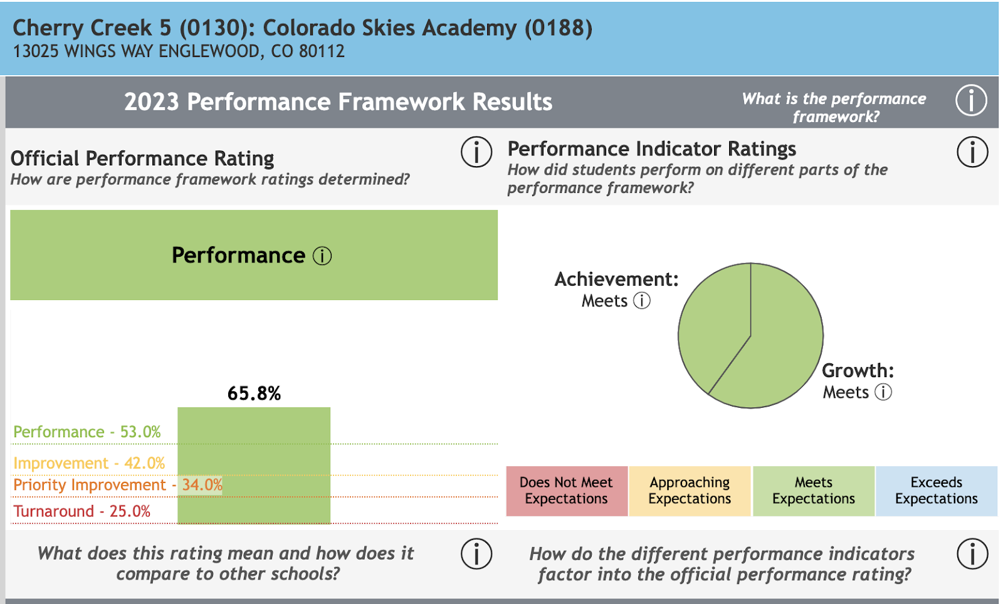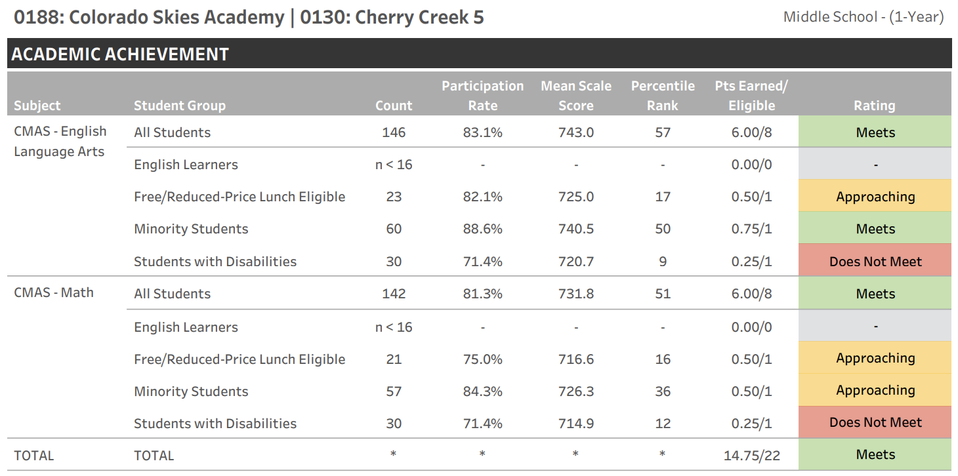
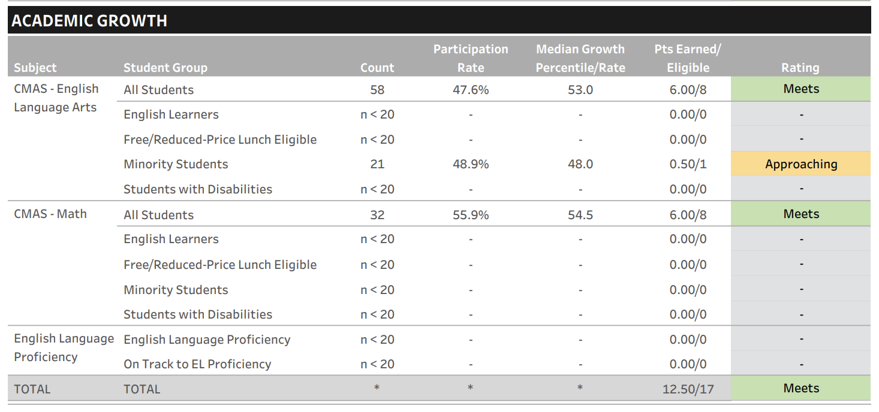

- How the school monitored progress towards meeting its goals, including the frequency of data analysis.

Colorado Skies Academy utilizes the NWEA MAP assessment as its primary measure of student academic success and growth. This is helpful when comparing academic performance and growth amongst other schools across the nation. The NWEA is administered three times a year. CSA creates a mini-action plan after the Fall (BOY) assessment to determine class placement level as well as universally screen students for MTSS. The Winter (MOY) assessment is used to ensure that teachers are making necessary instructional adjustments to meet all students' needs. The school engages in weekly professional learning communities to review data (including student work samples from daily work, weekly progress monitoring, and quarterly presentations of learning).

Student progress and achievement is measured using the percentile bands of the NWEA assessments. Students in the orange or red bands are placed into intervention classes for reading and/or mathematics. Their progress is monitored for 6 weeks using ReadTheory for reading and Zearn for mathematics.
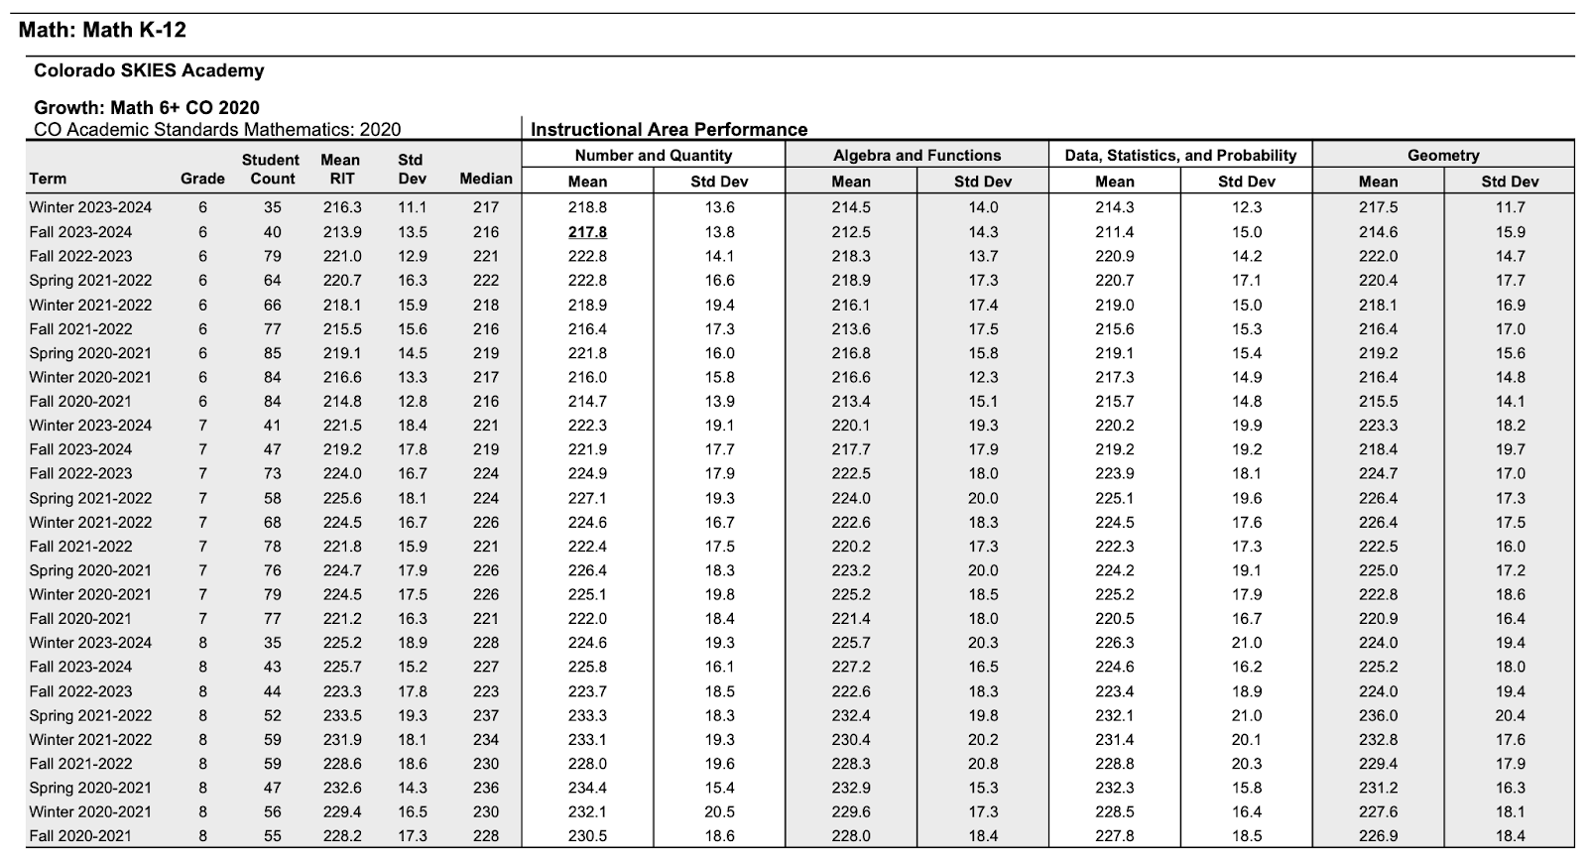

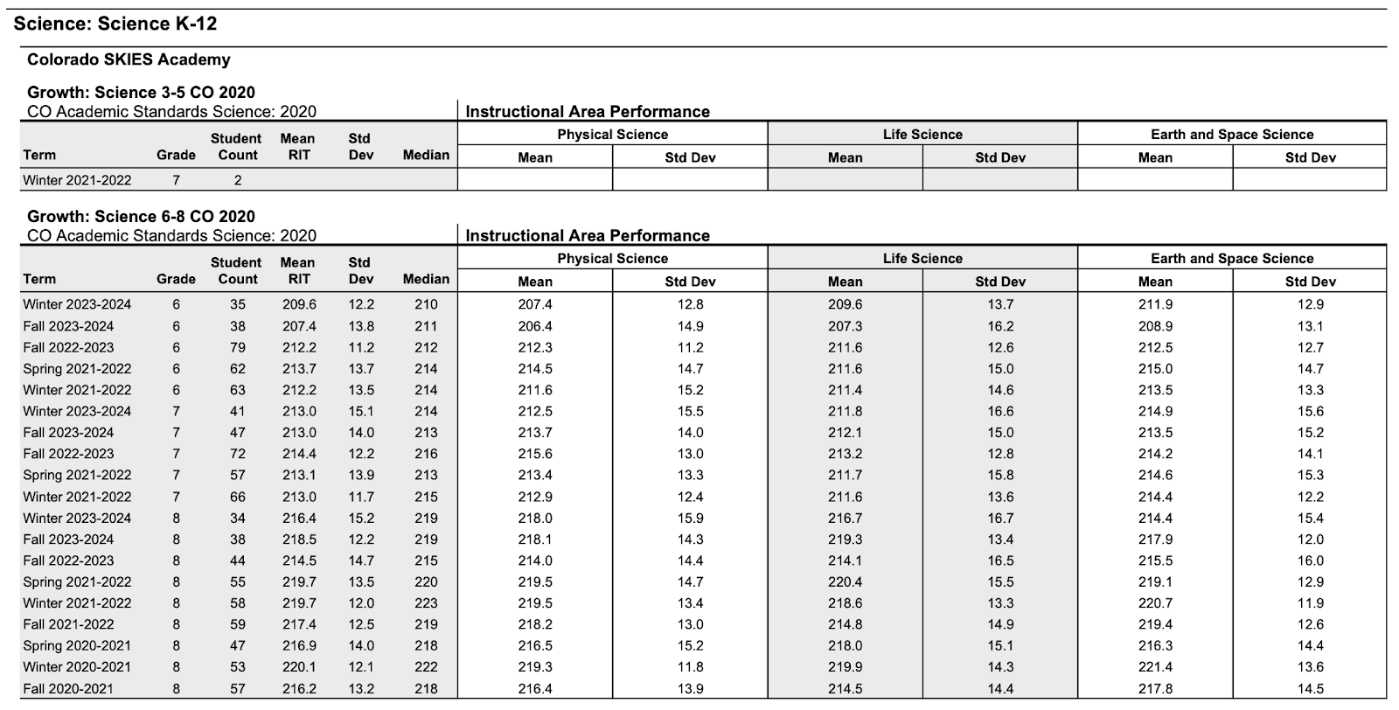
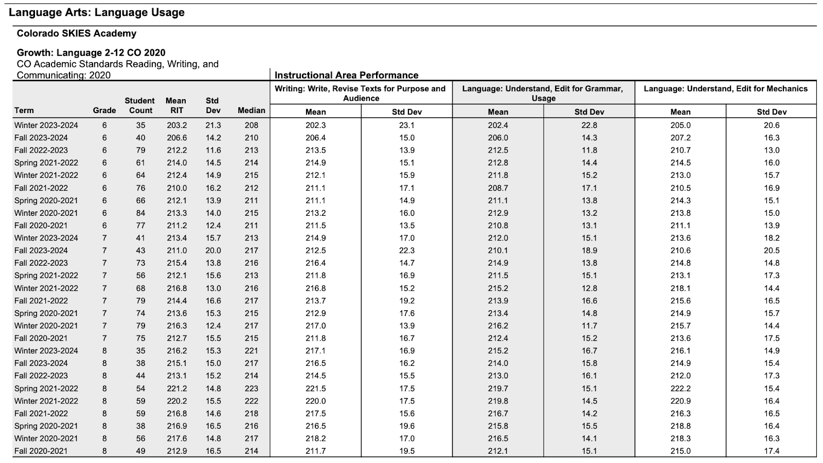
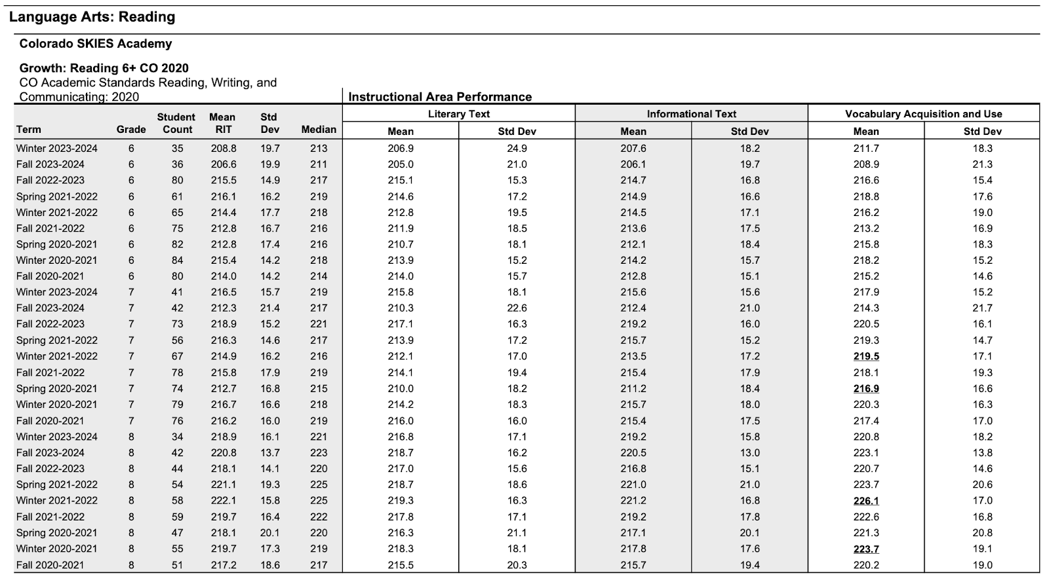

- A reflection upon the underlying factors that have contributed towards the school’s current progress (both positive and negative) towards meeting their goals.
Colorado Skies Academy’s system is based on integrating learning across all subject areas into Project Based Learning. We are preparing students for a world and workplace that requires innovation and creativity. We have added slightly more traditional approaches to literacy and mathematical fluency but will continue to integrate these subjects into projects. We focus on providing high-quality instruction using PBL, high-quality and frequent instructional feedback and unique opportunities with professionals in the field. We have a strategic focus on mathematical fluency, literacy development and growth.
- How authorization with CSI will support the school’s efforts at achieving its goals.

We see authorization with CSI as an opportunity for Colorado Skies Academy to continue to move in a positive direction when it comes to meeting the needs and goals of all students, and to continue to provide a unique educational experience. We believe the support and professional expertise in the areas of Special Education, Section 504, Gifted & Talented, Multilingual Learners and all students (including those with significant disabilities, McKinney-Vento) will be equally beneficial for the students and staff of Colorado Skies Academy.
- Please explain how the curriculum was selected, meets the needs of the student population, and is aligned to standards.

Colorado Skies Academy uses project-based learning (PBL) with a strong emphasis on social emotional learning (SEL). CSA contracts directly with Maker Learning Network (MLN) to serve as an Education Management Provider (EMP). Maker Learning provides professional learning, school model support, curriculum support, leadership coaching, and operational services. The entire staff of Colorado Skies Academy is directly trained and mentored by the MLN team of professional learning staff and coaches, ensuring authentic implementation of PBL and SEL.

Colorado Skies Academy implements the Maker Learning model of education, treating each learner as a whole child. A whole child approach lends itself to using the vocabulary of “learner” in place of student. Similarly, the role of the teacher, in this setting, better lends itself to the word “facilitator,” reflecting the vision that learners are responsible for their own learning, supported by competent and caring adults in the form of facilitators. Student learners are be dismissed early each Friday to provide proper time and attention to the staff’s professional development needs.

High-quality STEAM (Science, Technology, Engineering, Art, and Mathematics) education, using a rigorous PBL approach, prepares Colorado Skies Academy students for careers in the aviation and aerospace industries. Facilitators use backwards design techniques to create projects that incorporate culturally responsive strategies for all learners, including support for English Language Learners (ELL) and students with learning differences. Instructional technology, Common Core Standards, and 21st Century skills are integrated through lesson planning and instructional practice. The rigorous pedagogy includes:

- Data-driven course design incorporating real-world applications and relevance
- Research-based learning theories and design models
- Rigorous course content using multiple learning modalities and learner-centric, problem-based projects
- Critical thinking, creativity, collaboration, and communication skills development
- Multi-disciplinary curriculum, standards-based content, and personalized learning options
- Differentiated instruction
- Meaningful learner and facilitator interaction
- Formative and summative assessments and discussion-based assessments
- Metacognitive practices
- Demonstration of mastery through competency portfolio projects

Colorado Skies Academy uses personalized instruction to meet individual learner needs. A culture of excellence and achievement is nurtured by establishing mechanisms to calibrate proficiency, developing learner agency, and designing responsive systems of support for all learners. Learners are supported and challenged to become strong thinkers and problem-solvers through rigorous STEAM expeditionary learning in aerospace and aviation education.

At Colorado Skies Academy, each child, along with their parent/guardian, meets with their facilitator in the first few weeks of school to develop an Individualized Learning Plan (ILP). Assessment data and personal interests provide the basis for setting the academic and social/emotional goals that will be an integral aspect of the Individualized Learning Plan. The learning environment and instruction are geared toward achieving these goals. The ILP also serves as a means to inform parents of their child’s academic needs, strengths, and social-emotional targets as well as plans to support total growth in all areas.
- Provide a description of the procedures for taking corrective action if school performance falls below the goals and objectives outlined in the application. Include a corrective action timeline, the responsible person, and possible changes to be considered as appropriate.

In the event school performance falls below goals and objectives outlined in the Action Plan, the school’s administration creates a mini-action plan to address the achievement and growth concerns. These plans may include schedule changes, staff changes, curricular changes, the addition of intervention groups, more feedback to staff, and other appropriate changes. The following are the steps that are taken to address the needs with accountability and fidelity:

- School Directors will review NWEA and MTSS benchmark assessments.
2. If performance falls below goals and objectives, the School Directors immediately create a mini-action plan. The creation of these plans can also include teacher leaders.
3. The mini-action plan is shared with the CSA Board so they have access to the plan when conducting school visits and to monitor goal progress.
4. The mini-action plan is shared with the school staff, so they can understand the next steps and be a part of the process.
5. School Directors provide ongoing monitoring of the plan including data collected from daily spot observations, demonstrations of learning, completion of PBL projects, and other formative assessments that occur.
6. Updates on goal progress are provided to the CSA Board.
7. Adjustments are made based on observations and data by school and staff.
- Please describe programmatic and curricular changes anticipated following the change in authorizer.
Following the change in authorizer, we will only be changing the special education programming. These services have been provided by Cherry Creek School District, by changing to CSI, we will bring all of our services in house. The special education teacher will follow the programming outlined by the special education coordinator to meet the needs of all learners. Curriculum used for special education includes Specific Skill Series by McGraw Hill for reading comprehension; Orton-Gillingham for literacy, phonemic awareness and spelling; RightStart Mathematics for math intervention, and in-classroom support for writing instruction.

General education curriculum and programming will not change.

- Complete the table below to outline the data management system(s) that will be utilized.
- In the first column, please identify any other types of data management systems (in addition to a SIS and Plan Management System) that may be used at the school (ex: Learning Management System).
- In the System Name column, identify the name of any data management systems that will be used at the school (ex: Infinite Campus).
- In the Person Responsible for Data Management column, identify the staff position(s) that will be responsible for the system setup, data entry, and data analysis.
 | System Name | Person Responsible for Data Management
Student Information System | Infinite Campus | School directors, Office Manager
Student Plan Management System (if different than SIS) | Schoology | School directors, facilitators

- Please provide a copy of the following documents as attachments:

Attachment Contents |  | Attachment Title
a. | All reports/data dashboards provided to the local board in the last year related to academic performance | 22-23 CSA Unified Improvement Plan FINAL.pdf  CSA UIP 2020_21.pdf  CSA UIP 2021_22.pdf

Click to go back to the Application Checklist

B. Student Services

As applicable, please describe any adjustments to the current programming, resource allocation, and staffing that will occur if the proposed school becomes a CSI charter school.

- Include the comprehensive whole school plan for a Multi-Tiered System of Support or child study process that includes a data driven pre-referral prevention-based framework process that meets legal requirements including identification of special needs students.

MTSS
In alignment with the Colorado Department of Education’s Multi-System of Supports Strategy Guide,
CSA has incorporated MTSS as a prevention-based framework that is focused on a data-driven problem-solving approach to support all learners.

At CSA, using the Beginning, Middle, and End of year Map data taken from the Northwest Evaluation
Association (NWEA), learners who score below grade level are identified as learners in need of
intervention. In addition to academics, behavior is monitored, and students are identified in need of
supports based on the positive behavior system in place.

For identified learners in the areas of academic and/or behavior, formal communication is provided to parents and the MTSS process is initiated. Learners that are identified in need of intervention are monitored for at least three weeks by CSA facilitators and staff. After the initial three weeks, the CSA team reviews progress and determines the next steps. If warranted, further interventions are put in place for at least three additional weeks. After this cycle of intervention, CSA facilitators and staff meet to discuss regression, stagnation, or progress of the learner. Utilizing the data from the MTSS process, the team determines if further interventions and time are appropriate or if a referral to consider Special Education is appropriate.
- Detail plans to support and address student health including the process and procedures for immunizations, record keeping, vision and hearing screenings, health care plans, medication administration, and student illnesses.

At CSA, we promote a comprehensive school health program that integrates a set of planned, sequential, school- affiliated strategies, activities, and services designed to promote optimal physical, emotional, social, and educational development of all learners in accordance with the Health Guidance from CDE. This program is currently being executed by a school nurse that is contracted through the Cherry Creek School District. Upon transfer, CSA plans to either partner with a fellow CSI charter school to oversee the health needs at CSA or contract with the Nurse Consulting Service Provider, Tender Care Consulting (TCC) or a similar provider.

Our current process for supporting and addressing learner health is outlined below. We anticipate to continue the same practices after transfer to CSI with TCC providing oversight and an onsite employee who has delegation authority.

Immunizations: Colorado law requires all students attending Colorado schools to be vaccinated against certain diseases unless they have a Certificate of Medical or Nonmedical Exemption on file at the school. Annually, our school nurse follows a process to establish those learners who may be considered out of compliance and provides correspondence with parents/guardians. Collaboratively they work to secure compliance by way of immunizations or exemptions.

Vision and Hearing Screenings: The sight and hearing of all children in the seventh grade, and of children referred for testing, are provided with Vision and Hearing Screenings in accordance with CDE standards. Our School Nurse provides these tests and makes records of all vision and hearing screening within our school database platform. When a deficiency in these screenings is found, parents/guardians are notified of these results and our school nurse may provide more guidance on further steps.

Health Care Plan: The individualized healthcare plan (IHP) communicates nursing care needs to regular and special education educators, administrators, teachers, health assistants and parents. At CSA, if a learner requires an IHP, this is written by our school nurse in collaboration with the parent/guardian. The IHP is intended for learners with a health condition that requires the performance of a specific treatment, such as non-routine medication treatment, health treatment, emergency action or invasive health procedure. Through the IHP, CSA works to ensure that all necessary information, needs, and plans are considered to maximize the learner’s participation and performance in school. Although the IHP may comprise mainly of learners on an Individual Education Plan (IEP), or 504 plan, not all learners on those plans require an IHP.

At CSA, medical history obtained from health inventories, outside medical documentation, and parent/teacher referrals are utilized to consider if a learner requires an IHP. Upon referral, our school nurse works along with the school team and parents/guardian to assess the need for an IHP. Based on those assessment tools and questionnaires a determination is made. If an IHP is determined to be appropriate a meeting is arranged by the school nurse with the parent/guardian to formally create the IHP. The School Nurse establishes the type, amount and intensity of nursing care required by a particular learner in collaboration with the family, school, and healthcare provider. The IHP may also cover other aspects of care such as a learner’s knowledge about their condition, self-care abilities and any modifications needed to enhance learning and prevent emergencies that may occur within the school setting. The IHP is documented, signed, dated, and recorded within our school data-based platform. In accordance with FERPA regulations, only those with a legitimate need are made aware of the plan. In some cases, training and follow-up conversations with school staff may be required and are led by our School Nurse. In alignment with the Colorado School Nurse Delegatory Clause, there may be aspects of the IHP that are performed by other school personnel and not the School Nurse.

Ongoing evaluation throughout the course of the year is conducted by the School Nurse on the progress and intended outcome of the IHP. Based on the changing needs of the learner, the IHP may be adjusted.

Medication Administration: CSA adheres to the Medication Guidance set forth by CDE. There are a number of reasons why learners might require medications during school and school sponsored activities, including but not limited to: Chronic conditions requiring medication to benefit from classroom instruction; acute, but temporary medical needs that require medicine during the day, such as an antibiotic for an infection; conditions that might require emergency medication, such as a rescue inhaler for asthma.

At CSA, our School Nurse has the responsibility to assure that procedures are in place for the safe administration of all prescription and over-the-counter medications, including administration, documentation, storage, proper disposal, and follow-up/evaluation.

This process includes:

- Reviewing and understanding state laws, regulations, and rules related to medication administration, delegation, and ongoing supervision.
- Reviewing existing local school district policies, procedures, and forms related to medication and suggesting revisions as necessary to comply with federal and state mandates, nursing standards, and current best practices.
- Reviewing pharmacology and dosage of medications to be administered. Ensuring that medication administration is accompanied by proper written parental/guardian permission and prescriber orders in accordance with state and local policy within the past year.
- Establishing and ensuring documentation and quality control systems for storage and administration of medications on-site and off-site at school-sponsored events.
- Ensuring the proper disposal of expired and outdated medications.
- Establishing procedures for training, ongoing supervision, and evaluation of unlicensed assistive personnel (UAP) for any delegation. Working with school staff to clarify language referring to medication administration in all individualized education programs (IEPs and 504 plans). Individualized healthcare plans (IHPs), and/or emergency healthcare plans.
- Training all school staff to recognize signs and symptoms of medication adverse reactions and/or problems such as overdoses, skipped dosage(s), and necessary action steps.
- Reviewing the ability of all learners who are allowed to self-carry.
- Developing a communication plan with parents, healthcare providers and learners to address challenges with self-administration.
- Communicating medication administration policies and procedures on a regular basis to learners, parents, and school staff. Observing and evaluating learner health status and response to medication.
- Assuring that school transportation, field trips and emergency/disaster plans consider medication issues. The school nurse needs to ensure that any order for a prescription medicine is properly authorized as described above.

As it relates to the actual administration of medication either by the School Nurse or Delegated Staff, a process is followed to ensure the appropriate learner, medication, date, dosage, and any specific instructions is in place. Documentation of this process is logged and recorded upon every administration. Accordingly, a similar process of documentation is in place for any medication incidents that may occur and is recorded utilizing an incident report form. This communication is provided to School Administration and parents/guardians.

All medications, except emergency medications, are stored in a locked drawer or cabinet used exclusively for medications. For any medications requiring refrigeration, a locked refrigerator is utilized.

- Detail how the school will accommodate different learning styles and the needs of all students. Provide plans and procedures that describe how the school will ensure all students will progress adequately. This should include information related to student identification, programming, assessment, progress monitoring, redesignation/exiting, service model delivery and the continuum of supports the school will have in place to serve students. Please respond to these items for each subgroup identified below (a-e).

- Students with Individualized Education Programs (IEPs)

Special Education Program Description
Per CSA’s charter contract, all Special Education services are contracted through and provided by Cherry Creek School District currently. After transfer, CSA plans to contract with CSI’s Special Education Administrative Unit.
Currently, learners served at CSA are provided individualized instruction and intervention to support the whole child including academics, behavior, communication, social, emotional, adaptive, sensory, and physical needs in the least restrictive environment. Our purpose is to provide learners with access to general education and grade level standards in accordance with the IDEA guidelines and the Colorado Department of Education (CDE) According to the Individuals with Disabilities Education Act (IDEA), the term “special education” means specially designed instruction, at no cost to parents, to meet the unique needs of a child with a disability. To be eligible for special education and related services, learners must be evaluated and found eligible for one or more of the following disabilities listed in the IDEA: Autism, Deaf-Blindness, Developmental Delay, Emotional Disturbance, Hearing Impairment, Intellectual Disabilities, Multiple Disabilities, Orthopedic Impairment, Other Health Impairment, Specific Learning Disability, Speech or Language Impairment, Traumatic Brain Injury, and Visual Impairment. In accordance with the CDE, the special education process determines whether a child is eligible for special education and related services and if so, which of these are appropriate for the child. The Special Education process in conjunction with the child find obligation consists of: Referral, Evaluation, Eligibility, Development of the Individualized Education Program (IEP), IEP review, and Reevaluation. At CSA, services are guided by learner needs in the Least Restrictive Environment (LRE). All learners receive their Free and Appropriate Public Education (FAPE) in their LRE along a continuum of services. Through various modalities, learners may benefit from push-in (inclusion) within the general education setting or may receive pull-out (resource) services for more targeted intervention and instruction.
The records of incoming learners are thoroughly examined, first for IEP status and second for IEP effectiveness (does the IEP need updating, etc.). All expected protocols are followed, especially those from the Special Education Office of Cherry Creek School District.
CSA has a streamlined Response to Intervention (RtI) process that provides early intervention and disability identification. Facilitators and parents can make a request for an evaluation and can refer learners who have been identified as having barriers to their success. This referral is made to the RtI Team who does an initial data collection to examine attendance and past success, standardized test scores and possible socio-emotional concerns. Initial screening may also be done at this time. General and special education facilitators will meet to discuss possible areas of weakness and interventions that may be effective, and the learner’s family is included in the process to provide additional information and input. The full team reconvenes, involving the facilitator and the parent, to discuss results and to create a learner specific intervention plan. After an established interval, the team reconvenes to determine next steps, including a special education referral if needed.
If a referral for special education services is made, CSA follows the process guidelines and protocols of the CCSD Special Education Assessment Services (SEAS). Learners are also reviewed for ELL status and ELL learners are cross-checked to avoid misidentification.
Learners with IEPs at CSA are monitored, as are all subgroups, by a variety of measures which include state assessments as well as internal measures such as NWEA MAP. IEP goals, which are incorporated in the Individual Learning Plan (ILP), are monitored based on charting, observation, and assessments. Student progress regarding IEP goals is shared with parents on a quarterly basis or as directed in the IEP. Negative results or even “plateauing” causes a response within the building. Special Education at CSA takes a heightened interest in twice exceptional learners. The Special Education staff consults with the Gifted and Talented Coordinator, when appropriate.
The school monitors and evaluates the effectiveness of the school’s special education program by a variety of measures. Data is collected and analyzed on a school-wide, class-wide, and subgroup-wide basis. Possible trends are examined, and those trends are induced in the continuous improvement process for Colorado Skies Academy special education as well as the overall improvement in the ability of the building to serve learner needs. The school’s special education facilitators petition CCSD special education liaisons for support when appropriate. The school leader determines goals at the start of each school year and reviews the success of these goals prior to setting the goals for the next year.
- Students with Section 504 plans

CSA recognizes its legal responsibility to ensure that no qualified person with a disability shall, on the basis of disability, be excluded from participation, be denied the benefits of, or otherwise be subjected to discrimination under any program of Colorado Skies Academy. Colorado Skies Academy also understands that its learners may have exceptional needs that are not governed by the terms of the federal special education law but who may require accommodations or services pursuant to the terms of Section 504 of the Rehabilitation Act and that the school is responsible for planning and implementing any such accommodations or services.
Learners with disabilities are protected by the Office of Civil Rights to assure they receive free and appropriate public education. Section 504 of the Rehabilitation Act of 1973 is a civil rights law that prohibits all federally funded programs and activities, whether they be public or private, from discriminating based on disabilities. In accordance with the Colorado Department of Education’s resource guide on 504, for students to meet eligibility criteria for Section 504 established by the federal statute, students must possess a physical or mental impairment that “substantially” limits one or more life activities. There must be a record of the impairment, and the impairment should not be considered temporary. At CSA, eligibility and service decisions are made by the CSA 504 Coordinator who is knowledgeable about the child, about the meaning of the evaluation data, program/placement options, least restrictive environment requirements, and comparable facilities. Once found eligible for a 504, learners served at CSA are provided accommodations through a 504 plan. Upon completion by the CSA 504 Coordinator, compliance with the 504 plan is not optional and is overseen by the Office of Civil Rights (OCR).
- Students classified as English Learners

In accordance with the Colorado Department of Education’s ELD Program Requirements, CSA requires that every learner’s parent or guardian completes a Student Language Data Form/Parent Home Language Questionnaire as part of the enrollment process. This form identifies learners whose Primary or Home Language is Other Than English (PHOLTE). If a learner’s first language is not English or if the language regularly used by the student’s parent or guardian is not English, then the CCSD appointed personnel gives that learner the WIDA-ACCESS Placement Test (W-APT) to determine appropriate placement. The W-APT is administered within 30 days of the learner starting school or two weeks after October 1. The learner’s score on the W-APT determines the initial level of English Language Development (ELD) support they will receive. When a learner qualifies for ELD services, CSA sends a letter home to the family (in both English and the native language) notifying them that the learner will be receiving ELD services. The learner’s score on the W-APT determines the level of services and the specific strategies in the ELD Plan. The learner’s ELD Plan is led and developed by the CCSD employee in partnership with CSA leadership and shared with the learner’s family within 30 days of the start of the school year.
- Students identified as gifted and talented

Colorado Skies Academy believes in heterogeneous, diverse classrooms in which facilitators differentiate learning. High achieving learners are identified by scoring in the advanced range on internally developed standardized assessments, exceeding standards on the PARCC and Smarter Balanced Assessments, reading at least one or more years above grade level and achieving mastery in all core courses with a score of 4 or an A. These learners are provided with targeted instruction and enrichment opportunities intended to meet their specific learning needs. Project Based Learning, which is a cornerstone of Colorado Skies Academy’s educational program, lends itself to differentiation and deeper learning with accelerated pacing.

To ensure high performing learners are provided enrichment, facilitators consistently analyze learner data and performance to inform their instructional focus and promote appropriate opportunities for individualization for all learners. The accelerated pace at which gifted and talented learners acquire information requires flexible pacing strategies such as: skill grouping during direct instruction sessions, curricular compacting, contracting, and credit by examination. Other examples include:

- Using different text levels in independent reading and guided reading instruction
- Allowing learners to follow passions and interests within the project’s driving question (Voice/choice)
- Assigning optional challenge problem
- Vertical enrichment projects aligned to academic learning
- Activities to hone thinking, reasoning, communication, and self-regulation skills
- Utilizing technology to personalize learning, allowing learners to work ahead
- Providing alternative and/or extension activities for learners who have already mastered the content being taught
- Allowing gifted and high achieving learners to work at an accelerated pace
- Providing opportunities for learners to work in flexible groups with other intellectual peers
- Creating graduated task rubrics and product criteria negotiated jointly by the learner and facilitator
- Asking open-ended questions, both in the classroom and on homework assignments, that stimulate critical thinking
- Incorporating a variety of the levels of thinking described in Bloom’s taxonomy – including the higher levels of analysis, evaluation, and synthesis – into lesson content and learner work products
- Opportunities for leadership roles and mentoring outside of the classroom

As a result of program differentiation using the strategies just described, the unique learning needs of advanced learners are met within the regular classroom program. The progress and success of this subgroup of learners is overseen by the School Director.

To further the school’s ability to meet the needs of Gifted and Talented Learners, Colorado Skies Academy partners with Cherry Creek School District, the Colorado Association for Gifted and Talented, The Colorado Academy of Educators for the Gifted, Talented, and Creative, and the National Association for Gifted Children.

Colorado Skies Academy attracts many gifted and talented learners due to the emphasis on aviation aerospace STEAM. The learner-parent handbook includes a section detailing the unique characteristics and identifiers of gifted children and their learning. CSA's education team identifies children as gifted when their abilities, talents, and potential for accomplishment are so exceptional or developmentally advanced that they require special provisions to meet their educational needs. Gifted and talented learners are capable of high performance, exceptional production, or exceptional learning behavior by virtue of any or a combination of these areas:

● General or specific intellectual abilities
● Specific academic aptitude
● Creative or productive thinking
● Leadership and human relations ability
● Visual arts, performing arts, spatial or musical abilities
● Psychomotor abilities.

CSA's work reflects, and is in part, guided by the vision of the Colorado Department of Education. Gifted Education is addressed in the Exceptional Children's Education Act[4] in the Colorado Revised Statutes. In 2007, the Colorado Legislature adopted a law with guidelines for providing appropriate education for gifted and talented learners. The Colorado Rules and Regulations for the Administration of the Exceptional Children's Act (I CCR 301-8), obligates schools to identify learners with outstanding potential, especially in traditionally underserved populations. For the first time gifted education became
a mandate, like Special Education, although it receives a very small budget line item[5].

The federal Elementary and Secondary Education Act defines gifted and talented learners as "Students, children, or youth who give evidence of high achievement capability in areas such as intellectual, creative, artistic, or leadership capacity, or in specific academic fields, and who need services and activities not ordinarily provided by the school in order to fully develop those capabilities." (Title IX, Part A, Definition 22). The Jacob Javits Gifted and Talented Learners Education Act was passed in 1988 as part of the Elementary and Secondary Education Act (ESEA), currently reauthorized as the Every Student Succeeds Act[6](ESSA).

However, district-level funding for gifted education programs is not included as part of the Act; the Javits Act instead has three primary components:

- Researching effective methods of GT testing, identification, and programming, which is performed at the National Research Center on the Gifted and Talented
- Awarding of grants to colleges, states, and districts that focus on underrepresented populations of gifted learners
- Grants awarded to states and districts for program implementation. Therefore, funding and decisions for GT programming largely occurs at the state and local level, although of course GT best practices are an educational goal in every classroom, funded or not

CSA aims to employ educators with training and expertise in gifted education. The CSA education team has designed gifted programming options, relying on input from a steering committee of school leaders, the CSA parent association, and other key stakeholders.

Identification is essentially a needs assessment, because gifted children often require instruction at a different level and pace than their age-peers. The identification process may be initiated by learners, parents, facilitators, or other district personnel. Gifted learners' strengths usually lie in specific areas, i.e., not all gifted learners are advanced in every area. It is also possible for gifted learners to be "twice exceptional," meaning they have a learning challenge in addition to being gifted.

CSA strives to provide an appropriate and challenging education to each learner, including gifted and talented learners. It is important to give the mathematically gifted child who can work one, two, or even three grade levels above their typical age level, the appropriate placement, or to give the child with extraordinary ability to write fiction beyond their grade-level guidance and opportunity to reach their potential.

Improving Representation of Under-represented learners in GT Programs
CSA actively seeks to identify gifted and talented learners in their native languages. Where possible, the CSA education team leads the identification efforts using the appropriate tools and assessments. When necessary, consultants are solicited to administer testing or conduct direct assessment of learners outside the level of expertise of the CSA staff. Money is designated in the budget to use these professional services when needed.

Programs for GT Learners
CSA addresses GT programming through the ILP process. Facilitators continue to update the ILP annually with goals, opportunities and learning plans. CSA has developed a resource data bank of projects and websites for parents and learners to use at home. CSA staff has also created a GT curriculum that will be integrated throughout the academic year both in the coursework and projects. Learning objectives and lesson plans coincide with the core curriculum so incoming facilitators can easily identify ways to scaffold material for advanced learners.

Individual Learning Plans for Gifted Students
All CSA learners, including identified GT learners, have an Individualized Learning Plan (ILP) to serve as an academic and career tool and a record towards meeting that learner's individual needs. An ILP is "a written record of gifted and talented programming utilized with each gifted child and considered in educational planning and decision making." (Colorado Revised Statutes 22-20-103) The purpose of the ILP is to plan and communicate the development of gifted learners' high potential through proactive programming. Facilitators are aware of gifted learners' strength and passion areas and allow for various opportunities throughout the curriculum for related growth and learning. The ILP is used as a tool to assist facilitators in instructional planning by documenting annual goals and monitoring one-year commensurate academic growth. The plan tracks a learner's strengths, interests, goals, and achievement, wherever they attend school.

The ILP includes the learner's test results, achievement scores, cumulative academic folder, portfolios, and any other qualifying information (except parent and facilitator referrals), as well as a profile of strengths. These strengths may include verbal reasoning, verbal reading, verbal writing, quantitative, nonverbal, creative talent, physical ability above and beyond age-appropriate levels, and/or high-level leadership skills.

The ILP is maintained by the CSA Advisory facilitators and reviewed with learners and parents at least once a year, usually during parent/facilitator conferences and subsequent follow up meetings if needed. During this review, parents can ask questions and ensure that steps are being taken to help the child reach his or her potential and that the ILP reflects the child’s unique needs. The CSA facilitator leads and assists the learner to initiate and update the ILP as needed, documenting evidence throughout the year describing the accommodations and progress towards goals.

Parents also play an important role in the ILP process. In discussing ILPs, the Colorado Department of Education notes, "Parents have a great deal to add to our knowledge about a child due to their insight into their child's strengths, interests and social-emotional characteristics. Educators have an obligation to seek their perspective. Thus, parents contribute to the collaborative effort of ILP development by offering information about their child and their child's advancement along the learning continuum.”

GT Facilitator Qualifications and Training
CSA employs a classroom facilitator who is also endorsed as a Gifted and Talented Specialist. This person is tasked with creating and implementing training programs for the CSA education team. Gifted and talented experience is also a preferred qualification for all the facilitators who may be employed by CSA. These qualifications include:

- Understanding the processes of identifying and assessing gifted and talented learners
- Facilitating growth and learning in gifted and talented learners
- Applying leadership and communication skills to support gifted and talented education
- Creating and maintaining an effective set of strategies and practices that enhance learning for gifted and talented learners.

The CSA education team continues to identify and implement projects and lessons throughout the school experience that can be expanded and scaffolded to challenge gifted and talented learners as well as be level appropriate for other learners.

Evaluating Efficacy of GT Programming
The School Director works with the Gifted and Talented Specialist to create an evaluation process for GT programs. Evaluation is done once a year, most typically in the spring semester. Data and insight gained from the evaluation is used during summer months to upgrade and improve program options for the following year.

To evaluate the efficacy of GT programming, the education team considers several data points such as:

● Learner, parent, and facilitator surveys
● Core content grades and assessments
● Standardized assessment growth
● Learner portfolio work

Additional data points in the evaluation are collected at the discretion of the education team.

- Students identified as at-risk

Learners who enter Colorado Skies Academy below grade level are engaged and benefit from the CSA curriculum. The curriculum design of CSA is based on taking a learner where they are and preparing them for a successful experience in high school and post-secondary education. CSA supports through the curriculum and services any learners who are at risk of educational failure. The expectation for all learners is that they will be engaged in and benefit from the curriculum. Facilitators are prepared to provide remediation and additional support for learners who are achieving below grade level as indicated by baseline assessment data. In addition to the multi-tiered student supports (MTSS) which will include flexible grouping, tutoring and daily academic support; learners who qualify for special education services will have the support of the special education teacher based on the needs identified in the learner’s IEP. The in-classroom supports, along with the problem-solving analysis used as part of the Multi-Tiered System of Supports, provides numerous opportunities for support and assistance to learners who may be struggling.
- Detail the proposed staffing structure. Include any changes from the current staffing structure and plans to provide adequate numbers of qualified, in-field staff (including related service providers) to meet the needs of exceptional students in alignment with state requirements. Include information about the proposed contract model to employ staff, any secured agreements or MOUs, and describe the onboarding process for any contract staff.

Currently, CSA has a total caseload of 26 learners that receive support and services through an IEP and represents roughly 27% of CSA’s current enrollment. The current staffing structure is provided by Cherry Creek School District and consists of one licensed SPED Case Manager, a Speech Language Pathologist, Occupational Therapist, and a School Psychologist. Given the current need, related service providers are a combination of part-time and full-time employees.

Given the change in CSA’s charter authorizer and anticipated increase in enrollment, CSA plans to contract with CSI’s Special Education Administrative Unit for the 24-25 School Year. The school will staff at least one licensed SPED Case Manager, a Speech Language Pathologist, Occupational Therapist, and a School Social Worker or Psychologist. As enrollment finalizes and learner needs are determined, we will adjust the staffing model to ensure we meet all needs in all situations. As it relates to hiring, we work to employ CSA staff through formal hiring processes and may work with several contract agencies to assist in staffing.
- Detail how the budget will align with required resources to support special populations. The narrative should address the student plan management system to house student plans, curricula and instructional materials, and necessary staffing and training needed to serve special populations. The Applicant is required to submit a budget as part of the application submission as detailed in the CSI Budget Template. The description provided below should clearly align to and reference the submitted CSI Budget Template line items.
CSA currently utilizes Enrich as a student plan management system in alignment with Cherry Creek School District. However, CSA will be converting to Infinite Campus as the sole student plan management system. To support this transition, training on Infinite Campus will occur with staff prior to August 9th of 2024 and will be ongoing as new staff are hired.
- Please provide information regarding any Office of Civil Rights (OCR) or state complaints that have found the school to have violated students’ rights or any open OCR or state complaints, if applicable.

No formal OCR or state complaints for violation of students’ rights have been filed against Colorado Skies Academy.

Click to go back to the Application Checklist

C. Finance

- Provide a summary of how the transfer to a CSI charter school will financially impact the school (changes in per pupil revenue, categorical funding, grants etc.) Please include contingency plan to mitigate the impacts of decreased funding or increased expenditures, if applicable.

Transitioning to CSI oversight will result in a slight increase in funding because all Title funds will be available, and there will be less funding held back for administrative costs.

- Please provide a copy of the most recent version of the following documents as attachments:

Attachment Contents |  | Attachment Title
a. | Three years of independent financial audits | 2021 CSA Financials_final.pdf  2022 CSA Financials.pdf  2022 CSA Financials.pdf
b. | Quarterly financial statements pursuant to C.R.S. 22-45-102 | Colorado Skies Academy December 2023 Financials UMB (1).pdf
c. | Quarterly balance sheet | Colorado Skies Academy December 2023 Financials UMB (1).pdf
d. | 5-Year budget detailed by source/object code | CSA FY25 Working Budget 3.25.24 -CSI 5 Year (3).xlsx
e. | Financial policies and procedures | CSA FPP updated Nov 2020.pdf
f. | All reports/data dashboards provided to the local board in the last year related to financial performance | Colorado Skies Academy BOD Financials 02.2023-01.2024.pdf

- For the proposed budget included with the application, please provide:

  - Detailed assumptions for all donations, private grants, student fees, and foundation revenue

- Capital campaign funding assumed in each year to cover debt that exceeds the average 10% for facilities costs over 5 yrs (CSA 19% vs. 10% avg)
- $200/learner assumption for student fees
- $100K assumed for foundation revenue based on the conservative historical average for grant funding

  - Detailed assumptions for professional, technical, and consulting services expenditures.

- CSA will be switching vendors for our back-office support services in the 24/25 SY that is estimated to reduce support costs by roughly 15% compared to historical averages. CSA is negotiating a contract for financial, payroll, and HR services from G&G Consulting Services, Inc. using a per pupil cost rate. IT support is estimated based on the current tech needs with a percentage increase as enrollment and staff increase. Marketing needs for CSA are greater than a neighborhood school given our unique location on an airport that limits community visibility, and our 3-yr program results in a more constant need for a marketing presence. These factors contribute to the higher-than-average marketing budget for a charter school. There is an assumption for substitute teachers based on our current sick leave policy.

  - Detailed assumptions for liability, property, and other insurance coverage, including coverage and rates.

- CSA has purchased all insurance through Maker Learning Network since its inception in the fall of 2019. We are in the process of securing new quotes from HUB, a Colorado-based service provider, based on the existing policies in place for CSA. We used the preliminary guidance from the insurance broker in the budget.

  - An explanation of how restricted grant funding will be spent.

- Federal grants will be spent in the same manner as previous years in accordance with grant rules.
- There is roughly $2.1M assumed in the 5-yr budget for capital campaign grant funding. The school board and advisory committee are working with industry partners to secure multi-year commitments to offset the higher-than-average facilities costs for the state-of-the-art building that houses CSA.

- Detail financial metrics and targets, including any debt covenants, the board and school leadership will track during the transition to ensure financial solvency as the school changes authorizers.

CSA doesn’t anticipate any concern with financial solvency as the school changes authorizers. However, rigorous and continued monitoring of financial solvency is crucial to ensure sustainability and effective resource management.
Key metrics and targets that CSA monitors:
- Budget Variance: Regularly compare actual expenses and revenues against the budgeted amounts. This helps identify any significant discrepancies early.
- Fund Balance: Monitor the fund balance (reserves) to ensure it remains at a healthy level.
- Revenue Streams: Track CSA revenue, such as state funding, grants, and other income streams.
- Expenditure per Pupil: Calculate the average expenditure per student to ensure spending remains within budgetary constraints.
- Debt Levels: Keep track of CSA’s outstanding debt, including bonds and loans. Monitor debt service ratios to ensure that debt requirements are met.
- Cash Flow: Monitor cash flow to ensure we can meet financial obligations, such as payroll, debt payments, and other operational expenses without facing liquidity issues.
- Enrollment Trends: Track learner enrollment trends over time as changes in enrollment will have a significant impact on funding levels and resource allocation.
- Salary and Benefit Costs: Monitor salary and benefit costs as a percentage of the total budget. Controlling personnel costs is essential for financial stability.
- Economic Indicators: Monitor economic indicators at the local, state, and national levels that may impact finances, such as employment rates, property values, and tax revenues.
- Audit Findings: Review audit reports regularly to address any issues related to financial management and internal controls to ensure compliance with statutes, policies, and procedures.

By monitoring these metrics and targets closely, CSA can proactively identify financial challenges and implement strategies to maintain long-term solvency and financial sustainability.

- Detail how the budget aligns with the proposed execution of the school’s mission and focus including staffing, curriculum, professional development, and technology.
The budget prioritizes investments that directly support CSA’s mission and focus on Project Based Learning education by aligning resources with the recruitment and development of highly skilled educators, the implementation of a dynamic and forward-thinking curriculum, the provision of professional development opportunities, and the integration of technology to enhance teaching and learning experiences.

Click to go back to the Application Checklist

D. Governance
- Complete the Board Membership Matrix
Applicants are required to have a governing board in place and to submit the Board Membership Matrix as part of the Transfer Application. Information regarding terms and positions below should align with the board membership information included in your bylaws. Resumes for board members are required to be submitted as described in Section H8.
- In the Board Member Name row, please identify all board members by name. If there are any vacant seats, please identify them by typing “Vacant” in the cell. This form has room for 11 board members. Please only use as many cells as you need based on the range for the number of board members identified in your bylaws.
- In the Term row, please identify each board member’s term (ex: June 2016-June 2017)
- In the Board Position row, please identify each board member’s current role (Chair, Secretary, Treasurer, etc.)
- In the Competency column, please list the competencies you are seeking for the school board.
- Place an X in the box to identify which competencies each of the board members fill. For any vacant positions, place an X in the box to identify which competencies you are seeking in the vacant position.

 | 1 | 2 | 3 | 4 | 5 | 6 | 7 | 8 | 9 | 10 | 11
Board Member Name  🡪  Competency ↓ | Tommy Bryan | Dana Kirchmar | Mark Van Tine | Ralph Forsythe | Ashley Purviance | Jordan Ashley
Term 🡪 | 02/23-02/26 | 10/22-10/25 | 01/22-01/25 | 04/22-04/25 | 11/23-11/26 | 07/23-07/26
Board Position 🡪 | Chair | Secretary | Treasurer | Director | Director | Director
Finance | X |  | X |  |  | X
Legal | X |  |  |  | X
Bond Financing | X
Human Resources |  | X | X |  |  | X
IT | X |  |  | X |  | X
Aviation/Aerospace Industry |  | X | X | X |  | X
Parent | X |  |  | X | X

- Provide a description of the governance structure. Delineate the roles and responsibilities of the school board, school administration, and various non-board committees including but not limited to the School Accountability Committee and any advisory groups.

CSA currently has a 6-member Board of Directors which oversees the overall management of the school. The Board interacts primarily with the School Director and has delegated all management and personnel responsibilities for operating the school to the School Director. The day-to-day operations of the school have been delegated to the School Director, while the Board provides strategic oversight and governance to support the school. The Board has also created committees to help with various aspects of running the school. These committees include the School Accountability Committee, Capital Campaign Committee, Facilities Committee, Outreach Committee, and an Executive Committee.
- Provide a summary of past and planned board training, capacity building, self-evaluation, and succession planning. Please include a discussion of funding and time allocations for board professional development, as well as evaluation tools.

CSA has generally encouraged Board members to attend training offered by the Colorado League of Charter Schools and the Colorado Department of Education but has not had a formal training calendar or minimum training requirements. While no formal budget has been created for Board development, CSA has generally covered the minimal cost of local and/or online training.

- Submit most recent strategic plan and detail progress toward meeting the goals and/or objectives identified in the strategic plan.

The CSA Board and Staff have never held a formal strategic planning process. As part of CSA’s Charter transfer to CSI, the CSA Board is committed to creating and following a strategic plan to address CSA long-term growth and financial sustainability.

- Describe any organizational changes related to staffing and leadership anticipated following the transfer and the rationale for the changes.

The CSA Board does not anticipate making any changes to school leadership following the transfer to CSI. The Board does have plans to add additional members to the Board of Directors. Additionally, CSA does have plans to add several Staff/Teacher FTEs when enrollment projections are met.

- Complete the CSI Waiver Request Template if you plan to seek a waiver of rule, law, or policy.

- Please provide a copy of the most recent version of the following documents as attachments.

Attachment Contents |  | Notes | Attachment Title
a. | A copy of the current charter contract |  | School Charter Contract Amendment-Extending Contract Term_Signed by CSA Board President  Contract_CCSD CSA Charter Amendment 1 Gifted Talented.pdf  Signed Cherry Creek and CSA Contract.docx
b. | A copy of any contracts or instruments that describe preexisting obligations or relationships | This would include any facilities agreements, contracts with an education service provider, contracts with a back office support provider etc. This does not include contracts for school materials that will not extend beyond the current school year. | iSD_CSA Master Agreement- 2018.07.20.pdf  MLN-CSA_ServiceAgreement_2020-21_Final.pdf  CSA WOTR Use Agreement JB Signed.pdf  snow removal 23.24.pdf  Johnson Control Service Proposal_Signed.pdf
c. | Annual performance reports from the current authorizer for the past five years |  | 2020_21 CCSD Review.pdf  CSA Response to the Final Annual Evaluation 2021-2022updated 6.21.22.docx - Google Docs.pdf  CSA Final Annual Evaluation 22-23.pdf
d. | External evaluations (including CSSI site visit reports) |  | Colorado Skies Academy CCSI Summary Report 2021.pdf  Colorado Skies Academy CCSI Detailed Report 2021.pdf | ☐N/A
e. | Board bylaws | Should specify board size, length of term, board election process, board roles, frequency of meetings, dismissal policies and procedures for board members, and conflict of interest policy | 2024.03.28_Board Bylaws_Approved_CSA.pdf
f. | Employee handbook | Include the relationship between the school and its employees (at-will vs. contract). | 2023_0720_Employee Handbook 2023-2024_Approved_CSA.pdf
g. | Student handbook |  | 2023_0823_CSA_Family Guidebook 23-24_Board_Approved.docx
h. | Student discipline policy | Include suspension and expulsion policies that align with state law and that address the safety of students and staff, provide a level of due process for students, and explain how the school will provide expelled students with alternative education, if applicable. | 2023_0823_CSA_Family Guidebook 23-24_Board_Approved.docx
i. | Enrollment policy | The policy should be consistent with state law [22-30.5-507(3)] and applicable state board rules, and include a process for enrollment of students with special needs consistent with state and federal laws and state board rules. | 2023_0823_CSA_Family Guidebook 23-24_Board_Approved.docx
j. | Strategic plan |  |  | ☐N/A
k. | School Leader Evaluation Process | Include the process the school will use for school leader evaluation that aligns with the intent of SB 10-191 (including timeline, standards). | CSA_School_Leader_Evaluation.pdf
l. | Most recent board self-evaluation |  | 2021-2022 Board Assessment.docx
m. | All reports/data dashboards provided to the local board related to organizational performance |  |  | ☐N/A
n. | Lease agreement |  | Sublease Agreement (2).pdf | ☐N/A
o. | A copy of the original charter application |  | Signed Cherry Creek and CSA Contract.docx
p. | Any formal notices of noncompliance or notices of breach of contract received by the school | Schools are only required to include notices received in current school year and the two prior school years. |  | ☐N/A
q. | Board meeting minutes from the prior school year and the year-to-date (the preceding 18 months) |  | D7(q) Board Meeting Minutes Google Drive Folder
r. | School Accountability Committee meeting minutes for the prior school year and the year-to-date (the preceding 18 months) |  | CSA SAC Minutes.pdf  3.3 SAC Survey Dec21-Jan22.pdf

Click to go back to the Application Checklist

E. Operations

- Describe any significant operational adjustments that will be required to implement the program after the change in authorizer.

There are two operational changes that will be required after the change in authorizer. The delivery of Special Education services is currently contracted through and provided by Cherry Creek School District. The school will need to employ these roles directly and use the new authorizer’s Administrative Unit for oversight. The SFA for CSA will also change from CCSD to the new authorizer. We will contract a food service vendor and employ the food service staff directly through CSA.

Facilities
- Provide a description of the current facility and any anticipated changes to the facility (including any potential or proposed changes to location of the school) that may occur as a result of the transfer of authorization.

CSA is located on the grounds of Wings Over the Rockies – Exploration of Flight at Centennial Airport. At CSA we’re committed to fostering an innovative learning environment where students can thrive and realize their full potential.

Our flexible learning spaces are more akin to a modern, 21st-century workspace than to traditional, teacher-centered classrooms. We are committed to creating engaging, safe, and fun environments that facilitate our project-based learning model. Our design philosophy allows kids to learn in an interactive space that fosters curiosity, problem-solving, creativity, synergy, and critical-thinking skills.

There are no changes to facilities that would be impacted because of changing authorizers.

Safety
- Please submit your current Emergency Response Plan. If there are proposed changes to the school facility, please explain your process to create and maintain the required Emergency Response Plan.

The emergency response plan is in place without the need to make any changes. CSA Emergency Operations Plan.pdf – under attachments.

Transportation
- Please summarize the extent to which transportation is currently provided at the school.

No transportation is provided currently.

- Please identify the option below that best describes the school’s intended transportation should the school transfer to CSI. Then respond to all items within the option that you have selected.

Option 1: A school may choose to not provide any transportation services.
- Provide a rationale for why the Applicant is not proposing to provide transportation services.

Colorado Skies Academy has never provided transportation in the five years we have been operating. We open at 7:00 am and close at 5:00 pm, which allows families sixty minutes before school and ninety minutes after school to drop off/ pick up learners.

CSA is interested in providing transportation for learners at a future date if funding can be secured.

Option 2: A school may provide regular transportation services to and from school.
- Include a description of how the charter school plans to meet the transportation needs of students, including at-risk students.

- Provide a description of the daily route that aligns with the transportation plan to meet student needs.

- Provide cost details within the school’s budget and summarize details here.

- Include a plan to address insurance and liability issues pertaining to transportation services using private or school vehicles.

- Include a description of adequate safety measures that will be implemented for the transportation of students.

Option 3: A school may provide transportation services for extracurricular activities and events.

- Include a description of how the charter school plans to meet the transportation needs of all students, including at-risk students.

- Provide cost details within the school’s budget and summarize details here.

- Include a plan to address insurance and liability issues pertaining to transportation services using private or school vehicles.

- Include a description of adequate safety measures that will be implemented for the transportation of students.

Food Services

- Please summarize the extent to which food services are currently offered at the school.

Food service is provided for breakfast, lunch and snack daily for all learners and is contracted through Cherry Creek School District Food & Nutrition Services.

- Please check which of the following options the school intends to follow should the school transfer to CSI with regards to food services. Respond to all items within the option that you have selected.

Option 1: A school may choose not to participate in any federal Child Nutrition Program through a School Food Authority (SFA). Under this option, the school may elect not to operate a lunch program.
  - Provide a rationale for why the Applicant is not proposing to provide food services.

Option 2: A school may choose not to participate in any federal Child Nutrition Program through a School Food Authority (SFA). Under this option, the school may choose to operate their own meal service(s) that are unsubsidized by federal funds.

  - Provide a rationale for why the Applicant is proposing to operate its own meal service(s) unsubsidized by federal funds.

  - Include details about how the food service will be provided.

  - Address how the school will provide services to students who forget or cannot provide a lunch.

Option 3: A school may choose to participate in federal Child Nutrition Programs and receive federal reimbursement funds. Within this option, a school may elect to contract with a School Food Authority.

- Provide rationale for why the Applicant is selecting this food service option.

CSA would operate under an SFA to ensure we are meeting all the guidelines set forward by the USDA to include approved foods, portion sizes, and FRL application processes.

- Include details about how the food service will be provided.

The service to learners will be provided through a daily delivery of prepared breakfast, hot lunch, and snack provided by the food service vendor. A CSA employee who completes all training through the SFA will serve all food items to learners and input the data for learners served into the information system provided though the SFA. Daily logs will also be completed by this employee for snack reimbursement.

- Provide evidence of a plan for reimbursement through an authorized School Food Authority.

CSA plans to operate a reimbursement system through CSI SFA. The options for a food service include remaining with CCSD or identifying an independent vendor. We will need to be part of the CSI RFP process to solidify a contract with a food service provider.

- Address how the school will provide services to students who forget or cannot provide a lunch.

All learners may go through the lunch line and are provided with a lunch regardless of FRL status. No learner is turned away without a meal.

Option 4: A school may choose to participate in federal Child Nutrition Programs and receive federal reimbursement funds. Within this option, a school may obtain state designation as a School Food Authority.

- Provide rationale for why the Applicant is selecting this food service option.

- Include details about how the food service will be provided.

- Provide evidence of a plan for reimbursement through an authorized School Food Authority.

- Address how the school will provide services to students who forget or cannot provide a lunch.

F. Evidence of Need, Support
- Please identify the projected number of students that will be enrolled at each grade level for each of the first five years of operation following the transfer.

 | Year 1 | Year 2 | Year 3 | Year 4 | Year 5
PreK
K
1
2
3
4
5
6 | 100 | 100 | 100 | 100 | 100
7 | 50 | 85 | 85 | 100 | 100
8 | 50 | 50 | 65 | 75 | 75
9
10
11
12
Total | 200 | 235 | 250 | 275 | 275

If applicable, please describe whether any of the above Year 1 enrollment numbers vary significantly from your existing student population or if additional grades will be served.

This is about 100 learners higher than current enrollment as we anticipate an increase in 6th grade classes from 2 to 4 and a retention rate of over 90% for current 6th and 7th graders. Based on current new enrollments and planned marketing and communications efforts, we are on track to meet our enrollment projections.

- Please identify what percentage of each student population is currently served by your school.
For schools that anticipate demographics changing from following the transfer, please fill out the Projection row. If you anticipate demographic projections remaining the same, please only fill out one row.

Year | % Minority | % Free/Reduced Lunch Eligible | % Special Education | % English Learner | % Gifted/ Talented
Current Year | 37% | 31% | 27% | 3% | 7%
Projection (if applicable)

If applicable, please explain why any of the above percentages vary significantly from your existing student population.

- Describe the degree to which the school has engaged existing parents and community members regarding the proposed change in authorizer.

CSA has been communicating with parents and community members since mid-February when CCSD denied CSA’s charter extension application. Weekly updates are sent to existing families by the School Director detailing what actions have been taken throughout the week in regards to our authorization efforts for the 24/25 School Year. In addition, a CSA Town Hall was held on Thursday, March 14, 2024 to present the preliminary timeline for the charter authorization and answer any questions. This meeting was recorded and sent to all CSA stakeholders, and there is a web page on the school’s website that details the actions CSA is taking to transfer our charter authorization with the Town Hall recording included.

- Describe expectations and plans for ongoing parent and community involvement from the time of application through transfer.

The formal notification of CSA’s release from Cherry Creek School District was approved at the CCSD board meeting on March 11, 2024. There was a CSA board meeting on Wednesday, March 13, 2024 to discuss the CSI application process and approve CSA’s submission. CSA administration will continue to provide weekly updates to the parent and stakeholder communities as we work through the transfer process.

- Please provide evidence that an adequate number of parents, teachers, or pupils support transfer to the Institute. The following may satisfy this requirement and be submitted as attachments:

Attachment Contents |  | Attachment Title
a. | Results from a survey disseminated to all stakeholder groups, including the number and proportion of respondents from each group | CSI Transfer Support Survey Results for CSA.docx | ☐N/A
b. | Letters of support from identified stakeholder groups |  | ☐N/A
c. | Letters of intent to remain enrolled or enroll in the program following the transfer | CSI Transfer Intent to Return Survey Results for CSA.docx | ☐N/A

- In the table below, please list out all existing community partnerships and networking relationships.

Entity | Nature of Partnership / Description
Wings Over the Rockies | Instructional & industry partnership
City of Centennial | Philanthropic
Ray Foundation | Philanthropic
The Denver Foundation | Philanthropic
Liberty Energy | Industry partnership
Duncan Aviation | Industry partnership
Air Methods | Industry partnership
University of Windsor | Hands-on experiences with our learners in university labs
University of Oxford | International Space School & hands-on experiences with our learners in university labs
CrewConcept Inc. | Instructional & drone materials
US Drone Soccer | Materials & Instruction
India Universities & India-based corporations | International Exchange Program / Multiple Corporations & Universities provide hands-on experiences for our learners
Singapore Universities & Singapore-based corporations | International Exchange Program / Multiple Corporations & Universities provide hands-on experiences for our learners
BMW / Germany | Multiple Corporations provide hands-on experiences for our learners

- Many other industry partnerships are in process to bring expertise and experiences into the classrooms with our learners. We are also exploring other philanthropic partnerships with CDOT Aviation, Lockheed Martin, Raytheon, Boeing, etc.

Click to go back to the Application Checklist

Required Addenda as Applicable

Addendum I: Online School
The online school addendum should be completed if the school is proposing to be an online school as defined on the CDE website.
If the school intends to be a multi-district online school, the Applicant should submit its Plan for Operating an Online School, which begins on page 21 of the CDE Multi-District Online School Application, as an addendum to the application.

☐This school is proposing to be an online school. This addendum is included in the application packet.
☐Not Applicable

Addendum II: Innovation School
The innovation addendum should be completed it the application proposes a school model/program with strong potential to accelerate student success through dramatically different school designs, instructional strategies, uses of technology, staffing models, governance arrangements, family and community engagement strategies, and other approaches.
If the school intends to propose an innovative educational model/program, the following items should be addressed within the body of the Transfer Application Narrative and summarized in an addendum to the application.
- An applicant may propose a model centered on innovation in curriculum, instructional strategies, assessment, governance, family and community engagement strategies, or other areas, or in a combination of two or more areas. Please explain how the proposed model is fundamentally different from typical school models. This should include an explanation of the innovation and the rationale for the chosen innovation, including a detailed, thoughtful and appropriate use/integration of the innovation into the school model/program, and an explanation of how that innovation will improve student outcomes.
- Please describe and explain any available evidentiary basis for the efficacy of the model or for the ideas underlying the model.
- Please include an explanation of how the proposed model will be monitored and evaluated and held to the same high accountability standards to which CSI holds all schools.
- Please include any proposed mission-specific measures that would allow the school to demonstrate the efficacy of the proposed innovations. Use the mission-specific measures template to detail the anticipated design of the measures.
- Please include any specific staffing structures and/or professional development/training that are unique to the proposed innovations.

☐This school is proposing to be an innovation school. This addendum is included in the application packet.
☐Not Applicable

Addendum III: Education Management Provider, Collaborative, Incubator
An Education Management Provider is defined in Colorado law as a nonprofit, not-for-profit, or for-profit entity that contracts with a charter school to provide, manage, or oversee all, or substantially all, of the education services provided by the charter school. An Education Management Provider is different from a Charter School Collaborative or an Incubator. A Charter School Collaborative is defined by law as two or more charter schools contracting with one another to form a legal entity separate from the contracting charter schools and is authorized to provide any function, service, or facility that is lawfully authorized for each of the contracting charter schools. An Incubator is defined as any organization contracted to support the development of the charter school including but not limited to application development, professional development, human resource, and other services in the early years of the school’s operation.

If the school intends to contract with an education management provider, incubator, or collaborative, the following items should be addressed and included as an attachment. “Provider” below should refer to whichever contractors (EMP, incubator, or collaborative) you are proposing to contract with. This addendum should not exceed 15 pages.
- Provide the rationale for selection of the provider.
- Provide evidence that demonstrates the effectiveness of the provider with other schools, including particularly schools in Colorado and schools serving a similar population. This should include performance data around academic, financial, and operational success.
- Provide evidence demonstrating the capacity of the provider for successful expansion while maintaining quality in the school(s) it is currently managing.
- Include an explanation of any existing or potential conflicts of interest between the governing board of the proposed charter school and the provider.
- Provide evidence that the provider is authorized to conduct business in Colorado.
- Include a detailed description of cost sharing, fee structures, and central versus school level functions.
- Provide a clear understanding of financial obligation to the provider. This should include considerations of changes in costs (increases, decreases, etc.) throughout the duration of the charter term. This should also include building ownership if the developers are making payments to the provider.
- Include a copy of the actual or proposed performance contract between the governing board for the proposed charter school and the provider that specifies, at a minimum, the following material terms:
  - Performance evaluation measures
  - Methods of contract oversight and enforcement that the governing board will use
  - Delineation of central (provider) vs. school level functions
  - Conditions for contract renewal and termination
  - Information around which staff will be hired and terminated by the provider, report to the provider, or will be paid by the provider
  - The compensation structure and all fees that the proposed charter school will pay to the provider
- Include copies of the last three years of audited annual financial statements (balance sheets and profit and loss statements), copies of any current or past liens, and copies of and pending or past lawsuits.

☐This school is proposing to contract with a provider. This addendum is included in the application packet.
☐Not Applicable

Addendum IV: AEC
If the Applicant intends to apply for designation as an Alternative Education Campus (AEC), the following information must be included in the narrative of the application and summarized as an addendum to the application.

Colorado law allows each school, with its authorizer’s approval, to request designation as an Alternative Education Campus (AEC). Alternative Education Campuses (AECs) are defined as schools that have a specialized mission and serve either a special-needs and/or at-risk population, where more than 90% of students have either an Individualized Education Program or meet the definition of a high-risk student. The specific eligibility are listed in 1 CCR 301- 57-2207602-R-3.00. To receive this designation, schools must demonstrate that it meets the eligibility criteria annually.

- Identify the particular high-risk student populations your school will be focused on serving. (A list of the high-risk student populations can be found on the Summary tab of the CDE AEC Application.)
- Be sure your application specifically addresses how your outreach will reach the high-risk student populations required for AEC designation.
- Address how the proposed model will include at least two of the three required elements: a high-quality college and career-ready instruction, programs to build college and career-ready skills, and appropriate supports for students in the first year of postsecondary enrollment. Additionally, please describe how the required elements align to the proposed graduation policy.
- Complete AEC Target Setting Form
Performance Indicators | Measures/ Metrics | Annual Performance Targets |  | Interim Measures for  2018-2019 | Progress Monitoring Strategies
 |  | 2018-2019 | 2019-2020
Student Engagement | Attendance Rate
 | Truancy Rate
 | Supplemental Measure(s)
Postsecondary & Workforce Readiness | Completion Rate
 | Dropout Rate
 | Mean CO ACT
 | Supplemental Measure(s)

☐This school is proposing to be an AEC. This addendum is included in the application packet.
☐Not Applicable

