Transfer Application

Table of Contents
Page numbers within the Table of Contents will not automatically update. Therefore, please use this Table of Contents as a guide for understanding how this document is organized. You can click on any item below (ex: Applicant Eligibility, Application Components, etc.) to be taken to that section of the document.
Page numbers at the bottom of each page will automatically update. Therefore, once you have responded to all applicable items within this document, please identify below the page number that each section of the application begins on. You do not need to provide page numbers for the introductory, instructional pages (Applicant Eligibility through Application Instructions). Once you have added page numbers, please print this document to be included in the printed version of your application materials.

Contents | Page #
Applicant Eligibility | 3
The CSI Transfer Application Process | 3
Application Components | 6
Application Instructions | 6
Transfer Evaluation | 3
Application Checklist | 7-8
Executive Summary | 9-11
A. Academic Program | 12-22
B. Student Services | 23-29
C. Finance | 29-31
D. Governance | 32-35
E. Operations | 36-38
F. Evidence of Need | 38-40

Introduction
The Colorado Charter School Institute (CSI) is committed to fostering high-quality charter schools. We understand charter schools and advocate for their success. We offer support, flexibility, and transparent accountability to ensure our schools are in the best position possible to serve their students. This vision is reflected in our approach to requests for charter school expansions.

Transfer Evaluation
The primary method for evaluation of a school wishing to transfer authorization to CSI is through the CSI Annual Review of Schools (CARS) system. This system was developed in order to build upon the evaluation lens utilized by the State and to provide a more comprehensive and robust evaluation that includes strong indicators of charter viability and sustainability. At the foundation of this evaluation are the CSI Performance Frameworks (available at www.csi.state.co.us/accountability). These documents were developed in conjunction with the National Association of Charter School Authorizers (NACSA) to evaluate school performance in the areas of academics, finance, and organization.

At the foundation of this evaluation are the CSI Performance Frameworks (available at www.csi.state.co.us/accountability). These documents were developed in conjunction with The National Association of Charter School Authorizers (NACSA) to evaluate school performance in the areas of Academics, Finance, and Organization.

Transfer Application Process
Transfer applications should focus on providing evidence of the performance of the existing school. The application should be as concise as possible. All requested documentation should be provided as attachments to the narrative. This includes any specific, documented evidence, tables, statistics, and other information which may require elaboration beyond the scope of the narrative. CSI may request additional information during the review period. CSI may, but is not required to, accept any additional information the applicant provides that is not specifically requested.

Transfer Application Timeline
Schools should submit transfer application materials in accordance with the timelines established annually by the CSI Board and Staff, unless waived. The standard transfer application timeline includes application submission in January and CSI board action on the transfer application in March.

Applicant Eligibility
An application may only be submitted by an existing charter school. Private schools and current non-charter public schools may not apply to CSI through this process.

CSI can authorize charter schools in:
- districts that do not retain exclusive chartering authority (ECA), and
- districts that retain ECA but have or are willing to release an Applicant to CSI or waive ECA through a board resolution.

A list of districts with their chartering authority status can be found on the CDE website: www.cde.state.co.us/cdechart/distauthinfo. For applicants planning to locate in a district with exclusive chartering authority, please be sure you have already communicated with the geographic district about the potential to seek authorization with CSI. Please note, the CSI Board will be unable to act on an application unless the Board of Education of the geographic district releases the applicant.

Submission of Application Materials
All application materials—application, required attachments, applicable addenda, geographic district notification, etc.—must be submitted to CSI electronically. The Applicant must address all items within this Transfer Application. Please limit your responses so that the completed version of this Transfer Application document does not exceed 75 pages.

To confirm that you have reviewed your application for completeness before submitting to CSI, the Application Checklist contained within this document should be submitted along with the application.

If the Applicant would like to provide additional attachments to supplement information provided in the application narrative or to provide additional information that is not required as part of the Transfer application, the additional attachments should be clearly referenced within the Transfer Application Narrative by filename and/or document title/page number. The CSI Review Team is not required to review information that is not requested as part of the Transfer application process.

Completeness Check
An application is considered filed when the Institute receives the application. Within 15 days of receiving an application, CSI shall determine whether the application satisfies the requirements listed in the Application Checklist and is therefore complete. If the application is not complete, CSI shall notify the applicant within the 15-day period and provide a list of the information required to complete the application.

The applicant has 15 days after the date it receives the notice to provide the required information to CSI for review. Upon submission of a complete application, the 90-day clock between application receipt and Board vote begins. The Institute is not required to take action on the application if the applicant does not provide the required information within the 15-day period. CSI may request additional information during the review period and provide reasonable time for the applicant to respond.

Applicant Geographic Meeting
Applicants will host a geographic meeting in the community of the proposed transfer school in January or February, to be determined by the Applicant, once the application has been deemed complete. A CSI representative will be in attendance. Applicants will be asked to share information about the proposed transfer and change in authorizer and address questions and concerns from the community.

Applicant Interview
Applicants will have an interview with members of the CSI Review Team in early February. The date and time will be finalized once the application has been deemed complete. The Applicant should bring as many members of the school leadership team, governing board etc. to ensure the team can respond to questions across all sections of the application.

Applicant Presentation to CSI Board
Applicants will present a 15-minute summary of the proposed transfer school to the CSI Board’s Performance Management Committee during a public hearing in February. Following the presentation, there will be an opportunity for members of the Board to ask questions directly of the Applicant.

CSI Board Discussion
CSI staff will publicly share the staff recommendation report with members of the CSI Board at the Performance Management Committee meeting in March. Applicants are invited to attend and will receive a copy of the CSI staff recommendation report in advance of the meeting.

CSI Board Action
The CSI Board, in a public hearing, will rule on the application in March. The CSI Board can vote to approve, conditionally approve, or deny the application.
Summary of the Transfer Application Process Components | Date/Deadline
Letter of Intent Due | November
Application Due | December
Applicant Geographic Meeting | January or February, Date TBD by Applicant
Applicant Interview | Early February, Date TBD by Applicant and CSI
Applicant Presentation to CSI Board Performance Management Committee | February
Applicant Presentation to CSI Board | February
CSI Board Discussion of Recommendation | March
CSI Board Action | March

Please note that the CSI Executive Director may grant or deny a timeline waiver request for transfer applications provided the request is reasonable, that such timeline waiver does not interfere with CSI’s ability to execute its application processes in line with statutory requirements and best practice, and that the applicant demonstrates a legitimate need for the timeline waiver.

Application Components
The following components are required in order for an application to be deemed complete. A more detailed listing of application components can be found in the Application Checklist.

- Transfer Application Narrative
Unless otherwise noted, Applicants must complete all items in this Transfer Application Narrative. Please respond directly below each application question. Do not delete any questions or instructions from this document.

- Required Attachments
As detailed in the Transfer Application Narrative, some sections of the application require the Applicant to submit additional, supporting documentation (ex: the Governance & Operations and Evidence of Need, Support sections). Additionally, an Applicant may be required to submit one or more Addenda based on the proposed school’s model and as determined by responses in the Letter of Intent. A description of two of the required attachments is included below. Please see the Application Checklist or Transfer Application Narrative for a comprehensive list of required attachments.

- Notice to Geographic District
On or before submitting the application to CSI, the Applicant shall provide notice that it is submitting a Transfer application to CSI to the Board of Education and District Accountability Committee (DAC) of the geographic district in which it is proposing to locate. The Applicant shall provide the Institute proof that it has given such notice as part of its application submission. Such proof may consist of a certified mail receipt, a handwritten receipt or other written acknowledgement from the recipient that written notification was provided. Failure to provide the district with notice of the application will result in denial of the application by CSI.

Upon determining it has received a complete application, CSI will make the complete application available on the CSI website. CSI will also post on its website the schedule by which the application will be evaluated and voted on, the details of the geographic meeting, instructions regarding how the school may request additional information, and an invitation of the local board to send any concerns regarding any portion of the application. The Board of Education and District Accountability Committee may each comment on the application, amendment or supplement to the Institute, in writing, within 30 days of receiving notice from CSI of the submission.

- Board Resolution from Districts Retaining Exclusive Chartering Authority
For charter schools proposing to locate in districts that have retained exclusive chartering authority (ECA), a resolution from that district’s Board of Education releasing the school to apply to CSI will be required before the CSI Board can formally consider (i.e. vote on) the application. A list of districts with their chartering authority status can be accessed from the Colorado Department of Education’s website: www.cde.state.co.us/cdechart/distauthinfo. Applicants proposing to locate in districts that do not have exclusive chartering authority may submit a proposal directly to CSI without seeking the consent of the geographic district. However, all Applicants should still provide the geographic district notice of its application to CSI. If the Applicant is in the process of attaining the required resolution from the geographic district’s Board of Education, documentation detailing where the Applicant is in the process and the anticipated date of receiving the geographic district’s board resolution should be included.

- Signed School Board Resolution Expressing Intent to Apply to CSI
Applicants must provide a signed local school board resolution expressing intent to apply to transfer authorization to CSI.

Application Checklist
The Application Checklist should be used by the applicant to ensure all sections of the Transfer Application as well as any required supporting documentation have been completed. The CSI Review Team will also use this checklist during the Completeness Check process. Note - Please click on each application component to be taken to the corresponding section/requirement of the Transfer proposal.
Application Components |  | Applicant Check | Reviewer Check
Letter of Intent
Transfer Application Narrative  Items to be completed that are found within the Transfer Application Narrative. | Executive Summary
 | - Academic Program
 | - Student Services
 | - Finance
 | - Governance
 | - Operations
 | - Evidence of Need, Support
Required Attachments  Items to be completed that require the applicant to create separate attachments | Notice to Geographic District
 | Geographic District Board Resolution if applicable
 | Signed School Board Resolution APS Board Mtg. in March
 | A10(a) All Academic Performance Reports/Dashboards
 | C2(a) Independent Financial Audit
 | C2(b) Quarterly Financial Statements
 | C2(c) Quarterly Balance Sheet
 | C2(d) 5-Year Projected Budget
 | C2(e) Financial Policies and Procedures
 | C2(f) All Financial Performance Reports/Dashboards
 | D7(a) Current Charter Contract
 | D7(b) Any Contracts that Describe Preexisting Conditions | N/A | N/A
 | D7(c) Annual Performance Reports from Current Authorizer
 | D7(d) External Evaluations
 | D7(e) Board Bylaws
 | D7(f) Employee Handbook | N/A
 | D7(g) Student Handbook | N/A
 | D7(h) Student Discipline Policy
 | D7(i) School Enrollment Policy
 | D7(j) Strategic Plan
 | D7(k) School Leader Evaluation and Succession Plan
 | D7(l) Board Self-evaluation
 | D7(m) All Organizational Performance Reports/Dashboards
 | D7(n) Lease Agreement | N/A
 | D7(o) Original Charter Application
 | D7(p) Notices of noncompliance
 | D7(q) Board Meeting Minutes
 | D7(r) School Accountability Committee Minutes
 | E9 Evidence of Support
 | Addendum I: Online School if applicable | N/A | N/A
 | Addendum II: Innovation School if applicable | N/A | N/A
 | Addendum III: Education Management Provider if applicable | N/A | N/A
 | Addendum IV: Alternative Education Campus if applicable | N/A | N/A
Added page numbers to the Table of Contents
Electronic copy of entire application https://drive.google.com/drive/folders/1vk2qPyXjyn6FyL3ippf8K3WN7Gcojn32

Executive Summary
Please provide narrative that summarizes the elements of the application and provides an overview of the school. The Executive Summary should be three to five pages long and include the following:
- Overview and rationale for the proposed transfer
- The school’s name, grade levels served, proposed transfer date (month and year), and growth plan (if the school plans to grow enrollment or add additional grade levels)
- Student body to be served, such as key demographic data, targeted geographical area, etc.
- Evidence that an adequate number of stakeholders support the transfer to CSI.
- A brief description of how the school will adjust its organizational capacity to accommodate the transfer.
- A brief description of key financial implications for the organization as a result of the transfer.
- A brief description of the educational program and the school’s past track record of academic performance.

Third Future Schools (TFS) is expanding, and we currently operate ten schools in three states. As such,
we currently have seven different authorizers that we work with to successfully operate our schools. TFS desires to merge our Colorado schools under one authorizer, the Charter School Institute (CSI) for the 2024-
2025 school year. Our rationale for the proposed transfer is twofold: 1) efficiency and streamlining efforts under one authorizer for our Colorado schools and, 2) CSI oversight will result in increased funding.
On Oct. 26, 2023, during TFS’s national board meeting, Superintendent Zach Craddock shared with the Board, his request to be released from our contract with the Aurora Public School District (APS) and propose a transfer of authorizer to the Charter School Institute (CSI). CSI is the current authorizer for Coperni 3 in Colorado Springs. The national board approved the superintendent’s request to move forward in requesting a formal release from our contract with APS for the 2024-2025 school year and proposed transition to CSI. On Nov. 1, 2023, Supt. Craddock sent a letter to APS Director of Charter Schools, Amelia Meunier requesting a release from our contract. On Jan. 18, 2024, the Colorado subsidiary Board of TFS approved the request to be released from our APS contract. Lastly, on Feb. 20, 2024, Supt. Craddock addressed the Aurora Public Schools Board requesting a release from our contract. The APS Board approved the release with a formal vote. TFS will not have to adjust its organizational capacity to accommodate the transfer to CSI.
The Academy of Advanced Learning (AAL) will continue to serve grades K-8 with a proposed transfer date at the end of the 2023-2024 school year (May, 2024). We will continue to serve the students and parents in the Aurora community. In addition to our current marketing efforts to increase enrollment, we plan to implement an on-line pilot program for our 6th, 7th, and 8th graders. The target population for the on-line program is for 20 students maximum in each grade for a total of 60 students in year one. This program will provide more opportunities for students in underserved areas. Our synchronous online learning was successful during the pandemic and we have kept the program operational as a standard operating procedure in all instructional classrooms Network-wide. We have not stopped providing online learning and want to expand the opportunity state-wide for students that do not have access to high quality instruction.
Our mission is to serve the traditionally underserved populations and to turn around struggling schools.
AAL’s student population demographics mirrors our TFS turnaround schools currently serving students in Colorado, Texas, and Louisiana. We serve a population primarily comprised of students who qualify for FRL and are English Language Learners with unique challenges with which we are familiar and successful in supporting.

Instructional model

Our instructional model (titled LSAE) was designed to specifically narrow achievement gaps. It combines direct instruction with highly differentiated lessons and assignments. All students receive grade-level, direct instruction for the first 40 to 45 minutes of a 90-minute class. This is important because many students in struggling schools rarely receive grade-level activities or assignments. After direct instruction, students take a
“demonstration of learning” (DOL) and are then divided into four groups. The learners (L), who need more time with the specific objective for that class that day, stay with the teacher and receive more guided instruction and practice. The students who are “securing (S1)” their learning and who need more practice at a slightly higher-level work on a different activity in the classroom. Students who have “secured (S2)” their learning work on an activity or assignment that is yet more rigorous. The “accelerated (A)” student receives an even more rigorous assignment. The “secured” and “accelerated” students work in a “team center” outside of the classroom where learning coaches assist them during the remainder of that class period. This model has proven to significantly narrow achievement gaps for all students who are behind academically, including students challenged by language barriers. This is so because the lessons are highly differentiated, and students who are struggling with an objective get more small group instruction time with the teacher.

The unique LSAE design is also supported by other, tried and true practices such as:
- teacher effectiveness being monitored and coached daily
- more relevant time on task – 185 student-teacher contact days; a longer school day
- 90-minute classes in math and reading
- requirements for a minimum 500 words of text in each LSAE assignment or story problems in math
- students annotating while they read; and,
- the use of multiple response strategies.

The other half of our design model centers on the Dyad Concept. The Dyad Concept is the acquisition
of knowledge, perspective, and experiences. It is premised on the notion that a well-rounded education
includes knowledge and skills gained from disciplines other than the traditional core subjects and that a
person’s experiences provide context for perspective and critical thinking. The Dyad Concept further
presages that a Year 2035 workplace and world will require different and additional knowledge and
skills such as information literacy, problem solving, critical thinking, communications, computer
application literacy, and learning how to learn. Thus, we invest heavily in our Art of Thinking course
and require students to complete a set of experiences and activities over the course of two years (hence
the word Dyad for every two years).

Through our “dyad concept” we collaborate with the community to provide students with key, relevant experiences that add to their understanding of their interests, varying perspectives, and the world. Community members provide instruction in piano, photography, filmmaking, cycling, health and fitness, yoga, karate, and many others. In addition, students complete a list of requirements that include participation in a team sport, engaging the performance arts, community service, and travel out of state or out of country.

Financial implications

Transitioning to CSI oversight will result in increased funding because all Title funds will be available, there will be less funding held back for administrative costs and all of the available mill levy will now be passed to Charter Schools.
Increased Per Pupil Revenue
CSI charter schools often receive funding based on enrollment numbers, similar to traditional public schools. However, CSI oversight will provide additional funding that will be available to the school as a result of the new Mil Levy rules. In addition, less funding will be held back as administrative costs and thus, the actual per pupil revenue will be higher with CSI.

Enhanced Categorical Funding
With CSI oversight, the school may gain access to additional categorical funding or resources targeted to specific student populations, such as special education, English language learners, or low-income students. This can provide valuable support for meeting the diverse needs of students and enhancing educational outcomes.

Expanded Grant Opportunities
Currently, the school district does not pass all Federal funding to the Charter School. In this case, all Title 1 funds are withheld and used at the district level. With CSI, all federal funds are passed to the school which will increase the available funding for the school.

Strategic Resource Allocation
Third Future Schools has a strategic plan for allocating the increased funding in alignment with the school’s goals and prioritizing investments in areas such as academic programs, student support services, professional development, and leadership density to maximize the impact on student achievement and school success.

Long-Term Financial Planning
Third Future Schools have developed a long-term financial sustainability plan that takes into account potential fluctuations in funding levels and future growth opportunities. Establishing reserves, leveraging grants, and implementing cost-saving measures mitigate financial risks and ensure the school’s continued success over time. By leveraging the increased funding available under CSI oversight and implementing a strategic contingency plan, the school can enhance its educational programs, support services, and overall effectiveness in serving students and the community.

A. Academic Program
- Please provide usernames and passwords to the following:

Data System | Username | Password
NWEA | csi@Coperni3 | same CSI password used for Coperni3 profile
mClass (DIBELS) | CSI | same CSI password used for Coperni3 profile
iReady | CSI | same CSI password used for Coperni3 profile
TS Gold | CSI | same CSI password used for Coperni3 profile
Infinite Campus | CSI | same CSI password used for Coperni3 profile

- Complete the Assessment Matrix below, documenting all school-selected and state-required diagnostic, formative, and summative assessments that will be administered at the school.

Assessment Name | Content Areas (ex: Math, Early Literacy) | Purpose (Provide a rationale for the selection of this assessment, including alignment with curriculum and instruction.) | Type (Diagnostic, Interim, Summative) | Frequency (ex: Annual, 2/year) | Administration Calendar (ex: Jan-Feb)
NWEA | Reading, Math, Science (K-8) | NWEA assessments are used to measure a student’s growth across a school year. This assessment is used as a component of evaluating an educator’s effectiveness per Third Future Schools’ teacher evaluation system. The assessment is aligned to state academic standards for mathematics, reading, and science. | Interim | Beginning of the Year (BOY), Middle of the Year (MOY), End of Year (EOY) | August, December, May
DIBELS | Literacy (K-3), Literacy (students on a READ Plan K-8) | The subtests are designed to be short fluency and comprehension measures for kindergarten to 8th grade students. The measures align with state standards for early literacy Foundational Skills. This is a literacy assessment tool that is approved by the Colorado State Board of Education and is used to meet the requirements of the READ Act. For K-1 teachers, this assessment is used as a component of evaluating an educator’s effectiveness per Third Future Schools’ teacher evaluation system. | Diagnostic, Interim, Progress Monitoring | Beginning of the Year (BOY), Middle of the Year (MOY), End of Year (EOY) | Within 30 days of enrollment;  August, December, May
iReady | Reading, Math (K-8) | The i-Ready Diagnostic assessment is designed to help educators by providing meaningful reading and math data about the instructional needs of their students. The assessment is aligned to state academic standards for mathematics and reading. It provides feedback related to students’ progress toward their Target and Stretch goals. | Diagnostic | Beginning of the Year (BOY), Middle of the Year (MOY), End of Year (EOY) | August, February, May
ACCESS | English Language Proficiency (K-8) | The assessment measures all Multilingual Learners (NEP and LEP) English language proficiency in four domains (reading, writing, speaking, listening). This assessment is required by the state. | Summative | Annual | Middle of January to Early February
CMAS | Reading (3-8), Math (3-8) | The assessment measures the academic growth and achievement of students. This assessment is required by the state. | Summative | Annual | April
TS Gold | Social–Emotional, Physical, Language, Cognitive, Literacy, Mathematics, Science and Technology, The Arts (Kindergarten) | This is a kindergarten school readiness assessment tool that is approved by the Colorado State Board of Education.  Observation-based assessment system for children from birth through kindergarten. The tool has a total of 38 objectives. Two objectives are related specifically to English language acquisition, and the other 36 objectives are organized into nine areas of development and content-area learning. | Documents a child’s learning over time, inform instruction, and facilitate communication with families and other stakeholders. Teaching Strategies GOLD® is not intended as a screening or diagnostic measure, an achievement test, or a program-evaluation tool. | Within the first 60 days of the school year | Late August to early September
W-APT English | English (K-8) | The assessment identifies the language proficiency of students with a home language other than English. This assessment is required by the state. | Diagnostic | Upon enrollment | Within 30 days of  enrollment

- Please use the CSI Baseline Targets Template below to set annual targets on the various state-required assessments and performance measures.
For accountability purposes, schools are expected to set their own annual targets for academic achievement, academic growth, academic growth gaps and postsecondary and workforce readiness. Targets for all state-required assessments are required to be included in this form. If you have mission-specific measures that you wish to incorporate within these standard indicators (such as measures of postsecondary readiness above and beyond those evaluated by the State). Be sure to include or attach a definition of each additional measure, as well as the methodology used to evaluate, document and determine metrics for each measure.

- For each assessment identified in Assessment Template Matrix above, please include a target in this form.
- Under the Measure column, please identify the measure or interim assessment(s) that is being proposed.
- Under the Metric column, please identify what you will be measuring (% at/above benchmark, scale score, etc.)
- Under the Annual Performance Targets columns, please set a 1-year and 2-year target for each measure. Because the measure and metric have already been defined in other columns, these columns may just have a numeric value (ex: for the Grad Rate target, a 90 in the Year 1 and 95 in the Year 2 targets would mean that the school is targeting 90% and 95% graduation rates in Years 1 and 2, respectively.
- In the Interim Measures during Year 1 column, identify what interim assessment(s) will be used at least quarterly to monitor progress towards reaching the Year 1 target.
- In the Progress Monitoring Strategies column, identify any strategies that will be used to help the school meet the target.

Indicators | Measure | Metric | Student Group | Annual Performance Targets |  | Interim Measures during Year 1 | Progress Monitoring Strategies
 |  |  |  | Year 1 | Year 2
Academic Achievement | CMAS English Language Arts | Mean Scale Score (ES) | All Students (ES) | 731 | 736 | NWEA | LSAE
 |  |  | English Learners (ES) | 725 | 730 | NWEA | LSAE
 |  |  | Free/Reduced-Price Lunch Eligible (ES) | 729 | 734 | NWEA | LSAE
 |  |  | Minority Students | 730 | 735 | NWEA | LSAE
 |  |  | Students with Disabilities (ES) | 721  (n<16 in 2023) | 726 | NWEA | LSAE; Progress Monitoring IEP Goals
 |  | Mean Scale Score (MS) | All Students (MS) | 735 | 740 | NWEA | LSAE
 |  |  | English Learners (MS) | 733 | 738 | NWEA | LSAE
 |  |  | Free/Reduced-Price Lunch Eligible (MS) | 733 | 738 | NWEA | LSAE
 |  |  | Minority Students (MS) | 733 | 738 | NWEA | LSAE
 |  |  | Students with Disabilities (MS) | 720 | 725 | NWEA | LSAE; Progress Monitoring IEP Goals
 | CMAS Mathematics | Mean Scale Score (ES) | All Students (ES) | 731 | 736 | NWEA | LSAE
 |  |  | English Learners (ES) | 724 | 729 | NWEA | LSAE
 |  |  | Free/Reduced-Price Lunch Eligible (ES) | 728 | 733 | NWEA | LSAE
 |  |  | Minority Students | 727 | 732 | NWEA | LSAE
 |  |  | Students with Disabilities (ES) | 721  (n<16 in 2023) | 725 | NWEA | LSAE; Progress Monitoring IEP Goals
 |  | Mean Scale Score (MS) | All Students (MS) | 732 | 737 | NWEA | LSAE
 |  |  | English Learners (MS) | 730 | 735 | NWEA | LSAE
 |  |  | Free/Reduced-Price Lunch Eligible (MS) | 730 | 735 | NWEA | LSAE
 |  |  | Minority Students (MS) | 730 | 735 | NWEA | LSAE
 |  |  | Students with Disabilities (MS) | 712 | 717 | NWEA | LSAE; Progress Monitoring IEP Goals
 | ACCESS for ELL | % of students at benchmark | Elementary | 65 | 70 | NWEA | LSAE
 |  |  | Middle | 55 | 60 | NWEA | LSAE
 | READ Act (if applicable) | % of students with a Significant Reading Deficiency |  | 20 | 15 | DIBELS | LSAE
Academic Growth | CMAS English Language Arts | Median Student Growth Percentile (ES) | All Students (ES) | 60 | 65 | NWEA | LSAE
 |  |  | English Learners (ES) | 57 | 63 | NWEA | LSAE
 |  |  | Free/Reduced-Price Lunch Eligible (ES) | 57 | 63 | NWEA | LSAE
 |  |  | Minority Students | 57 | 63 | NWEA | LSAE
 |  |  | Students with Disabilities (ES) | 55  (n<16 in 2023) | 60 | NWEA | LSAE; Progress Monitoring IEP Goals
 |  | Median Student Growth Percentile (MS) | All Students (MS) | 65 | 70 | NWEA | LSAE
 |  |  | English Learners (MS) | 62 | 67 | NWEA | LSAE
 |  |  | Free/Reduced-Price Lunch Eligible (MS) | 62 | 67 | NWEA | LSAE
 |  |  | Minority Students (MS) | 62 | 67 | NWEA | LSAE
 |  |  | Students with Disabilities (MS) | 60  (n<16 in 2023) | 65 | NWEA | LSAE; Progress Monitoring IEP Goals
 | CMAS Mathematics | Median Student Growth Percentile (ES) | All Students (ES) | 60 | 65 | NWEA | LSAE
 |  |  | English Learners (ES) | 58 | 63 | NWEA | LSAE
 |  |  | Free/Reduced-Price Lunch Eligible (ES) | 58 | 63 | NWEA | LSAE
 |  |  | Minority Students | 58 | 63 | NWEA | LSAE
 |  |  | Students with Disabilities (ES) | 50  (n<16 in 2023) | 55 | NWEA | LSAE; Progress Monitoring IEP Goals
 |  | Median Student Growth Percentile (MS) | All Students (MS) | 77 | 82 | NWEA | LSAE
 |  |  | English Learners (MS) | 76 | 81 | NWEA | LSAE
 |  |  | Free/Reduced-Price Lunch Eligible (MS) | 76 | 81 | NWEA | LSAE
 |  |  | Minority Students (MS) | 76 | 81 | NWEA | LSAE
 |  |  | Students with Disabilities (MS) | 55  (n<16 in 2023) | 60 | NWEA | LSAE; Progress Monitoring IEP Goals
 | ACCESS for ELLs | Median Student Growth Percentile | Elementary | 55 | 60 | NWEA | LSAE
 |  |  | Middle | 62 | 67 | NWEA | LSAE
Postsecondary and Workforce Readiness | PSAT | Composite Mean Score | N/A | N/A | N/A | N/A | N/A
 | SAT | Composite Mean Score | N/A | N/A | N/A | N/A | N/A
 | Graduation Rate | % of Students Graduating | N/A | N/A | N/A | N/A | N/A
 | Dropout Rate | % of Students Dropping Out | N/A | N/A | N/A | N/A | N/A
 | Matriculation Rate | % of Students Matriculating | N/A | N/A | N/A | N/A | N/A

Optional Mission-Specific Measures | Measure 1: NWEA | Metric: Reading Average Growth | 1.7 years | 1.7 years | NWEA—MOY, BOY | LSAE
 |  | Metric: Math Average Growth | 1.7 years | 1.7 years | NWEA—MOY, BOY | LSAE
 |  | Metric: Science Average Growth | 1.7 years | 1.7 years | NWEA—MOY, BOY | LSAE
 | Measure 2:  DIBELS | Metric: At Benchmark | 70% | 75% | DIBELS—MOY, BOY | LSAE
 | Measure 3:  iReady | Metric: Reading--On Grade Level | 60% | 65% | i-Ready—MOY, BOY | LSAE
 |  | Metric: Math—On Grade Level | 60% | 65% | i-Ready—MOY, BOY | LSAE

- Describe the prior academic performance and the school’s progress towards meeting its goals. This response should address:
- Prior academic performance on the state assessments as well as any interim assessments.
CMAS Elementary School:
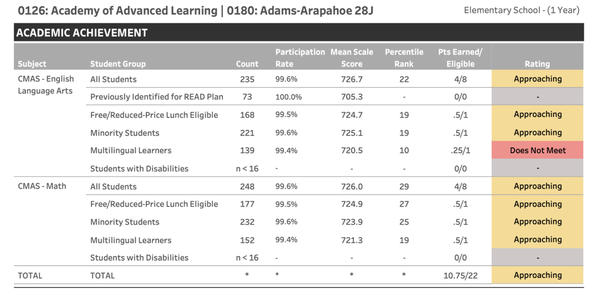
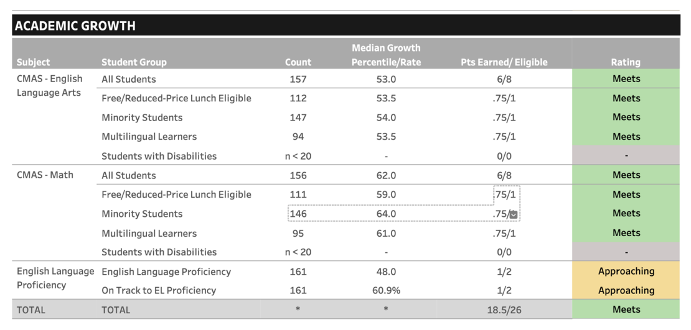

CMAS Middle School:
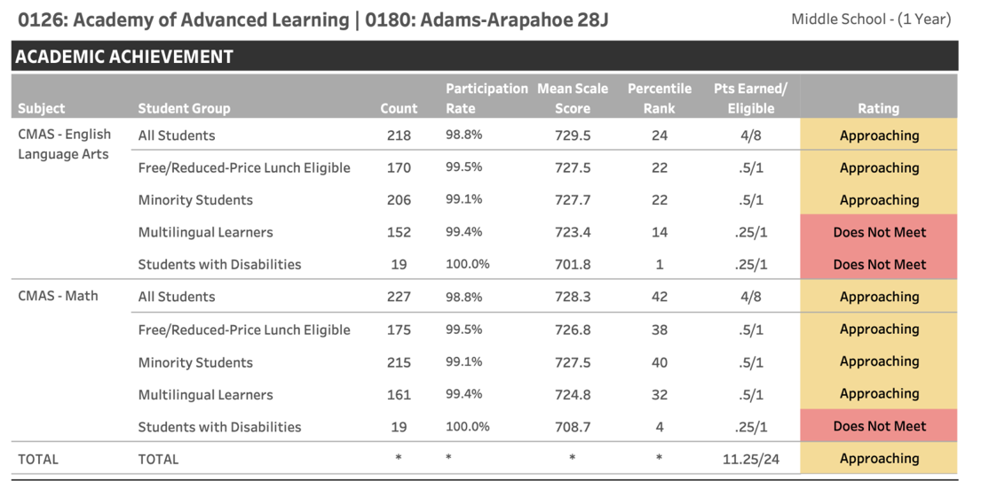
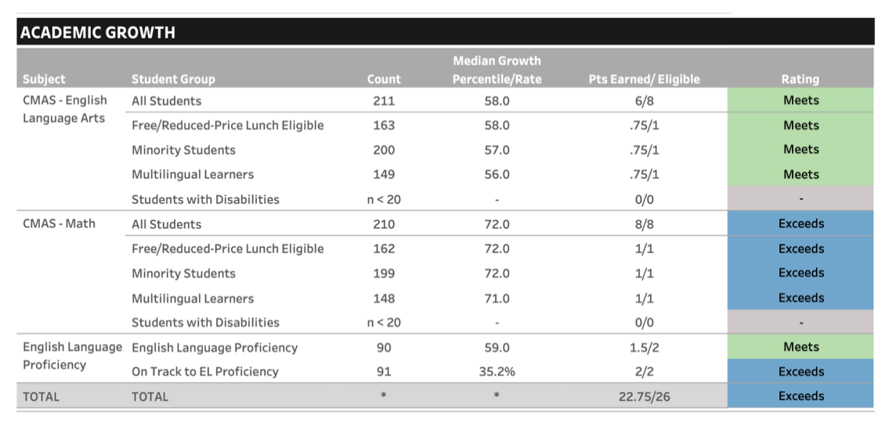

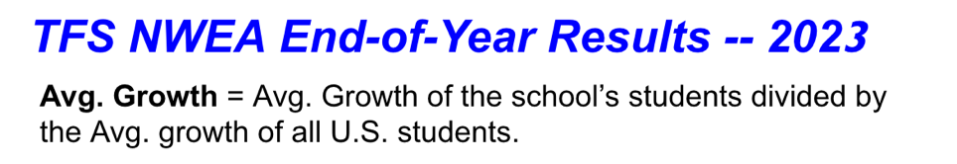 | 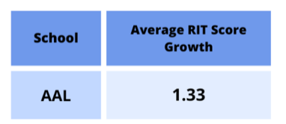
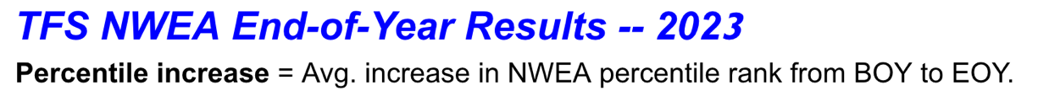 | 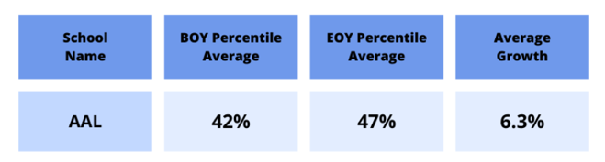

DIBELS
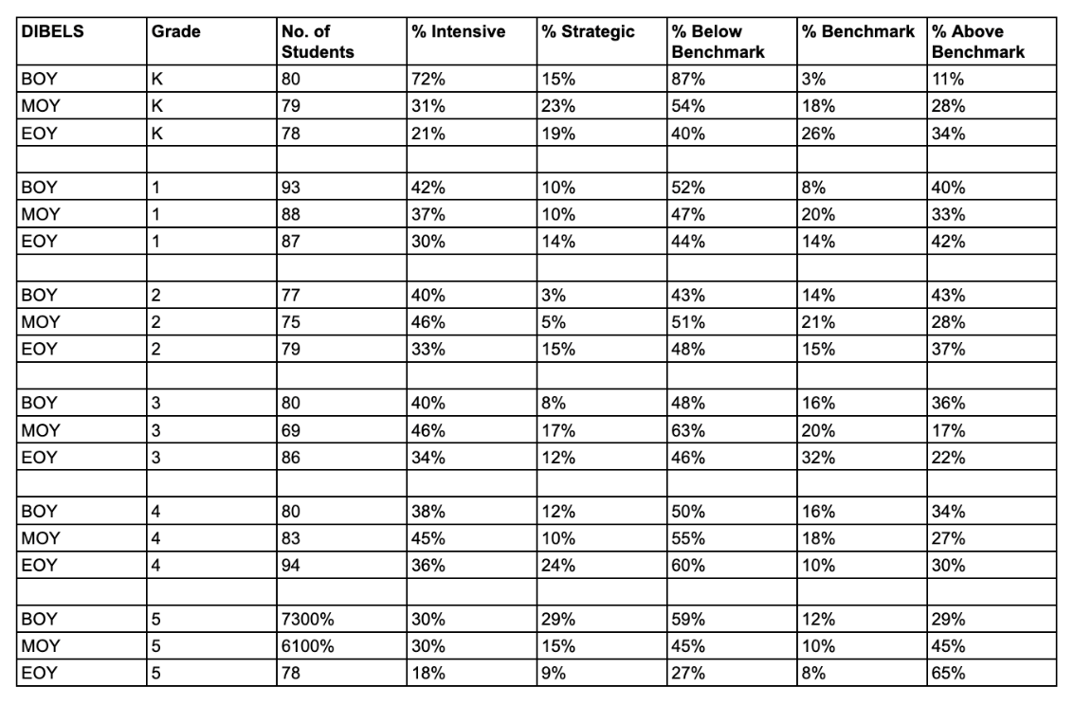

- How the school monitored progress towards meeting its goals, including the frequency of data analysis.

The Academy of Advanced Learning utilizes the NWEA MAP assessment as its primary measure of student academic success and growth. This is true for all Third Future Schools and is helpful when comparing academic performance and growth amongst our schools and across the nation. The NWEA is administered three times a year. AAL creates mini-action plans after the BOY and MOY to ensure that teachers are making the necessary instruction adjustments to meet all students needs. The school engages in bi-weekly professional learning communities to review data (including student work samples from daily demonstrations of learning (DOLs)).

Our model (called “LSAE”) provides students who are behind more time with guided assignments and students who are at grade level are challenged with more rigorous assignments. LSAE combines direct instruction with highly differentiated and more personalized learning.

All students receive grade-level, direct instruction for the first 40 to 45 minutes of a 90-minute class. This is important because many students in struggling schools across the nation never receive grade-level activities or assignments. After direct instruction, students take a “demonstration of learning” (DOL) and are then divided into four groups. The “learners (L),” who need more time with the specific objective for that class that day stay with the teacher and receive more guided instruction and practice. The students who are “securing (S1)” their learning and who need more practice at a slightly higher-level work on a different activity in the classroom. Students who have “secured (S2)” their learning work on an activity or assignment that is yet more rigorous. The “accelerated (A)” student receives an even more rigorous assignment. The “secured” and “accelerated” students work in a “team center” outside of the classroom where learning coaches assist them during the remainder of that class period.

A small percentage of students will be placed in a fifth group: Enriching (E). The students in this category know the objective so well that they are allowed to use the rest of the class period to work on their enrichment topics that will be outlined in their Student Learning Plan.

The demonstrations of learning (DOL) ensure that student knowledge is assessed every period every day. Teachers analyze these data every other Thursday during PLC and determine the student’s academic level and progress for the week. “Extended LSAE” on Fridays further helps remediate students or extend their learning.

Progress is also monitored using DIBELS for literacy. Intervention groups are established to support student growth.

- A reflection upon the underlying factors that have contributed towards the school’s current progress (both positive and negative) towards meeting their goals.
Third Future Schools’ system is based on some fundamentally different principles of operating schools and because we have an intense focus on closing the achievement gap and preparing students for a Year 2035 world and workplace. We will stay the course by ensuring we are meeting the key actions identified in the Action Plan. We focus on providing high-quality instruction in the LSAE model, high-quality and frequent instructional feedback (spot observations), unique opportunities in the Dyad concept, and strategic focus on literacy development and growth. We are relentless when it comes to the maintaining fidelity to the LSAE model.
- How authorization with CSI will support the school’s efforts at achieving its goals.
We see authorization with CSI as an opportunity for the Academy of Advanced Learning to continue to move in a positive direction when it comes to meeting the needs and goals of all students. We believe the support and professional expertise we have received with Coperni 3 in the areas of Special Education, Section 504, Gifted & Talented, Multilingual Learners, and all students (including those with Significant Reading Deficiencies, McKinney-Vento) will be equality beneficial for the students and staff of the Academy of Advanced Learning.

- Please explain how the curriculum was selected, meets the needs of the student population, and is aligned to standards.

Core Knowledge Language Arts (CKLA) was selected for Kindergarten to 4th grade students for the Academy of Advanced Learning and all Third Future Schools. This evidence-based instructional resource meets the requirements of the Colorado Department of Education’s (CDE) READ Act.

Led by the Director of Science of Reading, the network employs four Science of Reading curriculum specialists who create lessons for the Science of Reading teachers to execute in their classrooms. This has standardized our expectations of literacy instruction and provided an evidence-based instructional curriculum for staff and students. These lessons are aligned to the Colorado Academic Standards. Every lesson includes a lesson objective, PowerPoint presentation, activities and assignments, and demonstration of learning.

Lead Curriculum Developers (LCDs) create lesson plans (including PowerPoint presentations, lesson objective, demonstrations of learnings, activities and assignments, LSAE materials, and answer keys for the LSAE materials). The network LCDs create these lessons for 3rd-8th grade English Language Arts (ELA), Mathematics, Science, and Art of Thinking. These lessons are aligned tightly to Colorado Academic Standards and are reviewed by content experts. As appropriate, teachers can adjust the provided LCD materials to meet the needs of their students.

The instructional materials meet the needs of the students by being written at grade level standards. Additionally, the content is developed to be age and developmentally appropriate while also including content that is of interest and relevant to students.

- Provide a description of the procedures for taking corrective action if school performance falls below the goals and objectives outlined in the application. Include a corrective action timeline, the responsible person, and possible changes to be considered as appropriate.

In the event school performance falls below goals and objectives outlined in the networks Action Plan, the school’s administration creates a mini-action plan to address the achievement and growth concerns. These plans may include schedule changes, staff changes, curricular changes, the addition of intervention groups, more feedback to staff, and other appropriate changes. The following are the steps that are taken to address the needs with accountability and fidelity:

- School Administration and Network Administration review NWEA and DIBELS benchmark assessments.
2. If performance falls below goals and objectives, the School Administration immediately creates a mini-action plan in conjunction with the Director of Schools. The creation of these plans can also include teacher leaders.
3. The mini-action plan is shared with the Superintendent and Deputy Chief of Schools, so they have access to the plan when conducting school visits and to monitor goal progress.
4. The mini-action plan is shared with the school staff, so they can understand the next steps and be a part of the process.
5. School Principal and Director provide ongoing monitoring of the plan includes data collected from daily spot observations, demonstrations of learning, completion of LSAE materials, and other formative assessments that occur every 4-minutes in every class (through purposeful multiple response strategies).
6. Updates on goal progress are provided to the Superintendent and Deputy Chief of Schools.
7. Adjustments are made based on observations and data by school and network staff.

- Please describe the programmatic and curricular changes anticipated following the change in authorizer.

At this time, we see no programmatic or curricular changes following the change in authorizer.

- Complete the table below to outline the data management system(s) that will be utilized.
- In the first column, please identify any other types of data management systems (in addition to a SIS and Plan Management System) that may be used at the school (ex: Learning Management System).
- In the System Name column, identify the name of any data management systems that will be used at the school (ex: Infinite Campus).
- In the Person Responsible for Data Management column, identify the staff position(s) that will be responsible for the system setup, data entry, and data analysis.
 | System Name | Person Responsible for Data Management
Student Information System | Infinite Campus | Brenda Balderas

- Please provide a copy of the following documents as attachments:

Attachment Contents |  | Attachment Title
a. | All reports/data dashboards provided to the local board in the last year related to academic performance | - NWEA_Data_MOY_2023-2024_BoardonTrack (January 18, 2024)
Click to go back to the Application Checklist

B. Student Services
As applicable, please describe any adjustments to the current programming, resource allocation, and staffing that will occur if the proposed school becomes a CSI charter school.

- Include the comprehensive whole school plan for a Multi-Tiered System of Support or child study process that includes a data driven pre-referral prevention-based framework process that meets legal requirements including identification of special needs students.

MTSS
In alignment with the Colorado Department of Education’s Multi-System of Supports Strategy Guide,
AAL has incorporated MTSS as a prevention-based framework that is focused on a data-driven problem-solving approach to support all learners.

At AAL, using the Beginning, Middle, and End of year Map data taken from the Northwest Evaluation
Association (NWEA), students who score below grade level are identified as students in need of
intervention. In addition to academics, behavior is monitored, and students are identified in need of
supports based on the positive behavior system in place.

For identified students in the areas of academic and/or behavior, formal communication is provided to
parents and the MTSS process is initiated. Students that are identified in need of intervention are
monitored for at least three weeks by the classroom teacher. After the initial three weeks, the student
support team (SST) is assembled to review progress and determine the next steps. If warranted, further
interventions are put in place for at least three additional weeks. After this cycle of intervention, the SST
meets to discuss regression, stagnation or progress of the student. At the time, utilizing the data from
the MTSS process, the team determines if further interventions and time are appropriate or if a referral
to consider Special Education is appropriate.

- Detail plans to support and address student health including the process and procedures for immunizations, record keeping, vision and hearing screenings, health care plans, medication administration, and student illnesses.

At AAL, we a promote a comprehensive school health program that integrates a set of planned, sequential, school- affiliated strategies, activities, and services designed to promote optimal physical, emotional, social, and educational development of all students in accordance with the Health Guidance from CDE.
Immunizations: Colorado law requires all students attending Colorado schools to be vaccinated against certain diseases unless they have a Certificate of Medical or Nonmedical Exemption on file at the school. Annually, our school nurse follows a process to establish those students who may be considered out of compliance and provides correspondence with parents/guardians. Collaboratively they work to secure compliance by way of immunizations or exemptions.
Vision and Hearing Screenings: The sight and hearing of all children in the kindergarten, first, second, third, fifth, seventh, and ninth grades, of children in comparable age groups referred for testing, are provided with Vision and Hearing Screenings in accordance with CDE standards. ALL our team led by our School Nurse provide these tests and makes records of all vision and hearing screening within our school database platform. When a deficiency in these screenings is found, parents/guardians are notified of these results and our school nurse may provide more guidance on further steps.
Health Care Plan: The individualized healthcare plan (IHP) communicates nursing care needs to regular and special education educators, administrators, teachers, health assistants and parents. At AAL, if a student requires an IHP, this is written by our school nurse in collaboration with the parent/guardian. The IHP is intended for students with a health condition that requires the performance of a specific treatment, such as non-routine medication treatment, health treatment, emergency action or invasive health procedure. Through the IHP, AAL works to ensure that all necessary information, needs, and plans are considered to maximize the student’s participation and performance in school. Although the IHP may comprise mainly of students on an Individual Education Plan (IEP), or 504 plan, not all students on those plans require an IHP.
At AAL, medical history obtained from health inventories, outside medical documentation, and parent/teacher referrals are utilized to consider if a student requires an IHP. Upon referral, our school nurse works along with the school team and parents/guardian to assess the need for an IHP. Based on those assessment tools and questionnaires a determination is made. If an IHP is determined to be appropriate a meeting is arranged by the school nurse with the parent/guardian to formally create the IHP. The school Nurse establishes the type, amount and intensity of nursing care required by a particular student in collaboration with the family, school, and healthcare provider. The IHP may also cover other aspects of care such as a student’s knowledge about their condition, self-care abilities and any modifications needed to enhance learning and prevent emergencies that may occur within the school setting. The IHP is documented, signed, dated, and recorded within our school data-based platform. In accordance with FERPA regulations, only those with a legitimate need are made aware of the plan. In some cases, training and follow-up conversations with school staff may be required and our led by our School Nurse. In alignment with the Colorado School Nurse Delegatory Clause, there may be aspects of the IHP that are performed by other school personnel and not the School Nurse.
Ongoing evaluation throughout the course of the year is conducted by the school Nurse on the progress and intended outcome of the IHP. Based on the changing needs of the student, the IHP may be adjusted.
Medication Administration: AAL adheres to the Medication Guidance set forth by CDE. There are a number of reasons why students might require medications during school and school sponsored activities, including but not limited to: Chronic conditions requiring medication to benefit from classroom instruction, Acute, but temporary medical needs that require medicine during the day, such as an antibiotic for an infection, Conditions that might require emergency medication, such as a rescue inhaler for asthma
At AAL, our School Nurse has the responsibility to assure that procedures are in place for the safe administration of all prescription and over-the-counter medications, including administration, documentation, storage, proper disposal, and follow-up/evaluation.
This process includes:
- Reviewing and understanding state laws, regulations, and rules related to medication administration, delegation, and ongoing supervision.
- Reviewing existing local school district policies, procedures, and forms related to medication and suggesting revisions as necessary to comply with federal and state mandates, nursing standards, and current best practices.
- Reviewing pharmacology and dosage of medications to be administered. ➢ Ensuring that medication administration is accompanied by proper written parental/guardian permission and prescriber orders in accordance with state and local policy within the past year.
- Establishing and ensuring documentation and quality control systems for storage and administration of medications on-site and off-site at school-sponsored events.
- Ensuring the proper disposal of expired and outdated medications.
- Establishing procedures for training, ongoing supervision, and evaluation of unlicensed assistive personnel (UAP) for any delegation. ➢ Working with school staff to clarify language referring to medication administration in all individualized education programs (IEPs and 504 plans). Individualized healthcare plans (IHPs), and/or emergency healthcare plans.
- Training all school staff to recognize signs and symptoms of medication adverse reactions and/or problems such as overdoses, skipped dosage(s), and necessary action steps. ➢ Reviewing the ability of all students who are allowed to self-carry.
- Developing a communication plan with parents, healthcare provider and student to address challenges with self-administration.
- Communicating medication administration policies and procedures on a regular basis to students, parents, and school staff. ➢ Observing and evaluating student health status and response to medication.
- Assuring that school transportation, field trips and emergency/disaster plans consider medication issues. The school nurse needs to ensure that any order for a prescription medicine is properly authorized as described above.
As it relates to the actual administration of medication either by the School Nurse or Delegated Staff, a process is followed to ensure the appropriate student, medication, date, dosage, and any specific instructions that may be in place. Documentation of this process is logged and recorded upon every administration. Accordingly, a similar process of documentation is in place for any medication incidents that may occur and is recorded utilizing an incident report form. This communication is provided to School Administration and parents/guardians.
All medications, except emergency medications, are stored in a locked drawer or cabinet used exclusively for medications. For any medications requiring refrigeration, a locked refrigerator is utilized.

- Detail how the school will accommodate different learning styles and the needs of all students. Provide plans and procedures that describe how the school will ensure all students will progress adequately. This should include information related to student identification, programming, assessment, progress monitoring, redesignation/exiting, service model delivery and the continuum of supports the school will have in place to serve students. Please respond to these items for each subgroup identified below (a-e).

- Students with Individualized Education Programs (IEPs)

Special Education Program Description

Students served at AAL are provided individualized instruction and intervention to support the whole child including academics, behavior, communication, social, emotional, adaptive, sensory, and physical needs in the least restrictive environment. Our purpose is to provide students with access to general education and grade level standards in accordance with the IDEA guidelines and the Colorado Department of Education (CDE) According to the Individuals with Disabilities Education Act (IDEA), the term “special education” means specially designed instruction, at no cost to parents, to meet the unique needs of a child with a disability. The IDEA defines the term “related services” to mean transportation, and such developmental, corrective, and other supportive services as may be required to assist a child with a disability to benefit from special education. Some other examples of related services are counseling services, interpreting services, physical and occupational therapy, and school health services. To be eligible for special education and related services, students must be evaluated and found eligible for one or more of the following disabilities listed in the IDEA: Autism, Deaf-Blindness, Developmental Delay, Emotional Disturbance, Hearing Impairment, Intellectual Disabilities, Multiple Disabilities, Orthopedic Impairment, Other Health Impairment, Specific Learning Disability, Speech or Language Impairment, Traumatic Brain Injury, and Visual Impairment In accordance with the CDE, the special education process determines whether or not a child is eligible for special education and related services and if so, which of these are appropriate for your child. The Special Education process in conjunction with the child find obligation consists of: Referral, Evaluation, Eligibility, Development of the Individualized Education Program (IEP), IEP review, and Reevaluation. At AAL, services are guided by student need in the Least Restrictive Environment (LRE). All students receive their Free and Appropriate Public Education (FAPE) in their LRE along a continuum of services. Through various modalities, students may benefit from push-in (inclusion) within the general education setting or may receive pull-out (resource) services for more targeted intervention and instruction.

Discipline for Students with Disabilities
School personnel may remove a student with a disability who violates a code of student conduct from his or her current placement to an appropriate interim alternative educational setting, or suspension, for not more than 10 consecutive school days (to the extent those alternatives are applied to students without disabilities), and for additional removals of not more than 10 consecutive school days in that same school year for separate incidents of misconduct (as long as those removals do not constitute a change of placement). If a student with a disability has been removed from his or her current placement for a total of 10 cumulative school days in the same school year, then the Local Education Agency (LEA shall provide services to the extent required during any subsequent days of removal. Within 10 school days of any decision to change the placement of a student with a disability because of a violation of the code of student conduct, the LEA and relevant members of the team shall review all relevant information in the student’s file and conduct a Manifestation Meeting to determine if the conduct in question was caused by, or had a direct and substantial relationship to the student’s disability.

Disability Discrimination Complaint Procedures
The Colorado Department of Education has developed dispute resolution processes for resolving the disagreement about your child’s disability identification or eligibility, evaluation, the level of services or placement, the provision of FAPE, or payment for services that you have obtained. In the event of a disagreement, parents/guardians may pursue: IEP facilitation, Mediation, informal complaints, formal complaints, and Due Process. More information can be found in the Special Education Process and Procedural Safeguards handbook through the Colorado Department of Education.

- Students with Section 504 plans
Section 504 Program Description: Students with disabilities are protected by the Office of Civil Rights to assure they receive free and appropriate public education. Section 504 of the rehabilitation Act of 1973 is a civil rights law that prohibits all federally funded programs and activities, whether they be public or private, from discriminating based on disabilities. In accordance with the Colorado Department of Education’s resource guide on 504, students who meet eligibility criteria established by the federal statute and as determined by AAL’s School Building Level Committee (SBLC). While there is no specific list of disabilities, to meet criteria for Section 504, students must possess a physical or mental impairment that “substantially” limits one or more life activities. There must be a record of the impairment, and the impairment should not be considered temporary. At AAL eligibility and service decisions are made by a group of persons who are knowledgeable about the child, about the meaning of the evaluation data, program/placement options, least restrictive environment requirements, and comparable facilities. Once found eligible for a 504, students served at AAL are provided accommodations through a 504 plan. Upon completion by those familiar with the student, compliance with the 504 plan is not optional and is overseen by the Office of Civil Rights (OCR).

- Students classified as English Learners

ELL Program Description
In accordance with the Colorado Department of Education’s ELD Program Requirements, upon enrollment at AAL, a language information section is completed through the enrollment process. Those who indicate the use of a language other than English are contacted to obtain more specific information and a Home Language Survey (HLS) is completed. Based on the results of the interview and home language survey, more information is obtained from an English Language proficiency Screener (ELPS) Through the use of the World-class Instructional Design and Assessment (WiDA) screener and ACCESS testing, language needs and proficiency are determined. More specifically, academic English language is measured in the domains of listening, speaking, reading, and writing. At AAL, these assessments are completed by individuals who are trained in the administration and screening instruments. Based on the results, if a student is performing other than ‘Proficient’ on the ELPS, the student is classified as an English Language Learner and parents are provided formal notification. The identification, screening, and parental notification of eligible students must be completed within 30 days of enrollment.

ELL Services
At AAL, English Learners receive standards-based instruction along with their English-Speaking peers and progress monitoring is an ongoing practice to support and accelerate instruction. Identified students receive support and services that are carried out by certified staff. Assessments are used to monitor student progress toward ELL proficiency along with comprehension of academic content.

- Students identified as gifted and talented

Gifted and Talented
In accordance with the Colorado Department of Education’s office of Gifted Education, AAL has incorporated a system of identification and services with students who have been identified as ‘gifted’. The Exceptional Children's Education Act (ECEA) defines "gifted" children as: Those persons between the ages of four and twenty-one whose aptitude or competence in abilities, talents, and potential for accomplishment in one or more domains are so exceptional or developmentally advanced that they require special provisions to meet their educational programming needs. Gifted children are hereafter referred to as gifted students. Children under five who are gifted may also be provided with early childhood special educational services. Gifted students include gifted students with disabilities (i.e. twice exceptional) and students with exceptional abilities or potential from all socio-economic, ethnic, and cultural populations. Gifted students are capable of high performance, exceptional production, or exceptional learning behavior by virtue of any or a combination of these areas of giftedness:

• General or specific intellectual ability
• Specific academic aptitude
• Creative or productive thinking
• Leadership abilities
• Visual arts, performing arts, musical or psychomotor abilities 12.01(16)

At AAL, universal screenings are conducted with all students. Along with universal screenings, formal assessments, classroom performance and parent/teacher requests support in the referral process for considerations of gifted and talented. The overall body of evidence is then used to determine if a student meets the requirements of the gifted and talented. This review is conducted by the student support team (SST) and parents. At the conclusion of the meeting, a formal determination in writing is provided to parents. Once students have been identified, an Advanced Learning Plan (ALP) is put in place for the student. This plan outlines the needs and services a student will receive that will support them in achieving their level of rigor. This plan is developed by the SST and is reviewed annually.

- Students identified as at-risk
All of the aforementioned groups are categorized as students at-risk. At ALL, in accordance with best practices in alignment with guidance from CDE, we worked to establish pro-active measures to support our students. The early identification processes and interventions supports are in place to ensure that all students receive educational benefit as it relates to academics, behavior, medical and social emotional needs. As described in this section, this is a collaborative and whole school approach that utilizes professional expertise from a diverse group of individuals. This is an ongoing process that occurs every day to meet the needs of all students.

- Detail the proposed staffing structure. Include any changes from the current staffing structure and plans to provide adequate numbers of qualified, in-field staff (including related service providers) to meet the needs of exceptional students in alignment with state requirements. Include information about the proposed contract model to employ staff, any secured agreements or MOUs, and describe the onboarding process for any contract staff.

Currently AAL has a total caseload of 51 students that receive support and services through an IEP. Our current staffing structure comprises of three licensed SPED teachers, a Speech Language Pathologist, Occupational Therapist, School Social Worker, and a School Psychologist. Given the current need, related service providers are a combination of part-time and full-time employees. This is the anticipated structure for the 24-25 School Year. However, as student needs change, we will continue to work to meet those needs in those situations. As it relates to hiring, we work to employee TFS staff through formal hiring processes and work with several contract agencies that assist in staffing.

- Detail how the budget will align with required resources to support special populations. The narrative should address the student plan management system to house student plans, curricula and instructional materials, and necessary staffing and training needed to serve special populations. The Applicant is required to submit a budget as part of the application submission as detailed in the CSI Budget Template. The description provided below should clearly align to and reference the submitted CSI Budget Template line items.

AAL currently utilizes Enrich as a student plan management system in alignment with Aurora Public Schools. However, in alignment with Coperni 3, AAL will be converting to Infinite Campus as the sole student plan management system. To support this transition, training on Infinite Campus will occur with staff prior to June 30th of 2023 and will be ongoing as new staff are hired.

- Please provide information regarding any Office of Civil Rights (OCR) or state complaints that have found the school to have violated students’ rights or any open OCR or state complaints, if applicable.

No formal OCR or state complaints have been filed against the Academy of Advanced Learning.

Click to go back to the Application Checklist

C. Finance
- Provide a summary of how the transfer to a CSI charter school will financially impact the school (changes in per pupil revenue, categorical funding, grants etc.) Please include contingency plan to mitigate the impacts of decreased funding or increased expenditures, if applicable.

Transitioning to CSI oversight will result in increased funding because all Title funds will be available,
there will be less funding held back for administrative costs and all of the available mill levy will now be
passed to Charter Schools.

Increased Per Pupil Revenue
CSI charter schools often receive funding based on enrollment numbers, similar to traditional public schools. However, CSI oversight will provide additional funding that will be available to the school as a result of the new Mil Levy rules. In addition, less funding will be held back as administrative costs and thus, the actual per pupil revenue will be higher with CSI.

Enhanced Categorical Funding
With CSI oversight, the school may gain access to additional categorical funding or resources targeted to specific student populations, such as special education, English language learners, or low-income students. This can provide valuable support for meeting the diverse needs of students and enhancing educational outcomes.

Expanded Grant Opportunities
Currently, the school district does not pass all Federal funding to the Charter School. In this case, all Title 1 funds are withheld and used at the district level. With CSI, all federal funds are passed to the school which will increase the available funding for the school.

Strategic Resource Allocation
Third Future Schools has a strategic plan for allocating the increased funding in alignment with the school’s goals and prioritizing investments in areas such as academic programs, student support services, professional development, and leadership density to maximize the impact on student achievement and school success.

Long-Term Financial Planning
Third Future Schools have developed a long-term financial sustainability plan that takes into account potential fluctuations in funding levels and future growth opportunities. Establishing reserves, leveraging grants, and implementing cost-saving measures mitigate financial risks and ensure the school’s continued success over time. By leveraging the increased funding available under CSI oversight and implementing a strategic contingency plan, the school can enhance its educational programs, support services, and overall effectiveness in serving students and the community.

- Please provide a copy of the most recent version of the following documents as attachments:

Attachment Contents |  | Attachment Title
a. | Three years of independent financial audits | 2021 AAL Audit FINAL.pdf; 2022 AAL Audit Reissued.pdf; 2023 AAL Audit Final.pdf
b. | Quarterly financial statements pursuant to C.R.S. 22-45-102 | AAL Quarterly Report Dec 2022.xls; AAL Quarterly Report March 2023.xls; AAL Quarterly Report June 2023.xls; AAL Quarterly Report Sept 2023.xls; AAL Quarterly Report Dec 2023.xls
c. | Quarterly balance sheet | AAL trial balance SDS 4th QTR 2022.pdf; AAL trial balance SDS 1st QTR 2023.pdf; AAL trial balance SDS 2nd QTR 2023.pdf; AAL trial balance SDS 3rd QTR 2023.pdf; AAL trial balance SDS 4th QTR 2023.pdf
d. | 5-Year budget detailed by source/object code | AAL 5 Year Budget.xls
e. | Financial policies and procedures | Third Future Schools Finance Policy 2023 V4 KH.doc
f. | All reports/data dashboards provided to the local board in the last year related to financial performance | 2021-990-TFS-FINAL.pdf; AAL-adopted-budget-22-23-  new.pdf;  NOTICE_OF_Proposed_School_Budget_AAL_Revised.pdf; Amended Budget; 2021 AAL Audit FINAL.pdf; 2022 AAL  Audit Reissued.pdf; 2023 AAL Audit Final.pdf; AAL  Quarterly Report Dec 2022.xls; AAL Quarterly Report  March 2023.xls; AAL Quarterly Report June 2023.xls; AAL  Quarterly Report Sept 2023.xls; AAL Quarterly Report Dec  2023.xls; AAL-adopted-budget-22-23-new.pdf; Amended  Budget FY24 Appropriation Resolution AAL 18 Jan  2024.pdf; Amended Budget FY24 UBS AAL 18 Jan  2024.pdf; Amended Summary Budget FY 24 AAL 18 Jan  2024 FINAL.pdf

3. For the proposed budget included with the application, please provide:
a. Detailed assumptions for all donations, private grants, student fees, and foundation
revenue
i. No Donations, private grants or student fees are included.
ii. Foundation Program (PPR/Mil) expected with very little increase annually.

b. Detailed assumptions for professional, technical, and consulting services expenditures.
i. DYAD costs will remain at $30 per hour.
ii. Because technology is established – in house technical employee will handle the large
majority of technology issues and very little technology services will be purchased.
iii. Consulting services mainly support SPED needs. Cost will increase marginally
year to year but will remain relatively flat in that no new SPED costs are expected.
c. Detailed assumptions for liability, property, and other insurance coverage, including
coverage and rates.
i. We worked with our insurance agent to project costs and unless there are new
requirements due to legislation, our costs will remain relatively flat. In fact, from this year
to next year, our costs will go down some.

d. An explanation of how restricted grant funding will be spent.
i. There are no restricted grants other than Federal Grants. These Federal grants will be
spent in the same manner as previous years in accordance with grant rules.

4. Detail financial metrics and targets, including any debt covenants, the board and school
leadership will track during the transition to ensure financial solvency as the school changes
authorizers.
Monitoring financial solvency is crucial to ensure sustainability and effective resource management.
Here are some key metrics and targets that we monitor:
- Budget Variance: Regularly compare actual expenses and revenues against the budgeted
amounts. This helps identify any significant discrepancies early.
- Fund Balance: Monitor the fund balance (reserves) to ensure it remains at a healthy level. A
sufficient fund balance over time.
- Revenue Streams: Track the revenue, such as state funding, grants, and other income streams.
- Expenditure per Pupil: Calculate the average expenditure per student to ensure spending
remains within budgetary constraints and is comparable to other schools managed by Third
Future.
- Debt Levels: Keep track of the district’s outstanding debt, including bonds and loans. Monitor
debt service ratios to ensure that debt obligations are manageable within the budget.
- Cash Flow: Monitor cash flow to ensure we can meet financial obligations, such as payroll, debt
payments, and other operational expenses, without facing liquidity issues.
- Enrollment Trends: Track student enrollment trends over time as changes in enrollment will have
a significant impact on funding levels and resource allocation.
- Salary and Benefit Costs: Monitor salary and benefit costs as a percentage of the total budget.
Controlling personnel costs is essential for financial stability.
- Economic Indicators: Monitor economic indicators at the local, state, and national levels that may
impact the finances, such as employment rates, property values, and tax revenues.
- Audit Findings: Review audit reports regularly to address any issues related to financial
management and internal controls in order to ensure that in future audits there will be no
findings.

By monitoring these metrics and targets closely, a school district can proactively identify financial
challenges and implement strategies to maintain long-term solvency and financial sustainability.

5. Detail how the budget aligns with the proposed execution of the school’s mission and focus
including staffing, curriculum, professional development, and technology.
The budget prioritizes investments that directly support Third Future Schools’ mission and focus on
innovative education by aligning resources with the recruitment and development of highly skilled
educators, the implementation of a dynamic and forward-thinking curriculum, the provision of
professional development opportunities, and the integration of technology to enhance teaching and
learning experiences.

Click to go back to the Application Checklist

D. Governance
- Complete the Board Membership Matrix
Applicants are required to have a governing board in place and to submit the Board Membership Matrix as part of the Transfer Application. Information regarding terms and positions below should align with the board membership information included in your bylaws. Resumes for board members are required to be submitted as described in Section H8.
- In the Board Member Name row, please identify all board members by name. If there are any vacant seats, please identify them by Just a nthe number of board members identified in your bylaws.
- In the Term row, please identify each board member’s term (ex: June 2016-June 2017)
- In the Board Position row, please identify each board member’s current role (Chair, Secretary, Treasurer, etc.)
- In the Competency column, please list the competencies you are seeking for the school board.
- Place an X in the box to identify which competencies each of the board members fill. For any vacant positions, place an X in the box to identify which competencies you are seeking in the vacant position.

 | 1 | 2 | 3 | 4 | 5 | 6 | 7 | 8 | 9 | 10 | 11
Board member name | Patrick  Mills | Rachel Ngola- Trice | Pam  Robinson | Mary  Lindimore | Helen  Morgan
Term | 08/16-08/20
Board Position | Chair
Competency
Finance | X | X |  | X | X
Legal
Human Resources |  | X | X | X | X
Educational Experience (public, private, charter, etc.) | X | X | X | X | X

- Provide a description of the governance structure. Delineate the roles and responsibilities of the school board, school administration, and various non-board committees including but not limited to the School Accountability Committee and any advisory groups. Please see attachments – Organizational chart and SACs

- Provide a summary of past and planned board training, capacity building, self-evaluation, and succession planning. Please include a discussion of funding and time allocations for board professional development, as well as evaluation tools.

Please see attachments – Board Assessment Report

- Submit most recent strategic plan and detail progress toward meeting the goals and/or objectives identified in the strategic plan.

Please see attachments – TFS Network Action Plan

- Describe any organizational changes related to staffing and leadership anticipated following the transfer and the rationale for the changes.

We do not foresee any organizational changes related to staffing or leadership following the transfer.

- Complete the CSI Waiver Request Template if you plan to seek a waiver of rule, law, or policy.

- Please provide a copy of the most recent version of the following documents as attachments.

Attachment Contents |  | Notes | Attachment Title
a. | A copy of the current charter contract |  | AAL-charter-contract.pdf (thirdfuture.org)
b. | A copy of any contracts or instruments that describe preexisting obligations or relationships | This would include any facilities agreements, contracts with an education service provider, contracts with a back office support provider etc. This does not include contracts for school materials that will not extend beyond the current school year. | None
c. | Annual performance reports from the current authorizer for the past five years |  | Corrected AAL Annual Review 22-23
d. | External evaluations (including CSSI site visit reports) |  | Bellwether Report from New Schools Venture Fund | N/A
e. | Board bylaws | Should specify board size, length of term, board election process, board roles, frequency of meetings, dismissal policies and procedures for board members, and conflict of interest policy | Board bylaws
f. | Employee handbook | Include the relationship between the school and its employees (at-will vs. contract). | Employee handbook
g. | Student handbook
h. | Student discipline policy | Include suspension and expulsion policies that align with state law and that address the safety of students and staff, provide a level of due process for students, and explain how the school will provide expelled students with alternative education, if applicable. | Student discipline policy
i. | Enrollment policy | The policy should be consistent with state law [22-30.5-507(3)] and applicable state board rules, and include a process for enrollment of students with special needs consistent with state and federal laws and state board rules. | Enrollment policy
j. | Strategic plan |  | TFS Network Action Plan | N/A
k. | School Leader Evaluation Process | Include the process the school will use for school leader evaluation that aligns with the intent of SB 10-191 (including timeline, standards). | Principal Evaluation concept paper
l. | Most recent board self-evaluation |  | Board Assessment Report
m. | All reports/data dashboards provided to the local board related to organizational performance |  | SPF | N/A
n. | Lease agreement |  | Lease Agreement | N/A
o. | A copy of the original charter application |  | AAL Charter Renewal Application
p. | Any formal notices of noncompliance or notices of breach of contract received by the school | Schools are only required to include notices received in the current school year and the two prior school years. | Breach of Contract notification;  AAL Breach Resolution confirmation; Notice of Noncompliance Response | N/A
q. | Board meeting minutes from the prior school year and the year-to-date (the preceding 18 months) |  | Board meeting minutes
r. | School Accountability Committee meeting minutes for the prior school year and the year-to-date (the preceding 18 months) |  | AAL Q1 School Accountability mtg.; AAL Q2 School Accountability mtg.; AAL Q3 School Accountability mtg.

Click to go back to the Application Checklist

E. Operations

- Describe any significant operational adjustments that will be required to implement the program after the change in authorizer.

The only operational change that will need to happen is the SFA for the school.

Facilities
- Provide a description of the current facility and any anticipated changes to the facility (including any potential or proposed changes to location of the school) that may occur as a result of the transfer of authorization.

AAL is currently operating in three different buildings. Main Campus houses grades K-4. East Campus houses grades 5-6. and West campus houses grades 7-8. There are no changes to facilities that would be impacted as a result of changing authorizers.

Safety
- Please submit your current Emergency Response Plan. If there are proposed changes to the school facility, please explain your process to create and maintain the required Emergency Response Plan.

The emergency response plan is in place without the need to make any changes. Emergency Response Plan – under attachments.

Transportation
- Please summarize the extent to which transportation is currently provided at the school.

No transportation is provided at this time.

- Please identify the option below that best describes the school’s intended transportation should the school transfer to CSI. Then respond to all items within the option that you have selected.

Option 1: A school may choose to not provide any transportation services.
- Provide a rationale for why the Applicant is not proposing to provide transportation services.
Academy of Advanced Learning has never provided transportation in the seven years we have been operating. We open at 6:30 am and close at 6:00 pm, which allows families ninety minutes before school and two hours after school to drop off/ pick up students. This aligns with the rationale at Coperni 3 which does not provide transportation either.

Option 2: A school may provide regular transportation services to and from school.
- Include a description of how the charter school plans to meet the transportation needs of students, including at-risk students.

- Provide a description of the daily route that aligns with the transportation plan to meet student needs.

- Provide cost details within the school’s budget and summarize details here.

- Include a plan to address insurance and liability issues pertaining to transportation services using private or school vehicles.

- Include a description of adequate safety measures that will be implemented for the transportation of students.

Option 3: A school may provide transportation services for extracurricular activities and events.

- Include a description of how the charter school plans to meet the transportation needs of all students, including at-risk students.

- Provide cost details within the school’s budget and summarize details here.

- Include a plan to address insurance and liability issues pertaining to transportation services using private or school vehicles.

- Include a description of adequate safety measures that will be implemented for the transportation of students.

Food Services
- Please summarize the extent to which food services are currently offered at the school.
Food service is provided for breakfast, lunch and snack daily for all students.

- Please check which of the following options the school intends to follow should the school transfer to CSI with regards to food services. Respond to all items within the option that you have selected.

Option 1: A school may choose not to participate in any federal Child Nutrition Program through a School Food Authority (SFA). Under this option, the school may elect not to operate a lunch program.
  - Provide a rationale for why the Applicant is not proposing to provide food services.

Option 2: A school may choose not to participate in any federal Child Nutrition Program through a School Food Authority (SFA). Under this option, the school may choose to operate their own meal service(s) that are unsubsidized by federal funds.

  - Provide a rationale for why the Applicant is proposing to operate its own meal service(s) unsubsidized by federal funds.

  - Include details about how the food service will be provided.

  - Address how the school will provide services to students who forget or cannot provide a lunch.

Option 3: A school may choose to participate in federal Child Nutrition Programs and receive federal reimbursement funds. Within this option, a school may elect to contract with a School Food Authority.
- Provide rationale for why the Applicant is selecting this food service option.
AAL would operate under an SFA to ensure we are meeting all the guidelines set forward by the USDA to include approved foods, portion sizes, and FRL application processes.

- Include details about how the food service will be provided.
The service to students is provided through a daily delivery of prepared hot lunch provided by the food service vendor. When that delivery is completed, included are the items for that day's snack as well as breakfast for the following day. An AAL employee who has completed all trainings through the SFA serves all food items to the students and inputs the data for students served into the information system provided though the SFA. Daily logs are also completed by this employee for snack reimbursement.

- Provide evidence of a plan for reimbursement through an authorized School Food Authority.
Third Future Schools currently operates a reimbursement system through Charter Choice SFA that follows the exact plan laid out for AAL. We have already started the process of adding AAL to the contract and have begun the RFP process to solidify a contract with a food service provider.

- Address how the school will provide services to students who forget or cannot provide a lunch.
All students may go through the lunch line and are provided a lunch regardless of FRL status. No student is turned away without a meal.

Option 4: A school may choose to participate in federal Child Nutrition Programs and receive federal reimbursement funds. Within this option, a school may obtain state designation as a School Food Authority.

- Provide rationale for why the Applicant is selecting this food service option.

- Include details about how the food service will be provided.

- Provide evidence of a plan for reimbursement through an authorized School Food Authority.

- Address how the school will provide services to students who forget or cannot provide a lunch.

F. Evidence of Need, Support
- Please identify the projected number of students that will be enrolled at each grade level for each of the first five years of operation following the transfer.

 | Year 1 | Year 2 | Year 3 | Year 4 | Year 5
PreK | 0 | 0 | 0 | 0 | 0
K | 100 | 100 | 100 | 100 | 100
1 | 100 | 100 | 100 | 100 | 100
2 | 100 | 100 | 100 | 100 | 100
3 | 100 | 100 | 100 | 100 | 100
4 | 100 | 100 | 100 | 100 | 100
5 | 100 | 100 | 100 | 100 | 100
6 | 100 | 100 | 100 | 100 | 100
7 | 100 | 100 | 100 | 100 | 100
8 | 100 | 100 | 100 | 100 | 100
9 | 0 | 0 | 0 | 0 | 0
10 | 0 | 0 | 0 | 0 | 0
11 | 0 | 0 | 0 | 0 | 0
12 | 0 | 0 | 0 | 0 | 0
Total | 900 | 900 | 900 | 900 | 900

If applicable, please describe whether any of the above Year 1 enrollment numbers vary significantly from your existing student population or if additional grades will be served.

This is about 100 students higher than current enrollment as we anticipate a retention rate of over 90% as well as moving from three Kindergarten classes to four classes. Based on current new enrollments we are on track to meet our enrollment projections based on current marketing and communications.

- Please identify what percentage of each student population is currently served by your school.
For schools that anticipate demographics changing from following the transfer, please fill out the Projection row. If you anticipate demographic projections remaining the same, please only fill out one row.

Year | % Minority | % Free/Reduced Lunch Eligible | % Special Education | % English Learner | % Gifted/ Talented
Current Year | 51.7 | 66.4 | 7.2 | 62.3 | 1.1
Projection (if applicable)

If applicable, please explain why any of the above percentages vary significantly from your existing student population.

- Describe the degree to which the school has engaged existing parents and community members regarding the proposed change in authorizer.
This communication has been limited to TFS Board meetings, which are open meetings, due to the change in authorizer having no impact on the programming provided at the school. TFS Board agreed that due to no impact on students or staff at AAL as we already follow TFS governance and by laws, that this notification to parents is for information purposes as parent and community members will have the same contacts and board members without amendment.

- Describe expectations and plans for ongoing parent and community involvement from the time of application through transfer.
The formal notification of AALs release from Aurora Public Schools was ratified at the APS board meeting on February 20, 2024. We will have formal conversations with our SAC as well as the next two TFS Board meetings.

- Please provide evidence that an adequate number of parents, teachers, or pupils support transfer to the Institute. The following may satisfy this requirement and be submitted as attachments:
AAL is currently collecting intent to re-enroll forms from all current students via parent communication.

Attachment Contents |  | Attachment Title
a. | Results from a survey disseminated to all stakeholder groups, including the number and proportion of respondents from each group |  | N/A
b. | Letters of support from identified stakeholder groups |  | N/A
c. | Letters of intent to remain enrolled or enroll in the program following the transfer |  | N/A

- In the table below, please list out all existing community partnerships and networking relationships.

Entity | Nature of Partnership / Description
CSGF | Philantropic
Daniels Fund | Philantropic

Click to go back to the Application Checklist

Required Addenda as Applicable

Addendum I: Online School
The online school addendum should be completed if the school is proposing to be an online school as defined on the CDE website.
If the school intends to be a multi-district online school, the Applicant should submit its Plan for Operating an Online School, which begins on page 21 of the CDE Multi-District Online School Application, as an addendum to the application.

This school is proposing to be an online school. This addendum is included in the application packet.
Not Applicable

Addendum II: Innovation School
The innovation addendum should be completed it the application proposes a school model/program with strong potential to accelerate student success through dramatically different school designs, instructional strategies, uses of technology, staffing models, governance arrangements, family and community engagement strategies, and other approaches.
If the school intends to propose an innovative educational model/program, the following items should be addressed within the body of the Transfer Application Narrative and summarized in an addendum to the application.
- An applicant may propose a model centered on innovation in curriculum, instructional strategies, assessment, governance, family and community engagement strategies, or other areas, or in a combination of two or more areas. Please explain how the proposed model is fundamentally different from typical school models. This should include an explanation of the innovation and the rationale for the chosen innovation, including a detailed, thoughtful and appropriate use/integration of the innovation into the school model/program, and an explanation of how that innovation will improve student outcomes.
- Please describe and explain any available evidentiary basis for the efficacy of the model or for the ideas underlying the model.
- Please include an explanation of how the proposed model will be monitored and evaluated and held to the same high accountability standards to which CSI holds all schools.
- Please include any proposed mission-specific measures that would allow the school to demonstrate the efficacy of the proposed innovations. Use the mission-specific measures template to detail the anticipated design of the measures.
- Please include any specific staffing structures and/or professional development/training that are unique to the proposed innovations.

This school is proposing to be an innovation school. This addendum is included in the application packet.
Not Applicable

Addendum III: Education Management Provider, Collaborative, Incubator
An Education Management Provider is defined in Colorado law as a nonprofit, not-for-profit, or for-profit entity that contracts with a charter school to provide, manage, or oversee all, or substantially all, of the education services provided by the charter school. An Education Management Provider is different from a Charter School Collaborative or an Incubator. A Charter School Collaborative is defined by law as two or more charter schools contracting with one another to form a legal entity separate from the contracting charter schools and is authorized to provide any function, service, or facility that is lawfully authorized for each of the contracting charter schools. An Incubator is defined as any organization contracted to support the development of the charter school including but not limited to application development, professional development, human resource, and other services in the early years of the school’s operation.

If the school intends to contract with an education management provider, incubator, or collaborative, the following items should be addressed and included as an attachment. “Provider” below should refer to whichever contractors (EMP, incubator, or collaborative) you are proposing to contract with. This addendum should not exceed 15 pages.
- Provide the rationale for selection of the provider.
- Provide evidence that demonstrates the effectiveness of the provider with other schools, including particularly schools in Colorado and schools serving a similar population. This should include performance data around academic, financial, and operational success.
- Provide evidence demonstrating the capacity of the provider for successful expansion while maintaining quality in the school(s) it is currently managing.
- Include an explanation of any existing or potential conflicts of interest between the governing board of the proposed charter school and the provider.
- Provide evidence that the provider is authorized to conduct business in Colorado.
- Include a detailed description of cost sharing, fee structures, and central versus school level functions.
- Provide a clear understanding of financial obligation to the provider. This should include considerations of changes in costs (increases, decreases, etc.) throughout the duration of the charter term. This should also include building ownership if the developers are making payments to the provider.
- Include a copy of the actual or proposed performance contract between the governing board for the proposed charter school and the provider that specifies, at a minimum, the following material terms:
  - Performance evaluation measures
  - Methods of contract oversight and enforcement that the governing board will use
  - Delineation of central (provider) vs. school level functions
  - Conditions for contract renewal and termination
  - Information around which staff will be hired and terminated by the provider, report to the provider, or will be paid by the provider
  - The compensation structure and all fees that the proposed charter school will pay to the provider
- Include copies of the last three years of audited annual financial statements (balance sheets and profit and loss statements), copies of any current or past liens, and copies of and pending or past lawsuits.

This school is proposing to contract with a provider. This addendum is included in the application packet.
Not Applicable

Addendum IV: AEC
If the Applicant intends to apply for designation as an Alternative Education Campus (AEC), the following information must be included in the narrative of the application and summarized as an addendum to the application.

Colorado law allows each school, with its authorizer’s approval, to request designation as an Alternative Education Campus (AEC). Alternative Education Campuses (AECs) are defined as schools that have a specialized mission and serve either a special-needs and/or at-risk population, where more than 90% of students have either an Individualized Education Program or meet the definition of a high-risk student. The specific eligibility is listed in 1 CCR 301- 57-2207602-R-3.00. To receive this designation, schools must demonstrate that it meets the eligibility criteria annually.

- Identify the particular high-risk student populations your school will be focused on serving. (A list of the high-risk student populations can be found on the Summary tab of the CDE AEC Application.)
- Be sure your application specifically addresses how your outreach will reach the high-risk student populations required for AEC designation.
- Address how the proposed model will include at least two of the three required elements: a high-quality college and career-ready instruction, programs to build college and career-ready skills, and appropriate supports for students in the first year of postsecondary enrollment. Additionally, please describe how the required elements align to the proposed graduation policy.
- Complete AEC Target Setting Form
Performance Indicators | Measures/ Metrics | Annual Performance Targets |  | Interim Measures for  2018-2019 | Progress Monitoring Strategies
 |  | 2018-2019 | 2019-2020
Student Engagement | Attendance Rate
 | Truancy Rate
 | Supplemental Measure(s)
Postsecondary & Workforce Readiness | Completion Rate
 | Dropout Rate
 | Mean CO ACT
 | Supplemental Measure(s)

This school is proposing to be an AEC. This addendum is included in the application packet.
Not Applicable

