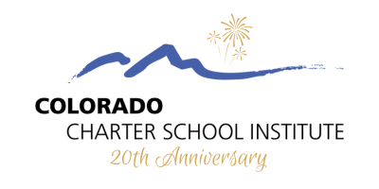

2024 CSI Scholarship Promotional Toolkit

About the Scholarship

The Colorado Charter School Institute (CSI) is celebrating its 20th anniversary this year! We are delighted to share with you an exciting opportunity that reflects our commitment to celebrating both our rich history and the outstanding achievements of our students.

To celebrate this important milestone, CSI is proud to announce a special scholarship initiative designed exclusively for graduating high school students of CSI schools. Our “theme” for this anniversary is school impact.

Social Media Graphic

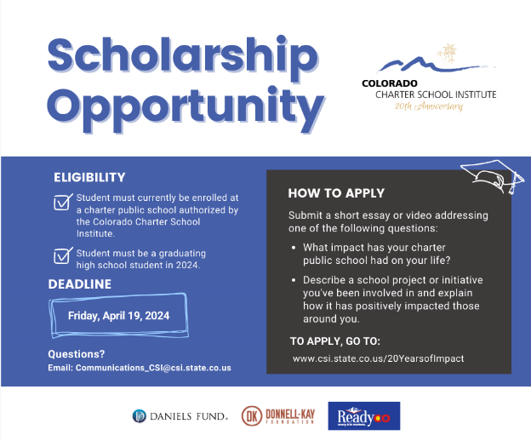
Download Social Media Graphic

Social Media Caption/Newsletter Blurb

Scholarship Opportunity! The Colorado Charter School Institute (CSI) is marking its 20th anniversary this year! To celebrate, CSI is presenting a special scholarship opportunity for graduating high school students from CSI schools in partnership with generous organizations. #CSI20Years

The deadline to apply is Friday, April 19, 2024 at 11:59 PM

To learn more and apply, visit CSI’s 20 Years of Impact webpage: https://www.csi.state.co.us/20yearsofimpact/

Questions? Email Communications_CSI@csi.state.co.us

Follow CSI on social media: Facebook | Twitter | LinkedIn
If you have any questions, please contact CSI’s Communications Team at: Communications_CSI@csi.state.co.us

