“Our Why” Promo Social Media Toolkit

About CSI’s “Our Why” Page

CSI is committed to fostering high-quality charter school options that meet the needs of their communities. Each member of the 20,000+ CSI community of schools has a unique story on why they have chosen a charter school. We have collected a selection of stories from CSI school staff, parents, and students. Each story highlights what charter schools and choice mean to them. We want to hear your story! What does your charter school mean to you?

View CSI’s “Our Why” page!

Help us spread the word! Let’s gather more stories and share the positive impact that charters are having in the community!

Social Media Graphics

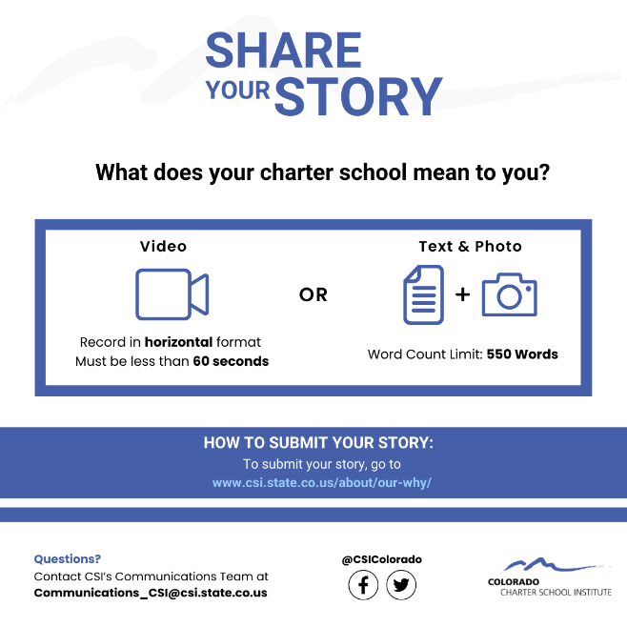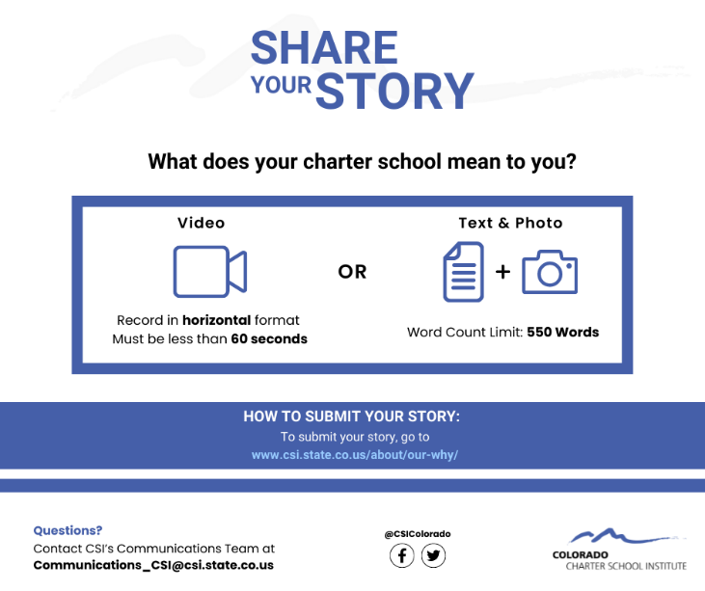
Download Instagram Graphic Download Facebook Graphic

Social Media Captions

Instagram/Facebook Caption:
What does your charter school mean to you? We want to hear your story! @CSIColorado is collecting a selection of stories from CSI school staff, parents, and students. Each one highlights what charter schools and choice mean to them. Share your to be featured on CSI’s webpage. To view other stories and to submit your story, go to www.csi.state.co.us/about/our-why/

Twitter Caption:
What does your charter school mean to you? @CSIColorado is collecting a selection of stories from CSI school staff, parents, and students. Share your story to be featured on CSI’s webpage. To view other stories and to submit your story, go to www.csi.state.co.us/about/our-why/

Newsletter Blurb:
What does your charter school mean to you? We want to hear your story! The Colorado Charter School Institute is collecting a selection of stories from CSI school staff, parents, and students. Each one highlights what charter schools and choice mean to them. Share your story in text format (up to 550 words) with a photo OR in video format (less than 60 seconds in horizontal orientation) to be featured on CSI’s webpage. To view other stories and to submit your story, go to www.csi.state.co.us/about/our-why/

  - Follow CSI on social media!
Facebook: @CSIColorado - https://www.facebook.com/CSIColorado
Twitter: @CSIColorado - https://twitter.com/CSIColorado

If you have any questions, please contact CSI’s Communications Team at: Communications_CSI@csi.state.co.us

