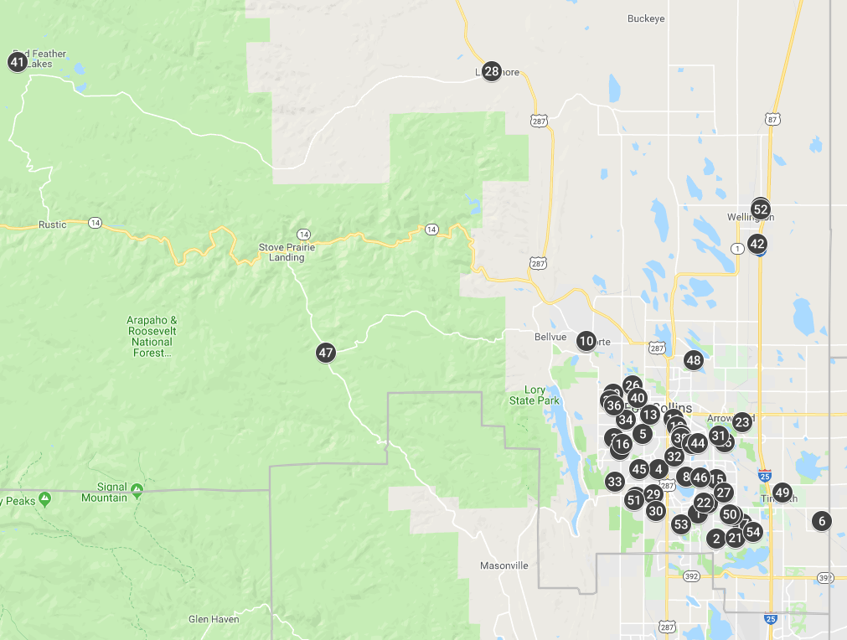
Map of Schools
To the left is a screenshot of the map located here: https://tinyurl.com/poudremap
This map has all the schools in Poudre School District (PSD) boundaries, both PSD and Charter School Institute (CSI) schools.
To learn more about each school in your neighborhood, look at the table on the next page and search in the “Map #” column.
More details are available by accessing the full map using the link above.

List of Schools in Poudre School District, Both PSD and CSI Schools
Map # | District Name | School Name | Website | Grades Served | Street Address | Charter | AEC | 2018 State Performance Rating | Statewide Percentile
1 | CSI | ACADEMY OF ARTS & KNOWLEDGE | http://www.aakelementary.org/ | KG-05 | 4800 WHEATON DRIVE | Charter | Non-AEC | Performance | 65
2 | POUDRE | BACON ELEMENTARY SCHOOL | https://bac.psdschools.org/ | PK-05 | 5844 SOUTH TIMBERLINE ROAD | Non-Charter | Non-AEC | Performance | 88
3 | POUDRE | BAUDER ELEMENTARY SCHOOL | https://bau.psdschools.org/ | PK-05 | 2345 WEST PROSPECT ROAD | Non-Charter | Non-AEC | Performance | 44.4
4 | POUDRE | BEATTIE ELEMENTARY SCHOOL | https://bea.psdschools.org/ | PK-05 | 3000 MEADOWLARK | Non-Charter | Non-AEC | Performance | 78.1
5 | POUDRE | BENNETT ELEMENTARY SCHOOL | https://ben.psdschools.org/ | KG-05 | 1125 BENNETT ROAD | Non-Charter | Non-AEC | Performance | 95.6
6 | POUDRE | BETHKE ELEMENTARY SCHOOL | https://bet.psdschools.org/ | KG-05 | 5100 SCHOOL HOUSE DRIVE | Non-Charter | Non-AEC | Performance | 92.1
7 | POUDRE | BLEVINS MIDDLE SCHOOL | https://ble.psdschools.org/ | 06-08 | 2101 SOUTH TAFT HILL ROAD | Non-Charter | Non-AEC | Performance | 37.2
8 | POUDRE | BOLTZ MIDDLE SCHOOL | https://bol.psdschools.org/ | 06-08 | 720 BOLTZ DRIVE | Non-Charter | Non-AEC | Performance | 54.1
9 | POUDRE | CACHE LA POUDRE ELEMENTARY SCHOOL | https://cpe.psdschools.org/ | PK-05 | 3511 W CR 54G | Non-Charter | Non-AEC | Performance | 59.2
10 | POUDRE | CACHE LA POUDRE MIDDLE SCHOOL | https://clp.psdschools.org/ | 06-08 | 3515 W CR 54G | Non-Charter | Non-AEC | Performance | 91.4
11 | POUDRE | CENTENNIAL HIGH SCHOOL | https://chs.psdschools.org/ | 9-12 | 330 EAST LAUREL STREET | Non-Charter | AEC | AEC: Performance | 10.8
12 | CSI | COLORADO EARLY COLLEGE FORT COLLINS | https://fortcollins.coloradoearlycolleges.org/ | 06-12 | 4424 INNOVATION DRIVE | Charter | Non-AEC | Performance with Distinction* | 86.5
13 | POUDRE | DUNN ELEMENTARY SCHOOL | https://dun.psdschools.org/ | KG-05 | 501 S WASHINGTON AVENUE | Non-Charter | Non-AEC | Performance | 94.7
14 | POUDRE | EYESTONE ELEMENTARY SCHOOL | https://eye.psdschools.org/ | PK-05 | 4000 WILSON AVENUE | Non-Charter | Non-AEC | Performance | 66.6
15 | POUDRE | FORT COLLINS HIGH SCHOOL | https://fch.psdschools.org/ | 09-12 | 3400 LAMBKIN WAY | Non-Charter | Non-AEC | Performance | 64.8
16 | POUDRE | FORT COLLINS MONTESSORI SCHOOL | https://focomontessori.org/ | PK-06 | 1900 SOUTH TAFT HILL ROAD | Charter | Non-AEC | Performance | 65.9
17 | POUDRE | FOSSIL RIDGE HIGH SCHOOL | https://frh.psdschools.org/ | 09-12 | 5400 ZIEGLER ROAD | Non-Charter | Non-AEC | Performance | 90.8
18 | POUDRE | HARRIS BILINGUAL ELEMENTARY SCHOOL | https://bil.psdschools.org/ | PK-05 | 501 EAST ELIZABETH | Non-Charter | Non-AEC | Performance | 92.3
19 | POUDRE | IRISH ELEMENTARY SCHOOL | https://iri.psdschools.org/ | PK-05 | 515 IRISH DRIVE | Non-Charter | Non-AEC | Improvement | 33
20 | POUDRE | JOHNSON ELEMENTARY SCHOOL | https://joh.psdschools.org/ | PK-05 | 4101 SENECA STREET | Non-Charter | Non-AEC | Performance | 84.4
21 | POUDRE | KINARD CORE KNOWLEDGE MIDDLE SCHOOL | https://kin.psdschools.org/ | 06-08 | 3002 EAST TRILBY ROAD | Non-Charter | Non-AEC | Performance | 96.3
22 | POUDRE | KRUSE ELEMENTARY SCHOOL | https://kru.psdschools.org/ | PK-05 | 4400 MCMURRY AVENUE | Non-Charter | Non-AEC | Performance | 93.1
23 | POUDRE | LAUREL ELEMENTARY SCHOOL | https://lau.psdschools.org/ | PK-05 | 1000 EAST LOCUST STREET | Non-Charter | Non-AEC | Improvement | 32.5
24 | POUDRE | LESHER MIDDLE SCHOOL | https://les.psdschools.org/ | 06-08 | 1400 STOVER STREET | Non-Charter | Non-AEC | Performance | 69.5
25 | POUDRE | LIBERTY COMMON CHARTER SCHOOL | http://www.libertycommon.org/ | KG-12 | 1725 SHARP POINT DRIVE | Charter | Non-AEC | Performance | 98.5
26 | POUDRE | LINCOLN MIDDLE SCHOOL | https://lin.psdschools.org/ | 06-08 | 1600 LANCER DRIVE | Non-Charter | Non-AEC | Priority Improvement | 9.8
27 | POUDRE | LINTON ELEMENTARY SCHOOL | https://lnt.psdschools.org/ | PK-05 | 4100 CARIBOU DRIVE | Non-Charter | Non-AEC | Performance | 51.3
28 | POUDRE | LIVERMORE ELEMENTARY SCHOOL | https://liv.psdschools.org/ | KG-05 | 360 RED FEATHER LAKES ROAD | Non-Charter | Non-AEC | Performance | 96.1
29 | POUDRE | LOPEZ ELEMENTARY SCHOOL | https://lop.psdschools.org/ | PK-05 | 637 WABASH STREET | Non-Charter | Non-AEC | Performance | 67.8
30 | POUDRE | MCGRAW ELEMENTARY SCHOOL | https://mcg.psdschools.org/ | PK-05 | 4800 HINSDALE DRIVE | Non-Charter | Non-AEC | Performance | 95.2
31 | POUDRE | MOUNTAIN SAGE COMMUNITY SCHOOL | http://www.mountainsage.org/ | KG-08 | 2310 EAST PROSPECT ROAD | Charter | Non-AEC | Performance | 85.2
32 | POUDRE | O'DEA ELEMENTARY SCHOOL | https://ode.psdschools.org/ | KG-05 | 312 PRINCETON ROAD | Non-Charter | Non-AEC | Performance | 74.5
33 | POUDRE | OLANDER ELEMENTARY SCHOOL | https://ola.psdschools.org/ | PK-05 | 3401 AUNTIE STONE STREET | Non-Charter | Non-AEC | Performance | 68.2
34 | POUDRE | POLARIS EXPEDITIONARY LEARNING SCHOOL | https://pol.psdschools.org/ | KG-12 | 1905 ORCHARD PLACE | Non-Charter | Non-AEC | Performance | 79.1
35 | POUDRE | POUDRE COMMUNITY ACADEMY | https://pca.psdschools.org/ | 08-12 | 2540 LAPORTE AVENUE | Non-Charter | AEC | AEC: Improvement | 6.7
36 | POUDRE | POUDRE HIGH SCHOOL | https://phs.psdschools.org/ | 09-12 | 201 IMPALA DRIVE | Non-Charter | Non-AEC | Performance | 42
37 | POUDRE | PRESTON MIDDLE SCHOOL | https://pre.psdschools.org/ | 06-08 | 4901 CORBETT DRIVE | Non-Charter | Non-AEC | Performance | 57.5
38 | POUDRE | PSD GLOBAL ACADEMY | https://pga.psdschools.org/ | KG-12 | 703 EAST PROSPECT ROAD | Non-Charter | Non-AEC | Performance | 79.3
39 | POUDRE | PSD OPTIONS PROGRAM | https://options.psdschools.org/ | KG-08 | 703 EAST PROSPECT ROAD | Non-Charter | Non-AEC | No rating required | --
40 | POUDRE | PUTNAM ELEMENTARY SCHOOL | https://put.psdschools.org/ | PK-05 | 1400 MAPLE STREET | Non-Charter | Non-AEC | Performance | 62.8
41 | POUDRE | RED FEATHER LAKES ELEMENTARY SCHOOL | https://red.psdschools.org/ | KG-05 | 505 N COUNTY ROAD 73C | Non-Charter | Non-AEC | Performance | 93.2
42 | POUDRE | RICE ELEMENTARY SCHOOL | https://ric.psdschools.org/ | PK-05 | 7000 THIRD STREET | Non-Charter | Non-AEC | Performance | 77.9
43 | POUDRE | RIDGEVIEW CLASSICAL CHARTER SCHOOLS | https://www.ridgeviewclassical.com/ | KG-12 | 1800 SOUTH LEMAY AVENUE | Charter | Non-AEC | Performance | 92.5
44 | POUDRE | RIFFENBURGH ELEMENTARY SCHOOL | https://rif.psdschools.org/ | KG-05 | 1320 EAST STUART STREET | Non-Charter | Non-AEC | Performance | 81.9
45 | POUDRE | ROCKY MOUNTAIN HIGH SCHOOL | https://rmh.psdschools.org/ | 09-12 | 1300 WEST SWALLOW ROAD | Non-Charter | Non-AEC | Performance | 63.2
46 | POUDRE | SHEPARDSON ELEMENTARY SCHOOL | https://she.psdschools.org/ | PK-05 | 1501 SPRINGWOOD DRIVE | Non-Charter | Non-AEC | Performance | 89.4
47 | POUDRE | STOVE PRAIRIE ELEMENTARY SCHOOL | https://sto.psdschools.org/ | KG-05 | 3891 STOVE PRAIRIE ROAD | Non-Charter | Non-AEC | Priority Improvement | 14.7
48 | POUDRE | TAVELLI ELEMENTARY SCHOOL | https://tav.psdschools.org/ | PK-05 | 1118 MIRAMOUNT DRIVE | Non-Charter | Non-AEC | Performance | 89.3
49 | POUDRE | TIMNATH ELEMENTARY SCHOOL | https://tim.psdschools.org/ | PK-05 | 3909 MAIN STREET | Non-Charter | Non-AEC | Performance | 79.1
50 | POUDRE | TRAUT ELEMENTARY SCHOOL | https://tra.psdschools.org/ | PK-05 | 2515 TIMBERWOOD DRIVE | Non-Charter | Non-AEC | Performance | 98.2
51 | POUDRE | WEBBER MIDDLE SCHOOL | https://web.psdschools.org/ | 06-08 | 4201 SENECA STREET | Non-Charter | Non-AEC | Performance | 65.6
52 | POUDRE | WELLINGTON MIDDLE SCHOOL | https://wel.psdschools.org/ | 06-08 | 4001 WILSON AVENUE | Non-Charter | Non-AEC | Performance | 35.6
53 | POUDRE | WERNER ELEMENTARY SCHOOL | https://wer.psdschools.org/ | KG-05 | 5400 MAIL CREEK LANE | Non-Charter | Non-AEC | Performance | 95.1
54 | POUDRE | ZACH ELEMENTARY SCHOOL | https://zac.psdschools.org/ | KG-05 | 3715 KECHTER ROAD | Non-Charter | Non-AEC | Performance | 82.6
-- | CSI | AXIS INTERNATIONAL ACADEMY | https://axiscolorado.org/ | KG-05 | LOCATION FORTHCOMING | Charter | Non-AEC | NEW SCHOOL: Opens in 2019-20 | --
*This rating value is unique to Charter School Institute schools. It represents the highest performing schools in the CSI portfolio, awarded to any CSI school in the top 25% of schools statewide.
Use this link to download the full table.

